**DevOps Learning Report – GIT, GITHHUB, CI/CD WITH JENKINS.**

*By ShivKumar*

# SYNOPSIS

*This report documents my complete hands-on DevOps journey from* ***Git to Jenkins Pipelines****, learning 4 different way of setting up Jenkins and within each approach of installation, we are exploring further concepts like*

1. *Spring Boot Application CI Pipeline with Maven & Jenkins – via Project*
2. *Understanding the functionality of CI by Pipeline Job*
3. *Master-Slave setups.*

Contents

SYNOPSIS 1

**1. Introduction to DevOps** 3

**2. Git & GitHub (Day 1)** 3

**3. Version Control Systems & Java Setup (Day 2)** 9

**4. Continuous itegration CI with Jenkins (Day 3)** 10

**5. Jenkins Java Continuous Integration CI (Day 4)** 21

**6. Jenkins Setup as developer/devops - using WAR file Deployment (Oracle - Day 4 Contd.)** 33

**7. Project 1 – Java Spring Boot Application CI Pipeline with Maven & Jenkins (Day 5)** 34

**8. Setup Jenkins with dockerised container (Approach 3)** 47

**9. Jenkins by Windows desktop installer [end user approach] (Approach 4)** 61

**10. Master-Slave Configuration Setup in Jenkin (Day 6)** 63

## **1. Introduction to DevOps**

**Definition:** DevOps is a combination of development (Dev) and operations (Ops) practices that aims to shorten the software development life cycle and deliver high-quality software continuously.

**Basic Knowledge Required:** Understanding of version control, continuous integration, scripting, cloud infrastructure, and automation tools.

## **2. Git & GitHub (Day 1)**

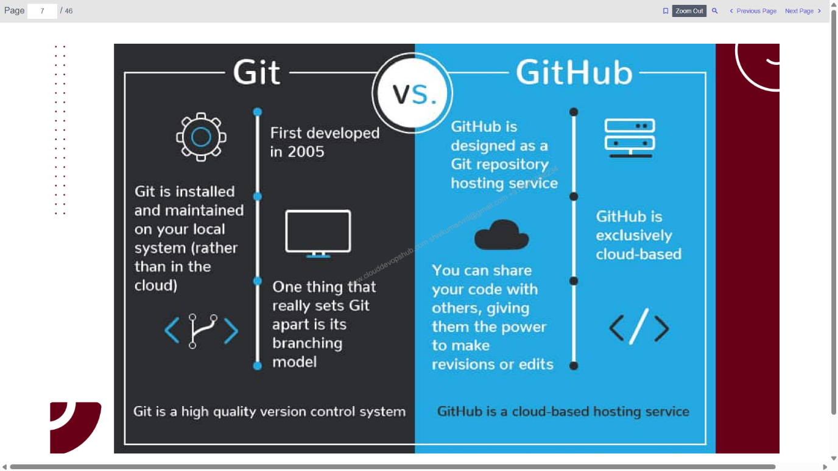

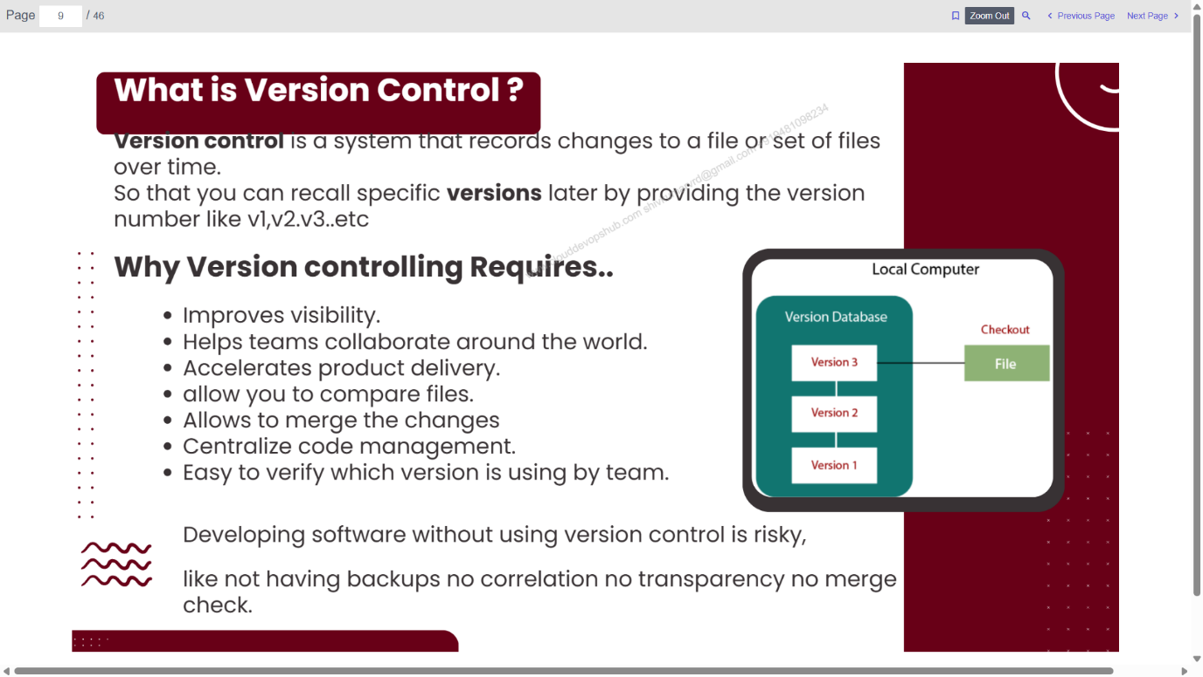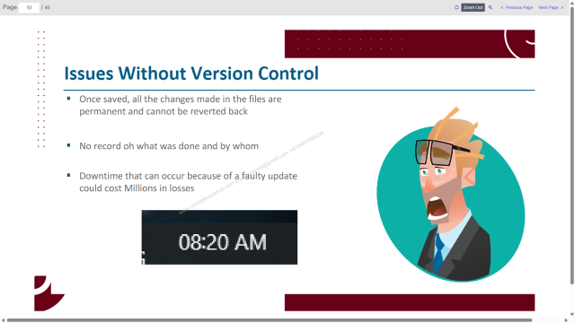

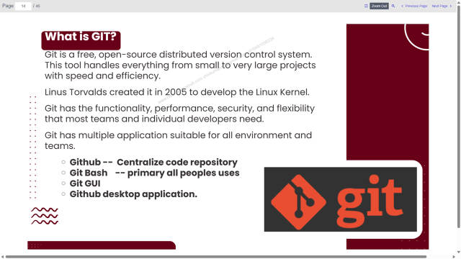 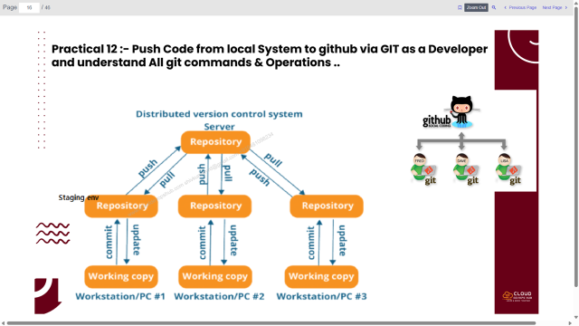 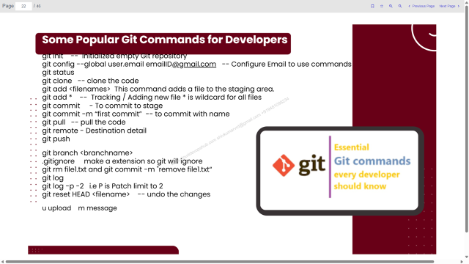 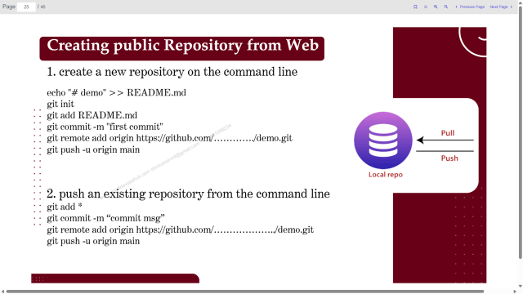

**Git:** A distributed version control system used to track code changes. **GitHub:** A web-based hosting service for version control using Git.

**Git Workflow:** Working Directory → Staging Area → Local Repository → Remote Repository

**Tools Installed:**  
**1. Git for Windows** *(Used to execute Git commands via Git Bash)*

**Practical 1:** *Push code to GitHub using Git Bash.* First time creation of git repository

**Steps:** ➤ Configure Git identity  
➤ Initialize repo  
➤ Add README  
➤ Commit  
➤ Add remote origin  
➤ Push to GitHub

**Code:**

git config --global user.name "Shiv Kumar"  
git config --global user.email shivkumarvrd@gmail.com  
echo "# firstrepo" >> README.md  
git init  
git add README.md  
git commit -m "first commit"  
git branch -M main  
git remote add origin https://github.com/ShivK8431/firstrepo.git  
git push -u origin main

**Note:** Execute code one by one.

**Practical 2:** *Add and commit new files*  
**Code:**

git add *  
git status  
git commit -m "Add new file"  
git push

**Learned:**

* **git init**: Initializes a git repo.
* **git add**: Stages files.
* **git commit**: Saves changes.
* **git push**: Sends local repo to remote.
* **git pull**: Fetches and merges changes.
* **git status**: Shows repo status.

**Difference:** Fork vs Clone

* *Fork* creates a copy of a repo under your account.
* *Clone* copies repo locally.

difference between tracked and untracked file: if tracked file is modified, it'll become untracked file and is not yet commit. fix it by git add *

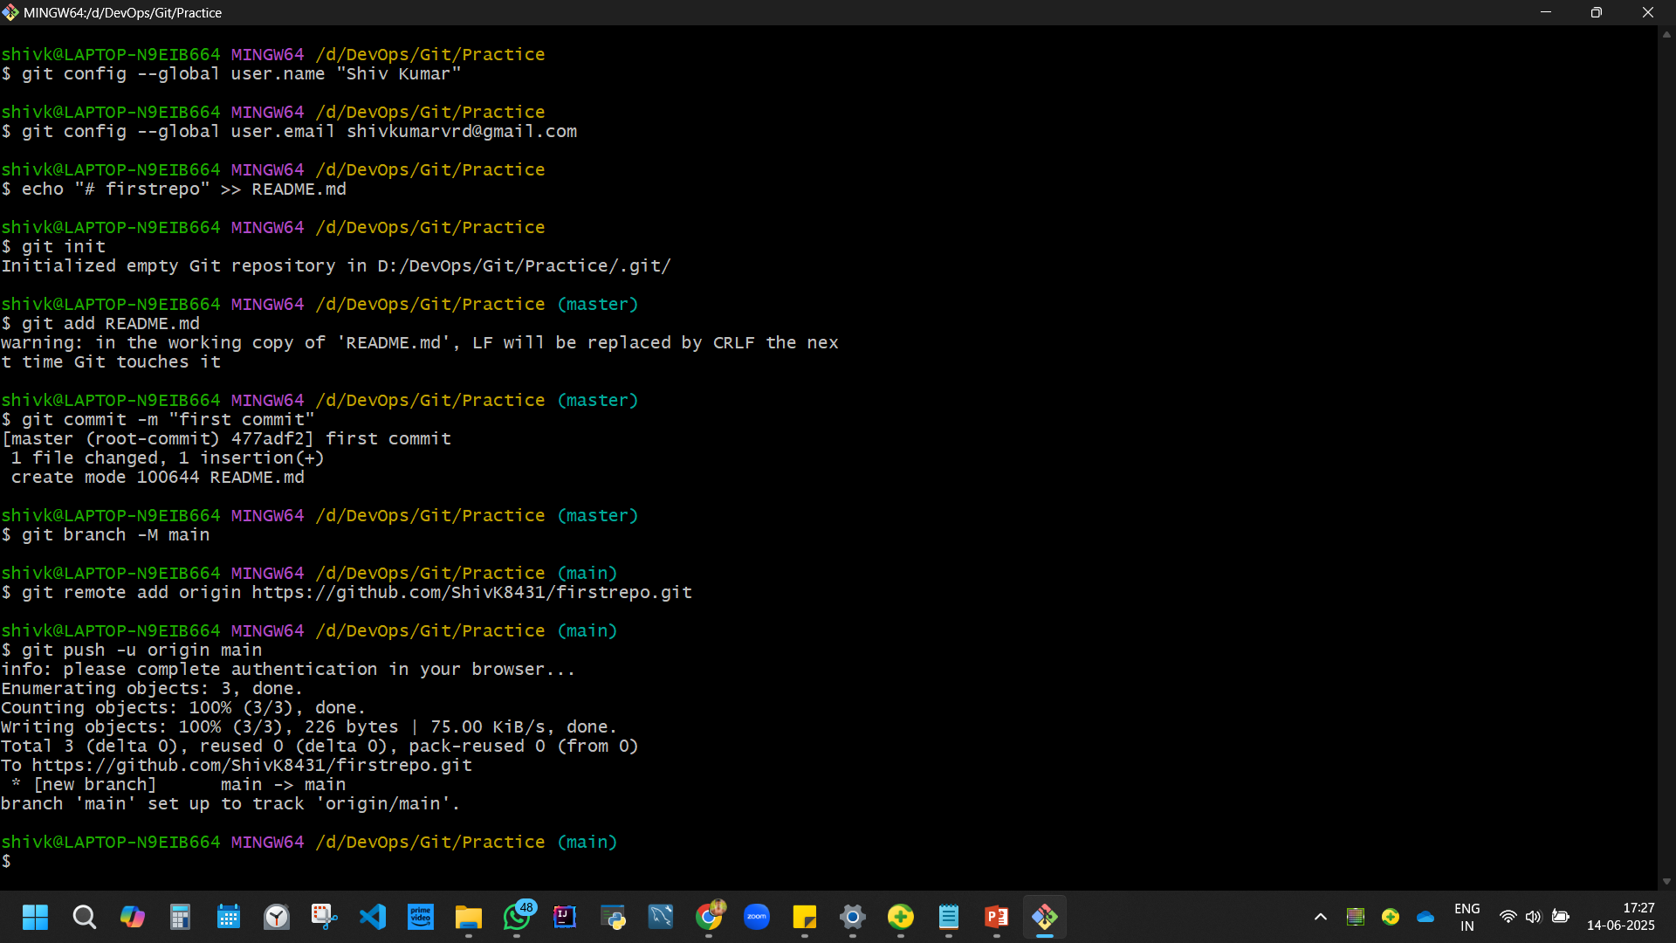 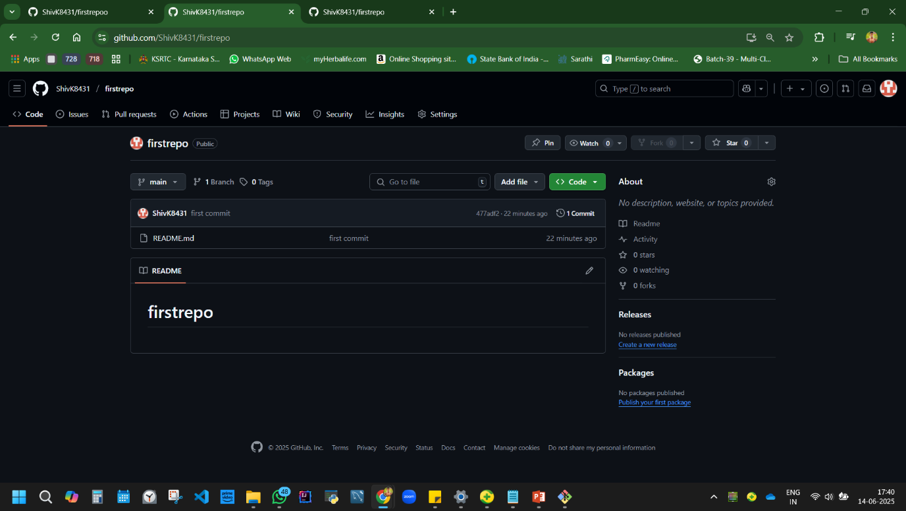

**Disadvantage:** Git has a steep learning curve; GitHub requires internet access for collaboration.

## **3. Version Control Systems & Java Setup (Day 2)**

**Version Control:** Tracks changes to code over time, allowing rollback, collaboration, and auditing.

**Tools Installed:**  
**2. VirtualBox-7.1.10-169112-Win**  
**3. Java JDK 17.0.12**

**Note:** //javac compiles the code

**Learned:** Compiling Java and pushing code via VS Code to GitHub. using JDK file. [JRE not installing yet]. **Note:** Java JDK/JRE installations can be confusing for beginners.

**Practical 3:** *Push code using Visual Studio Java*

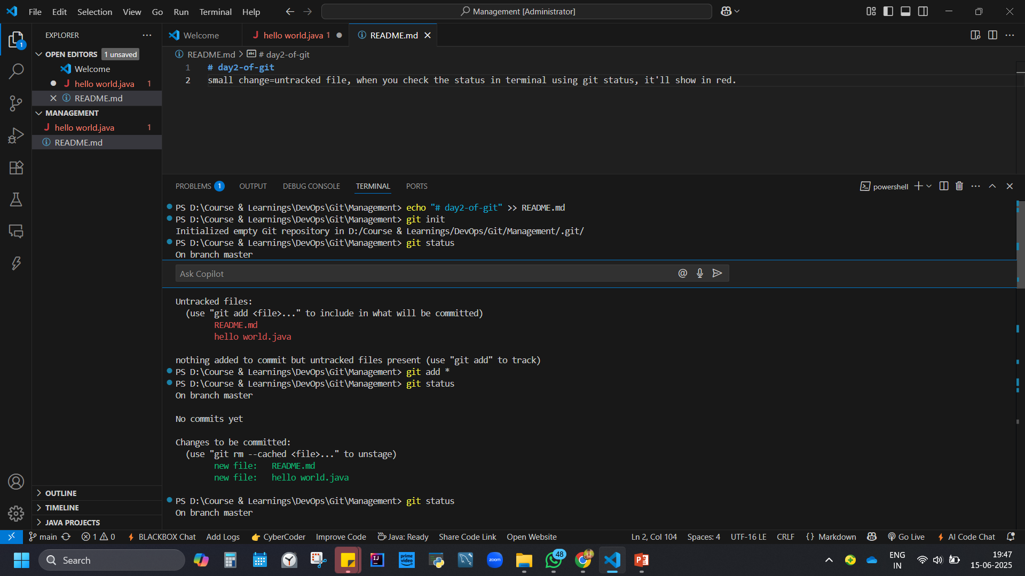

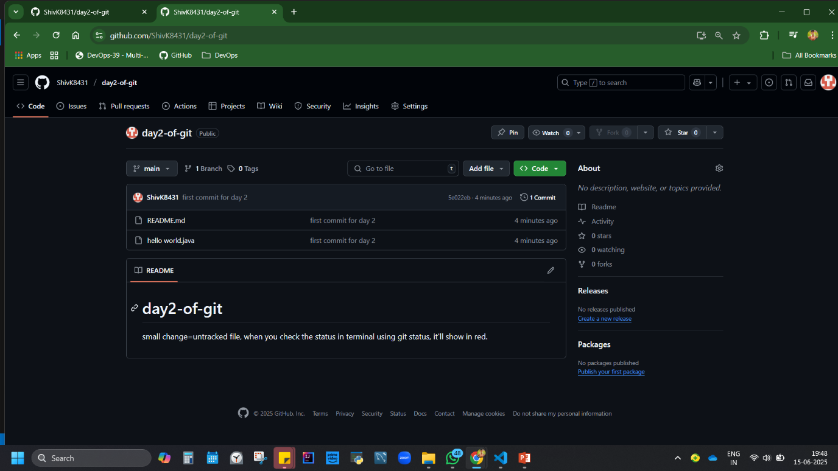

## **4. Continuous itegration CI with Jenkins (Day 3)**

**CI (Continuous Integration):** Developers integrate code into a shared repo frequently, verified by automated builds.

**CI Tools:** Jenkins, GitLab CI, Codeship, Bamboo, Travis CI

**Jenkins:** A centralized CI/CD automation server integrating with tools like JIRA, Maven, etc. it a centralsied tool and how it can be integrated with for ex: jira, maven etc. and attached with other tools using plugin.

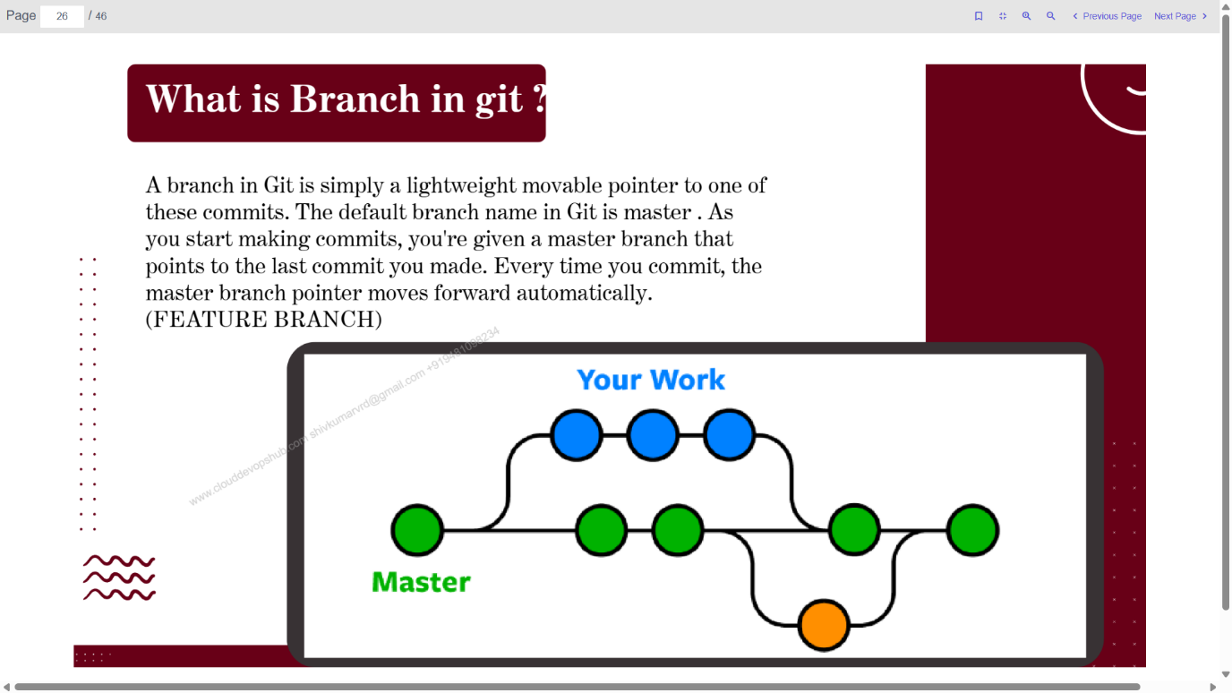

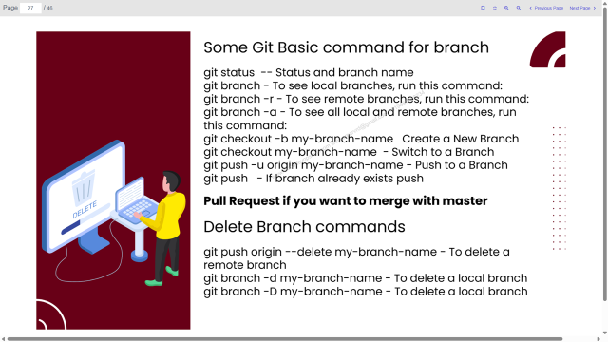 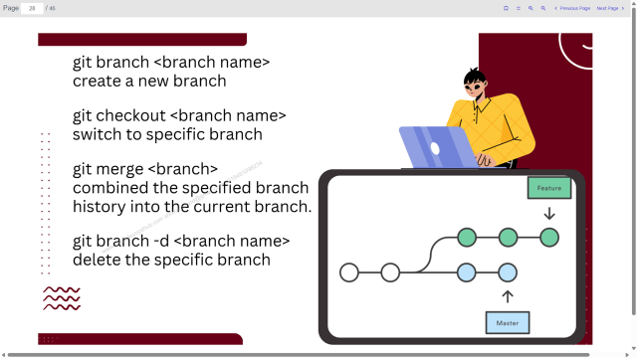 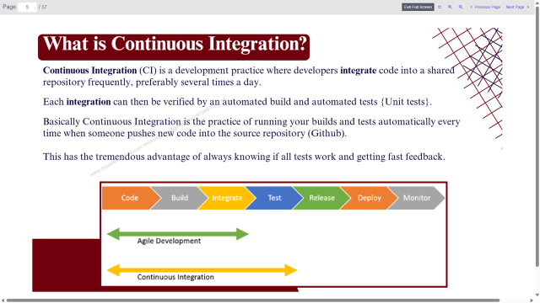 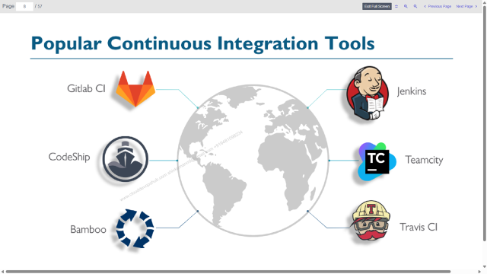

workflow, tradition vs CI.

**Disadvantage:** Jenkins requires setup and plugin management.

Four ways/approach to install jenkin.

Approach 1: Installation of Jenkin on Ubuntu VM from linux via google cloud

Approach 2: Jenkins Setup as developer/devops - using WAR file Deployment.

Approach 3: Setup Jenkins with dockerised container

Approach 4: Jenkins by Windows desktop installer [end user approach]

**Tools Installed:**  
**4. Installation of Jenkin on Ubuntu VM from linux via google cloud (Approach 1)**

[can do via AWS also, preferred google cloud. aws has limited size machine].

steps to set up my google cloud account. compute engine API, VM instance, name ciserver, Operating system - ubuntu, not minimal, take lts version 24.04 x86/64 noble, 20gb machine, networking tab allow traffic, create. ssh connect, authorise, server connects.

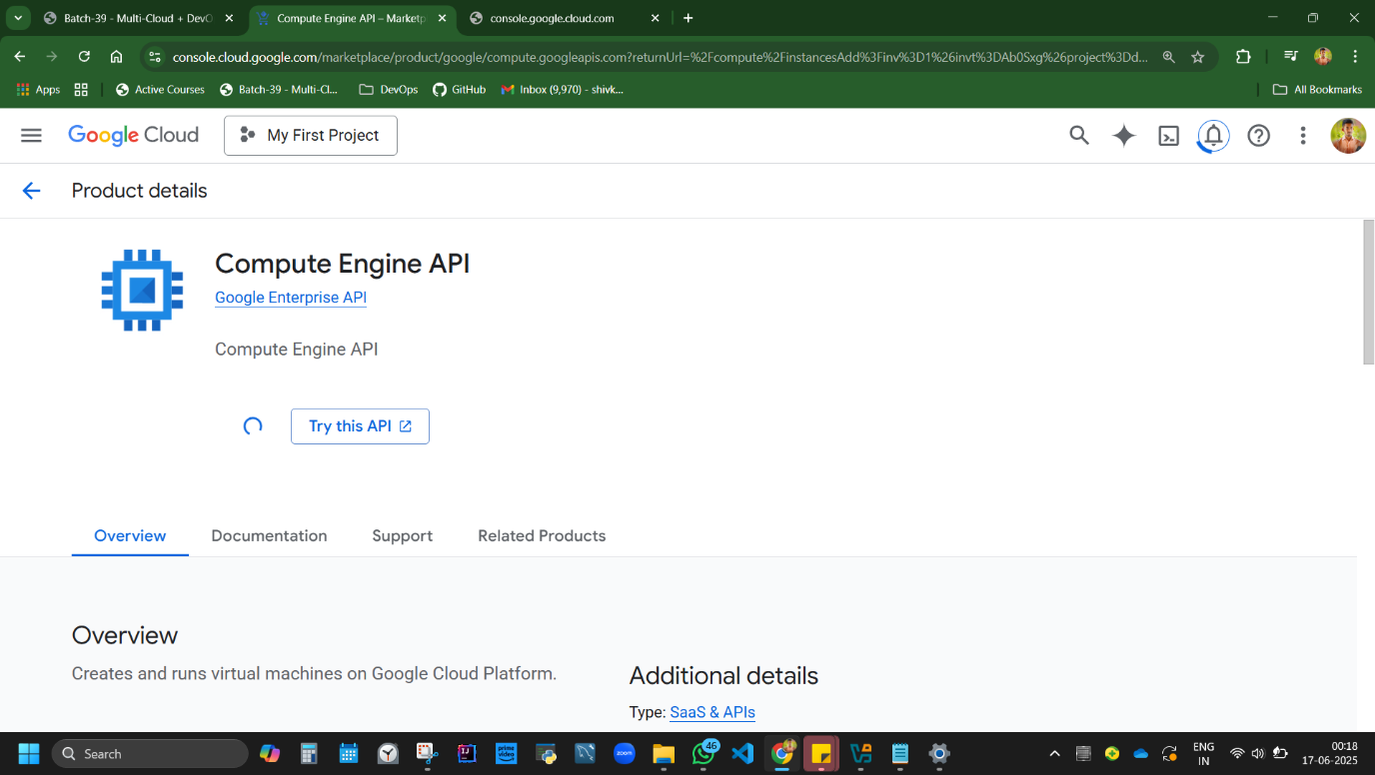

**Practical 4:** *Install Jenkins on Ubuntu VM*  
**Steps:** ➤ Create VM instance (Ubuntu 24.04)  
➤ Enable networking  
➤ SSH into VM  
➤ Install Java + Jenkins repo [ss attached in next page]  
➤ Start Jenkins service

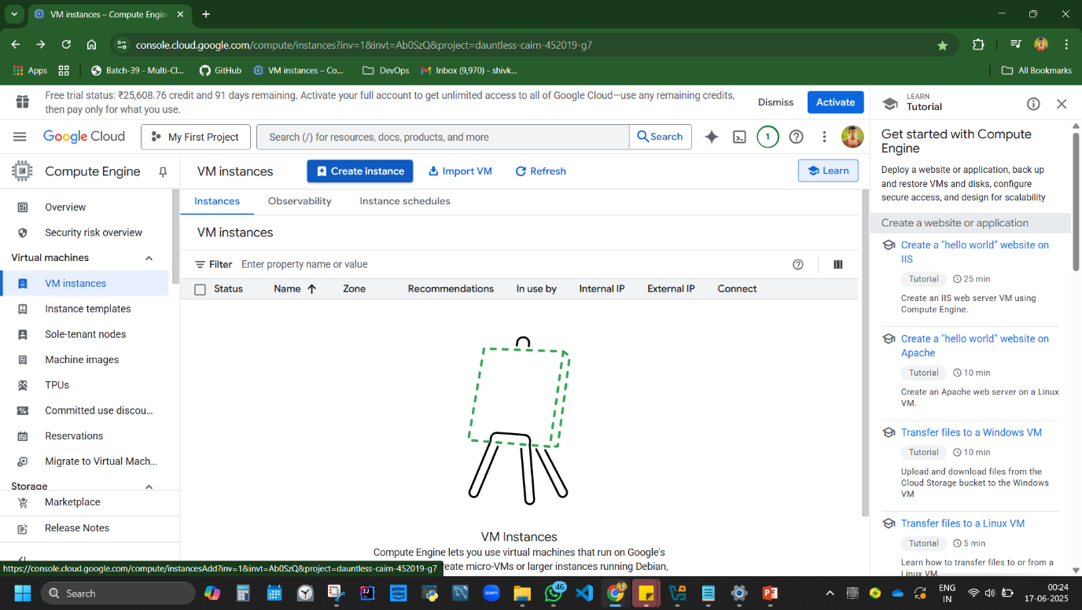

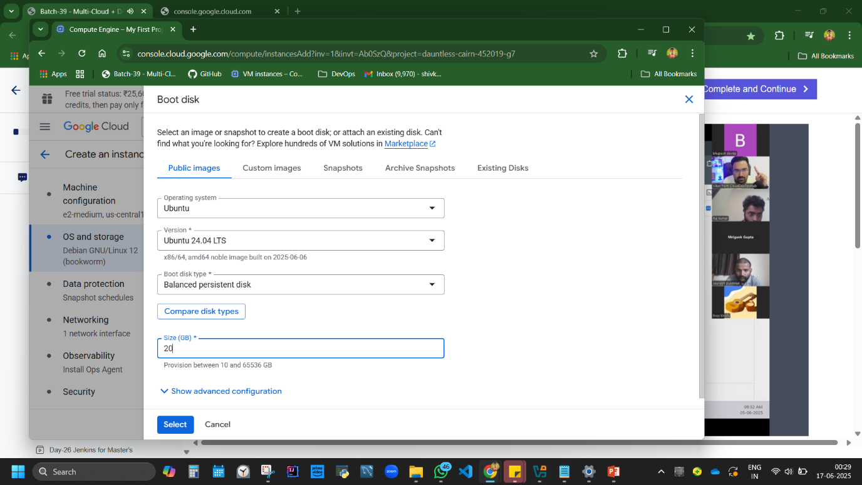

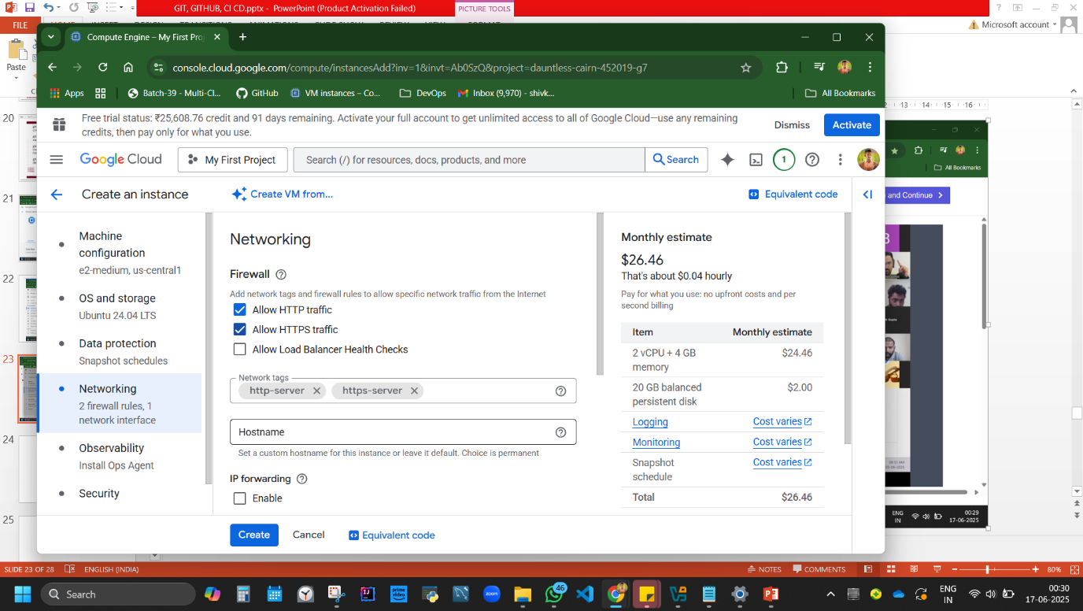

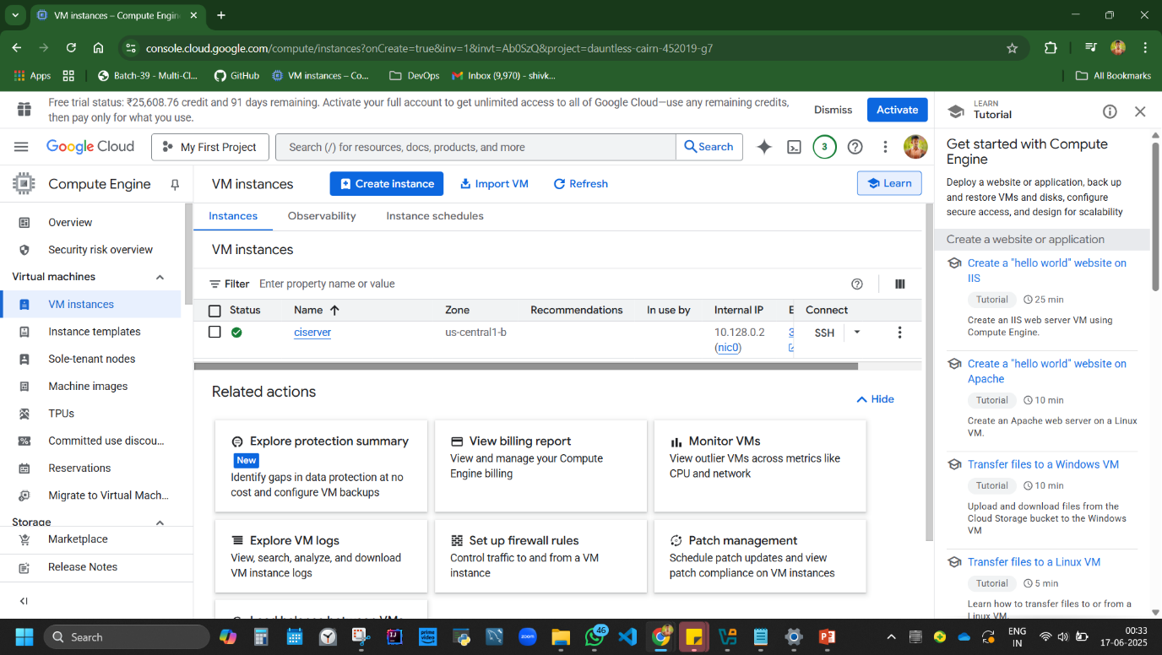

**Code:**

sudo apt install openjdk-17-jre-headless -y  
curl -fsSL https://pkg.jenkins.io/debian/jenkins.io-2023.key | sudo tee /usr/share/keyrings/jenkins-keyring.asc > /dev/null  
echo deb [signed-by=/usr/share/keyrings/jenkins-keyring.asc] https://pkg.jenkins.io/debian binary/ | sudo tee /etc/apt/sources.list.d/jenkins.list > /dev/null  
sudo apt update  
sudo apt install jenkins -y

**Note:** //Disable firewall if browser doesn’t load Jenkins.

//sudo=we become root user, gives admin access.

# Add the key

curl -fsSL https://pkg.jenkins.io/debian/jenkins.io-2023.key | sudo tee /usr/share/keyrings/jenkins-keyring.asc > /dev/null

# Add Jenkins repository

echo deb [signed-by=/usr/share/keyrings/jenkins-keyring.asc] https://pkg.jenkins.io/debian binary/ | sudo tee /etc/apt/sources.list.d/jenkins.list > /dev/null

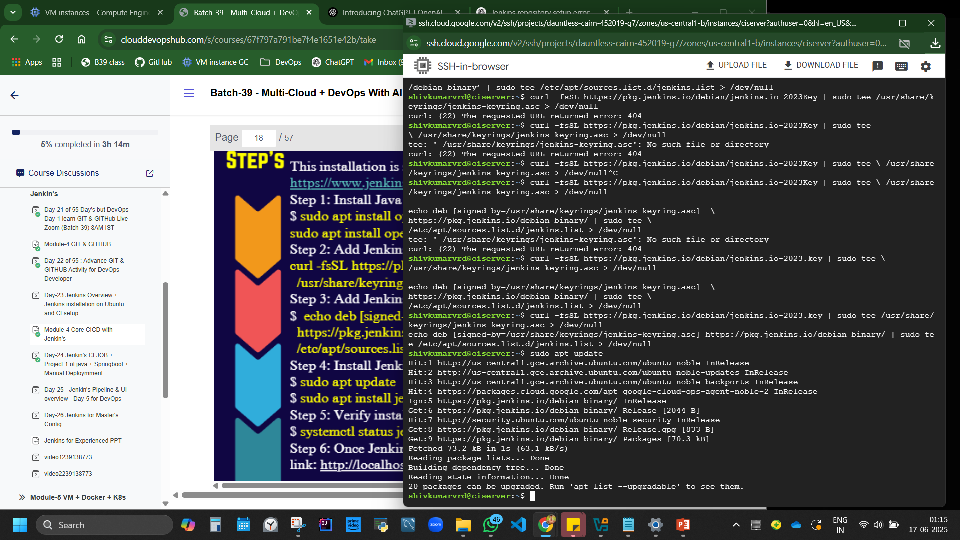 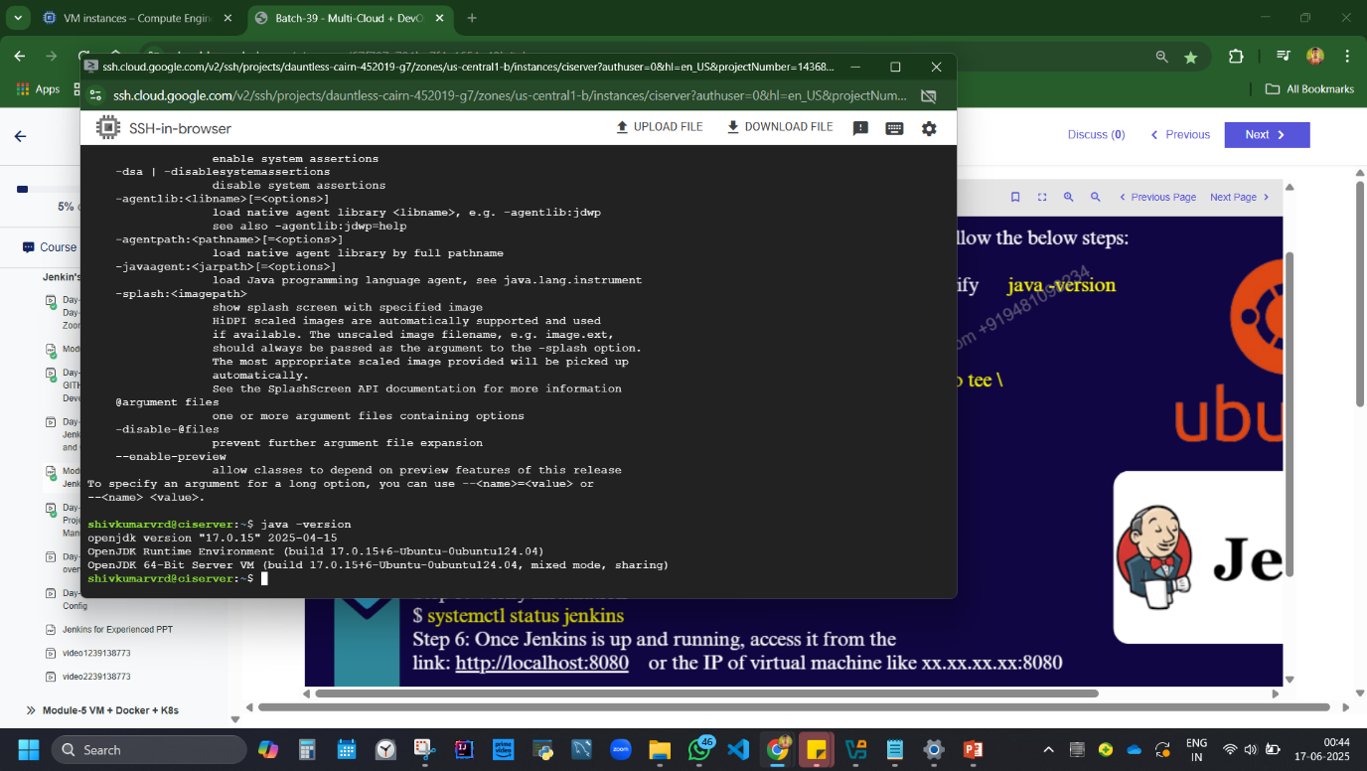

sudo apt update

sudo apt install Jenkins

systemctl status jenkins

jenkin will be installed. steps - copy link from external IP, add :8080 paste in browser,

//if not opened, disable firewall, firewall policies, allowall under protocols and port or mention 8080 under specified protocol

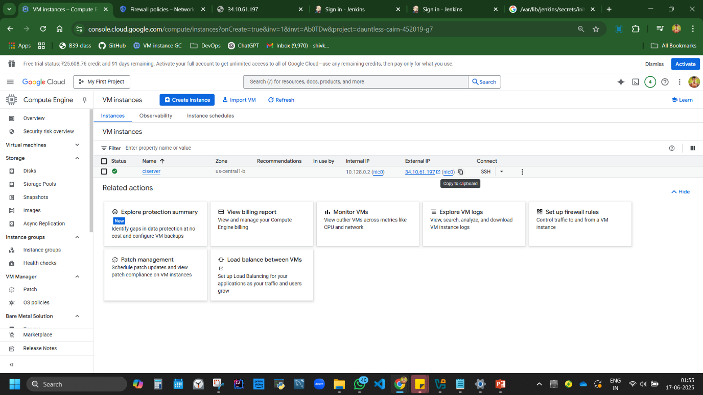

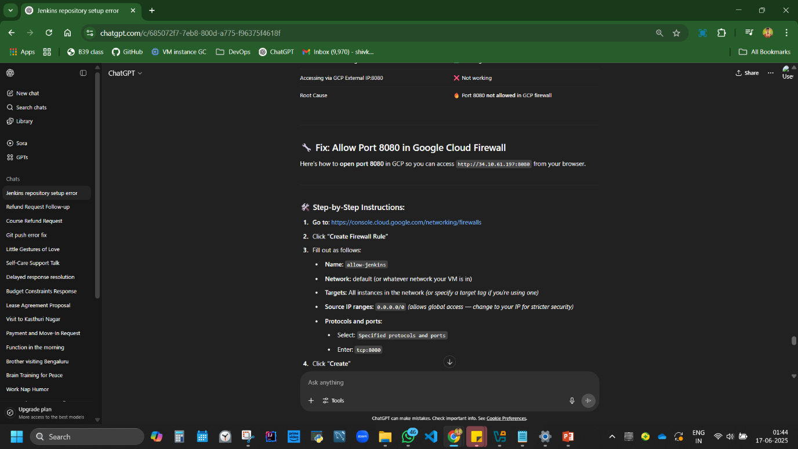

jenkin window opens, unlock and get password?,

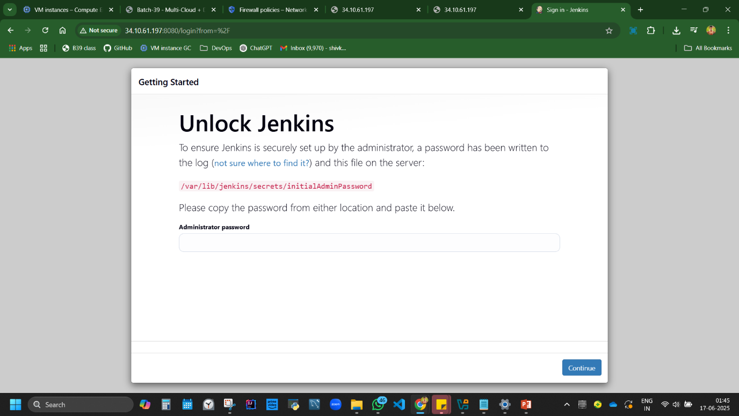

copy red text location, run code

sudo cat /var/lib/jenkins/secrets/initialAdminPassword

gets password, copy paste in broser jenkin,

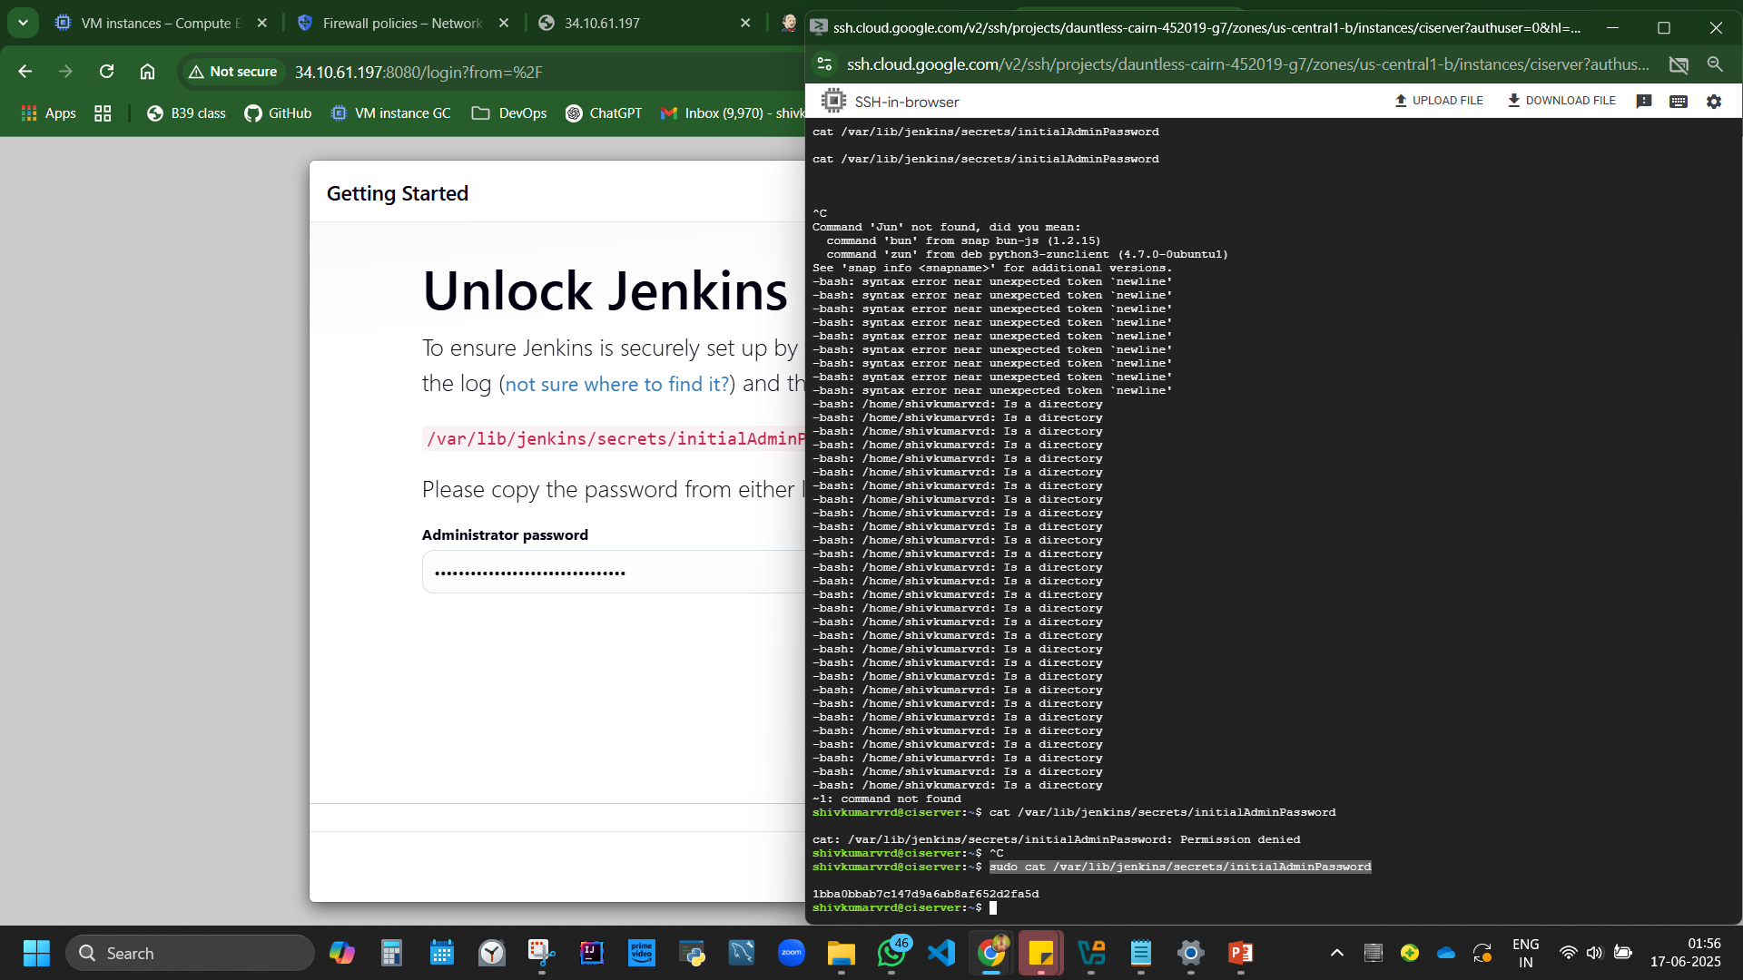 install suggested plugin, about 100+ plugins will be installed. understood top 10 plugins for interview.

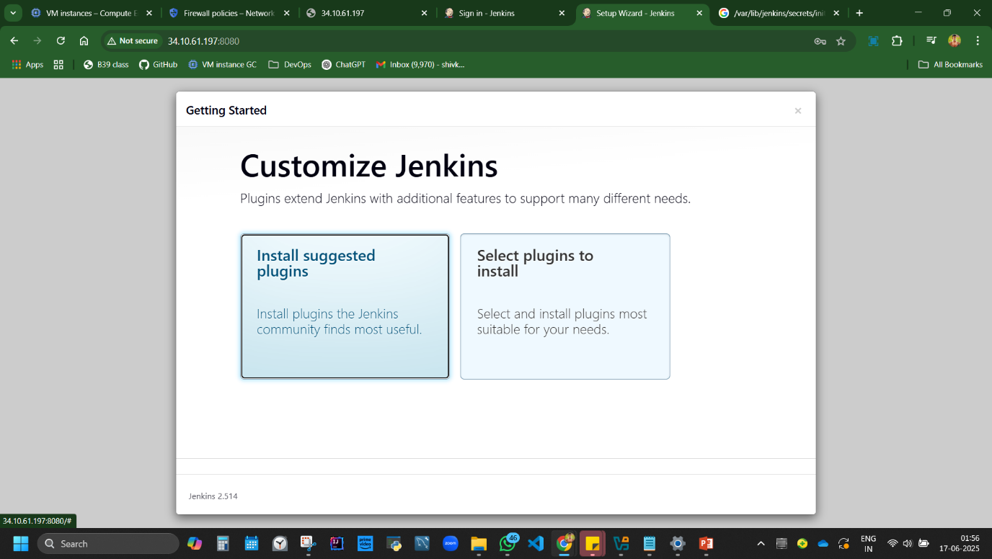

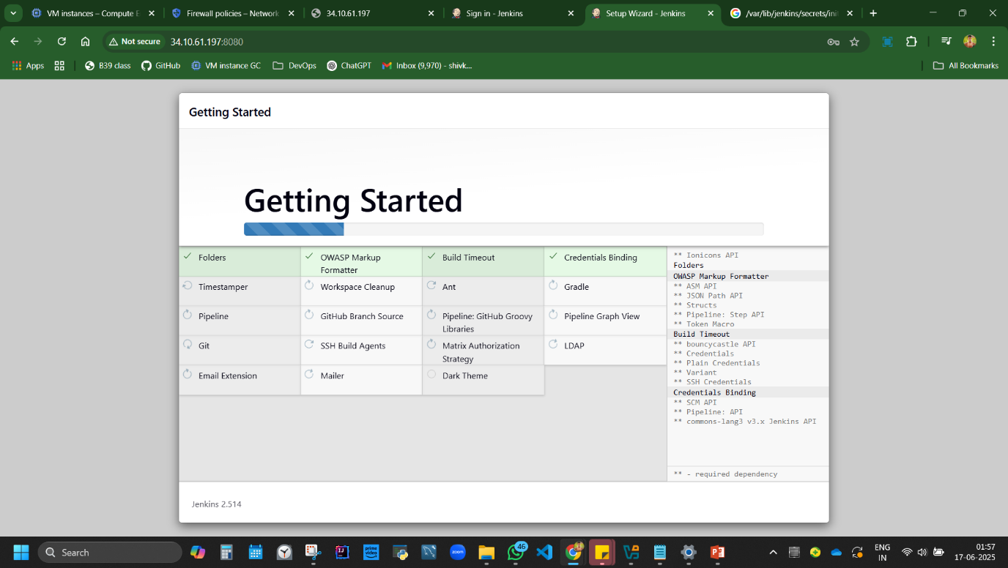

entered credentials - admin.

IP address is created.

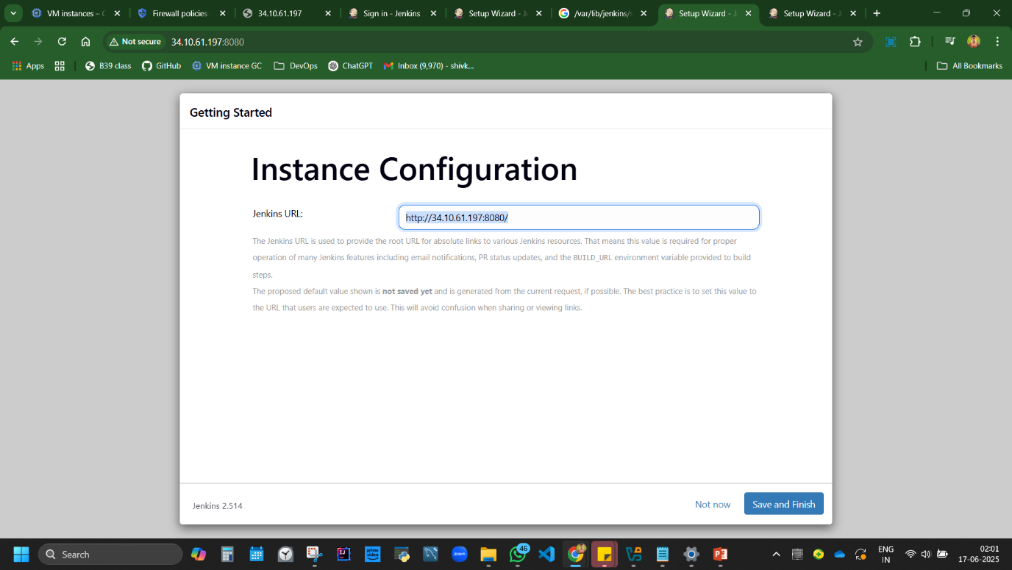

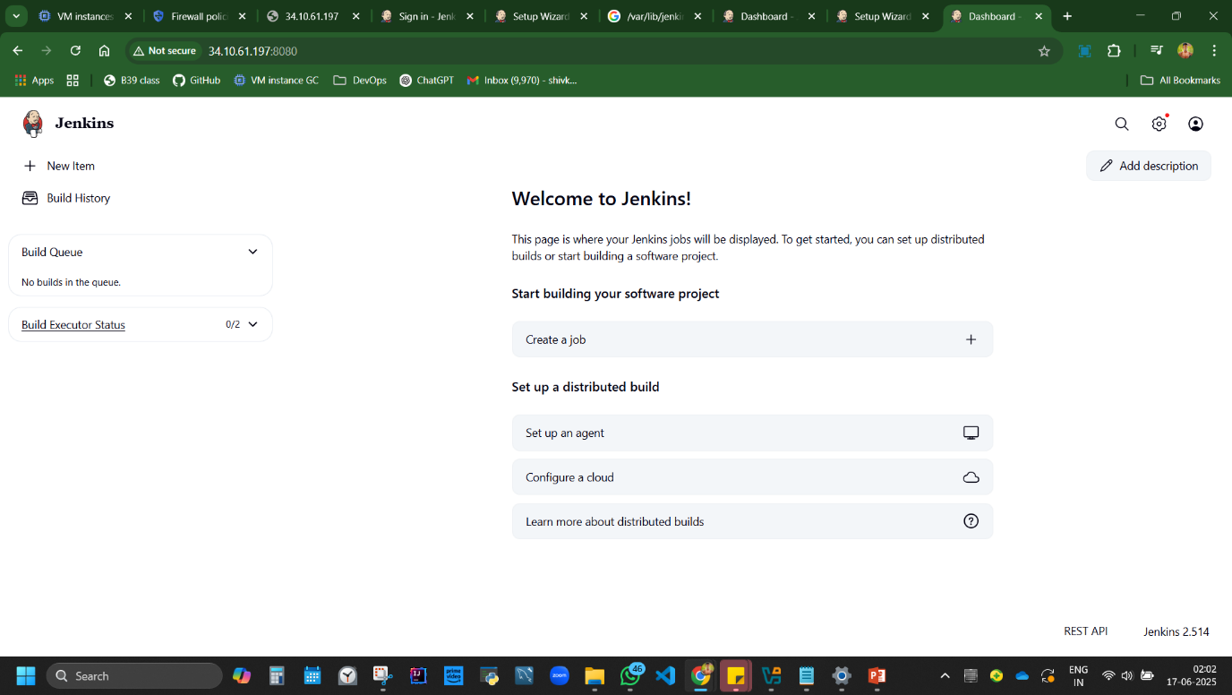

official link to install Jenkins: <https://www.jenkins.io/doc/book/installing/linux/>

**Learned:** Job types in Jenkins: Freestyle, Pipeline, Multi-config.

## **5. Jenkins Java Continuous Integration CI (Day 4)**

steps: new folder [workspace] in pc - java project, right click open git bash in java ws. add new project 'helloworld' chatgpt, wrp for java print hello world in java, VS, create empty file helloworld.java, paste code,

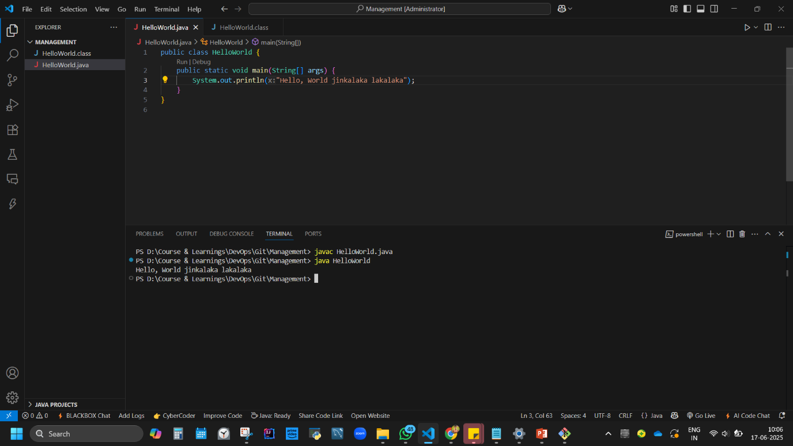

terminal, compile code: javac helloworld.java //class name and file name should be same.

// helloworld.class is now an independentent file it can be run in any platform.

now execute the code: java helloworld

//this will create a helloworld in github aswell.

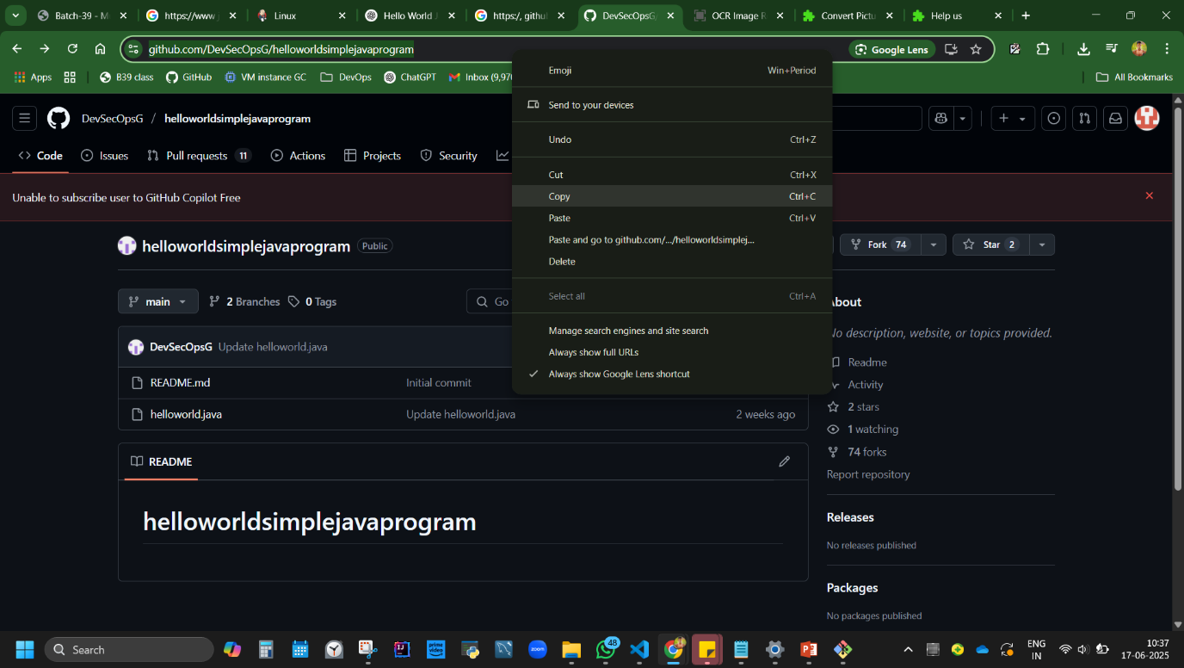

steps: jenkins, item, freestyle proj, description: java compile from git, go to source code management, copy browser link from git, paste in repo URL, save,

<https://github.com/ShivK8431/helloworldsimplejavaprogram>

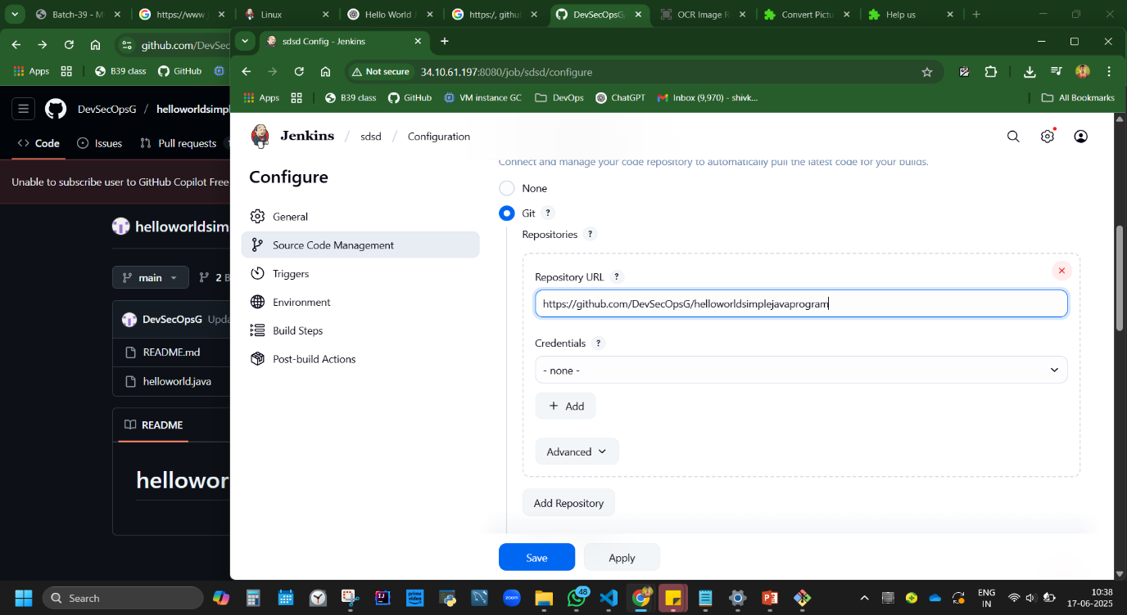

build, error, click the build error, click on number,

console output, read error description, 'verify repo and branch config'

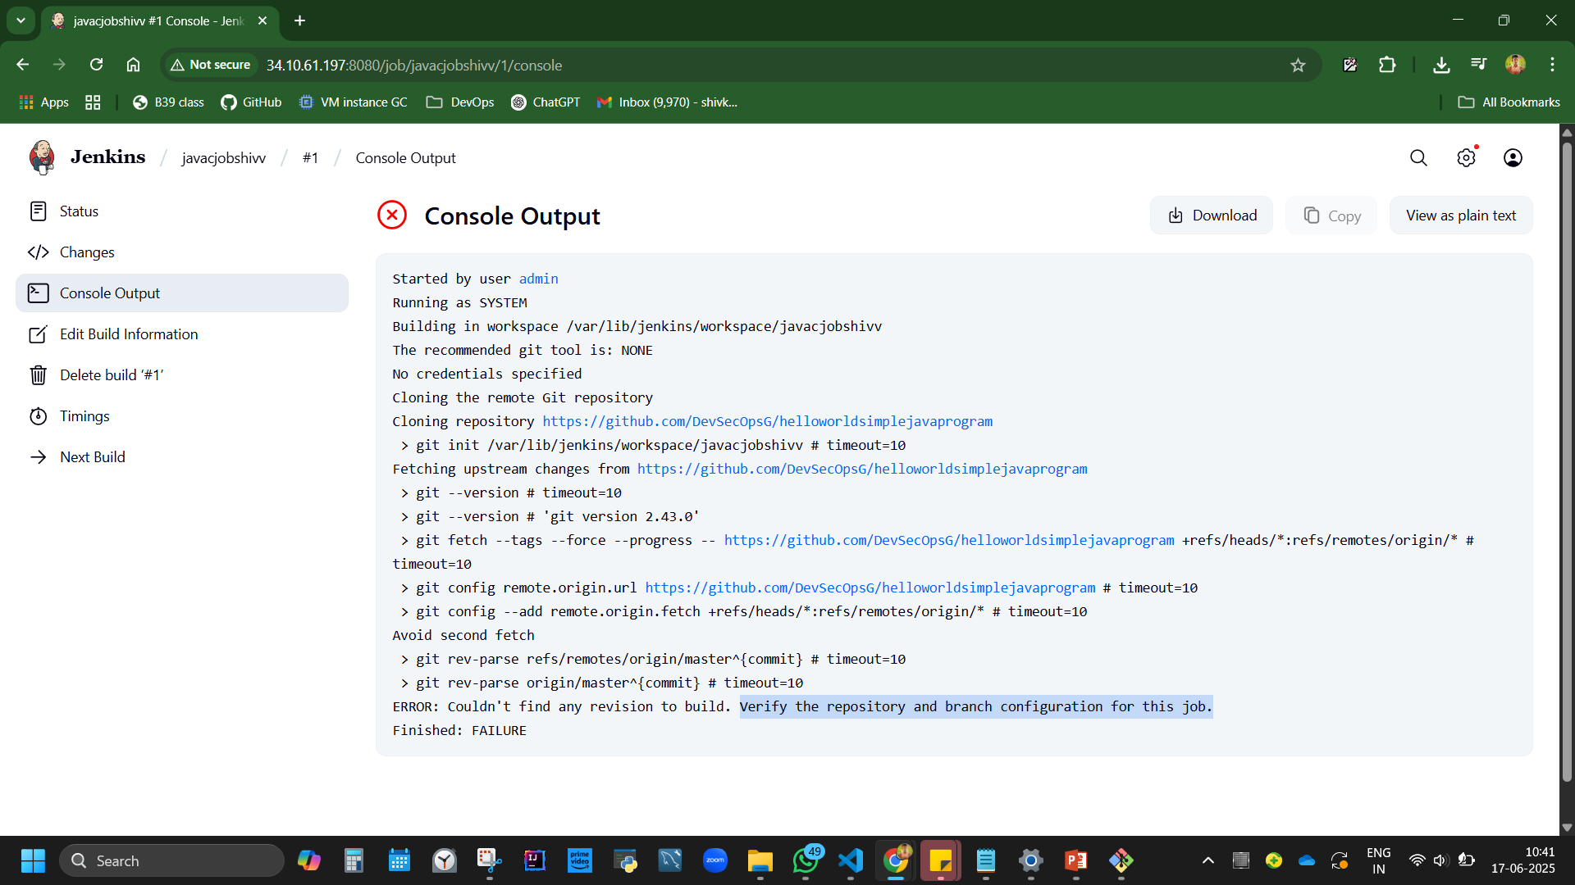

master main. source code management, change master to main, build, success.

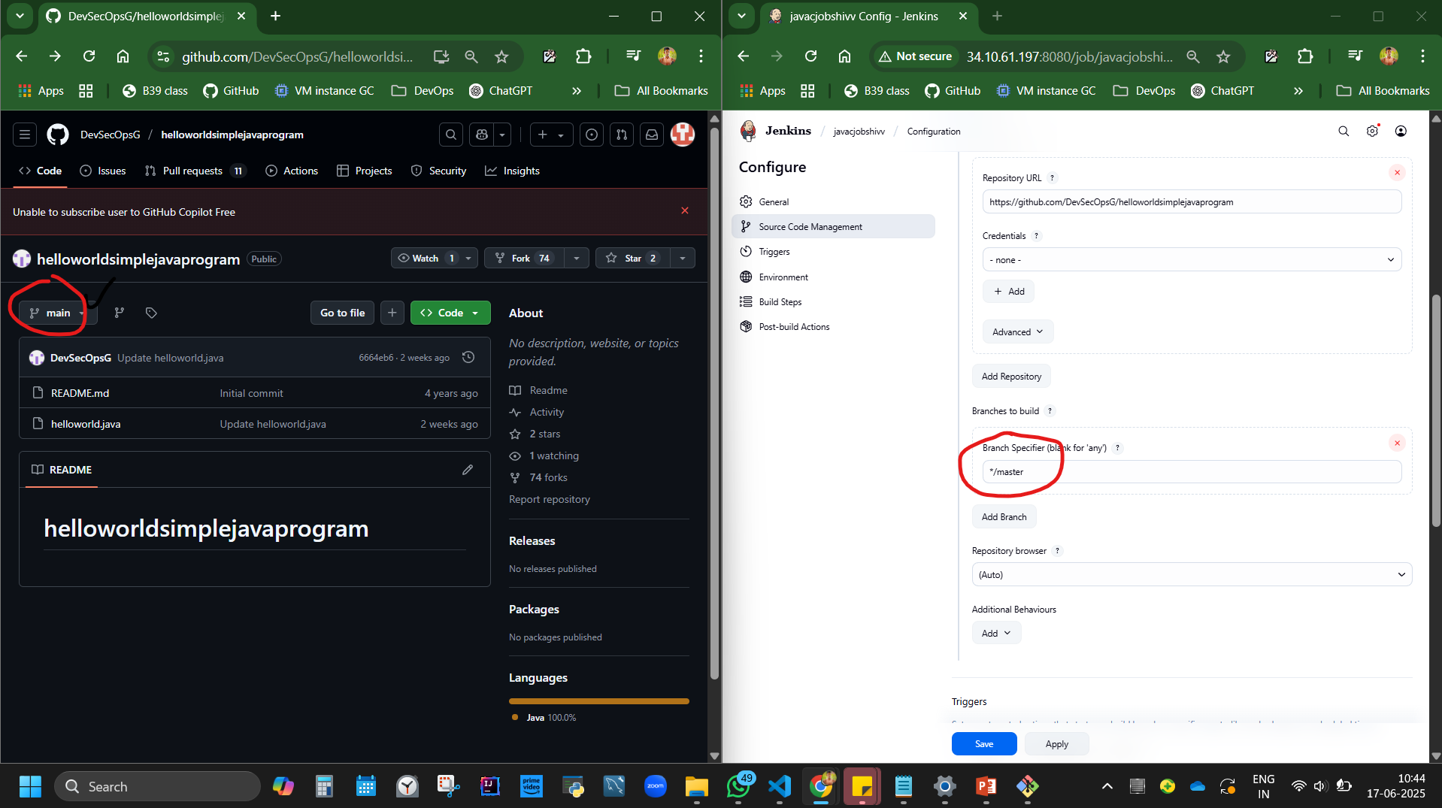

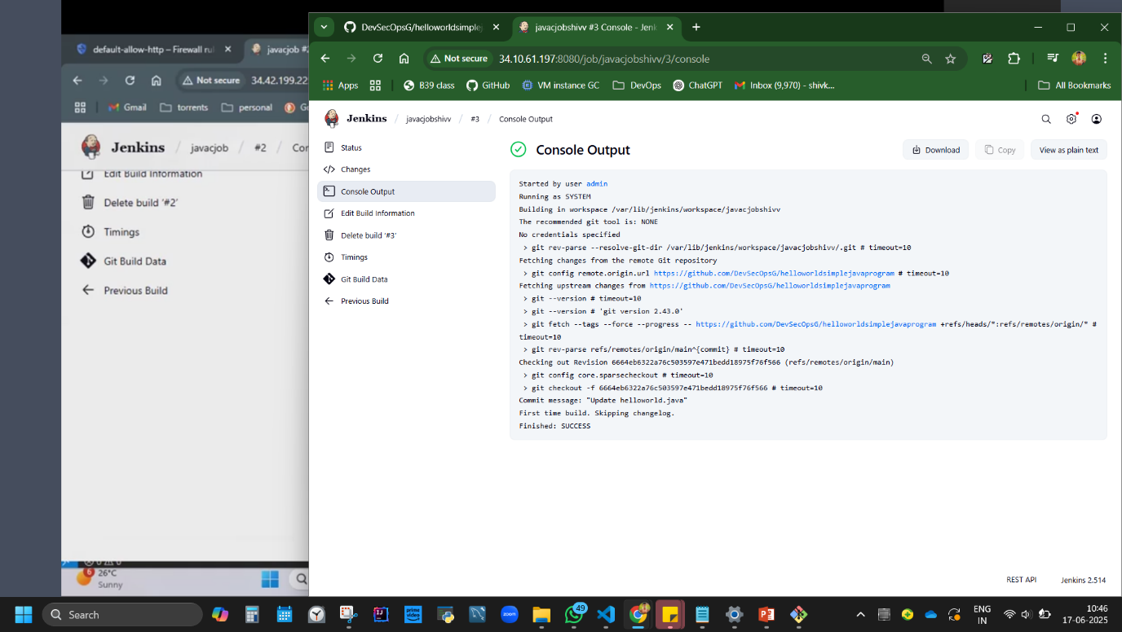 GIThub=jenkin is integrated and connected.

Need to configure now. How to compile the git hub code in jenkins?

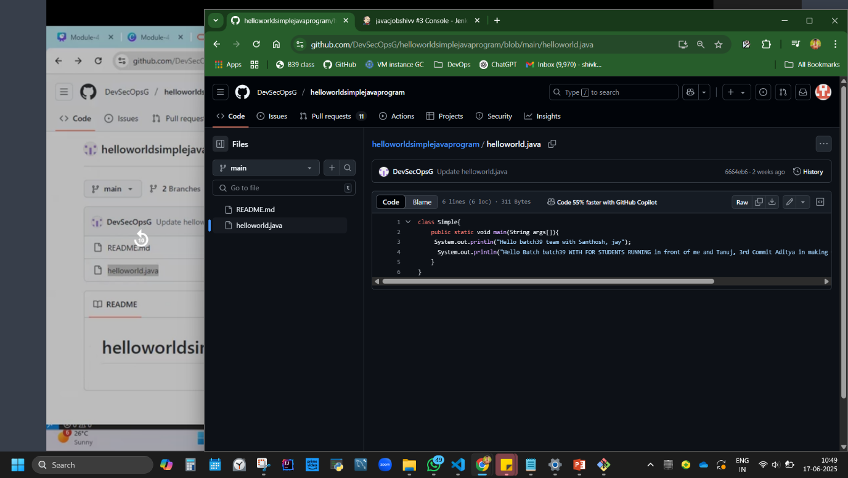

code:

javac helloworld.java

java Simple

//Javac <file name>

//Java <classname>

put the above code in Jenkins job, config, build step, execute shell (cause we are in linux), save, build, error, console output,

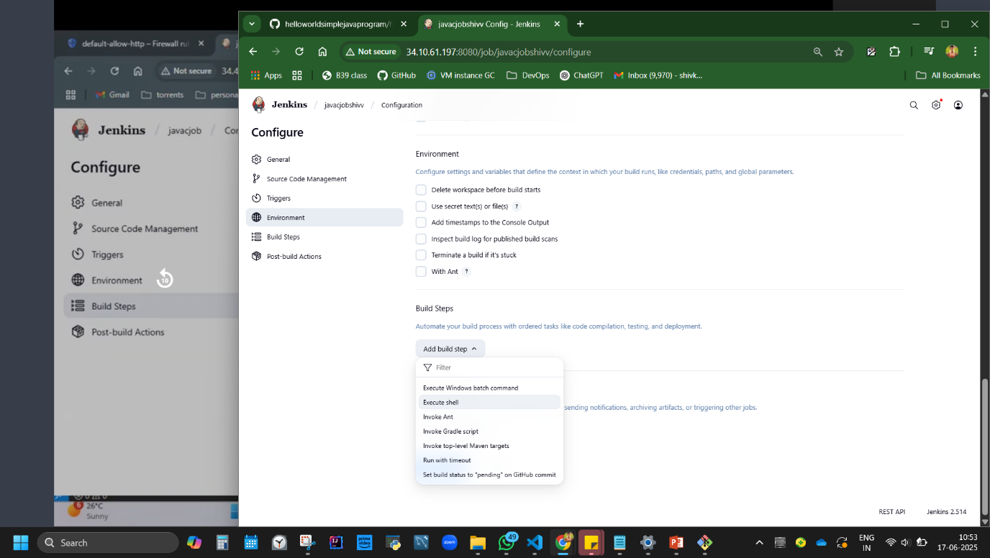 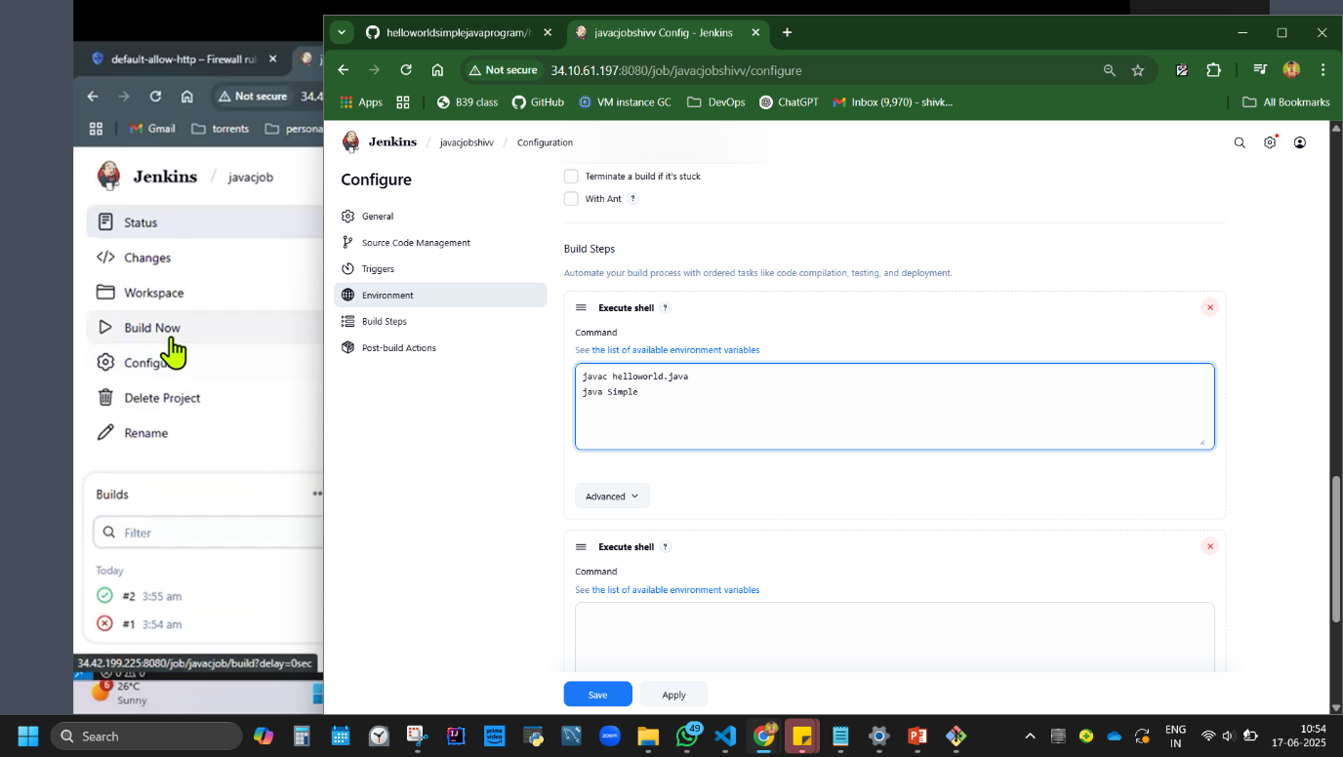

error: JAVA C NOT FOUND.

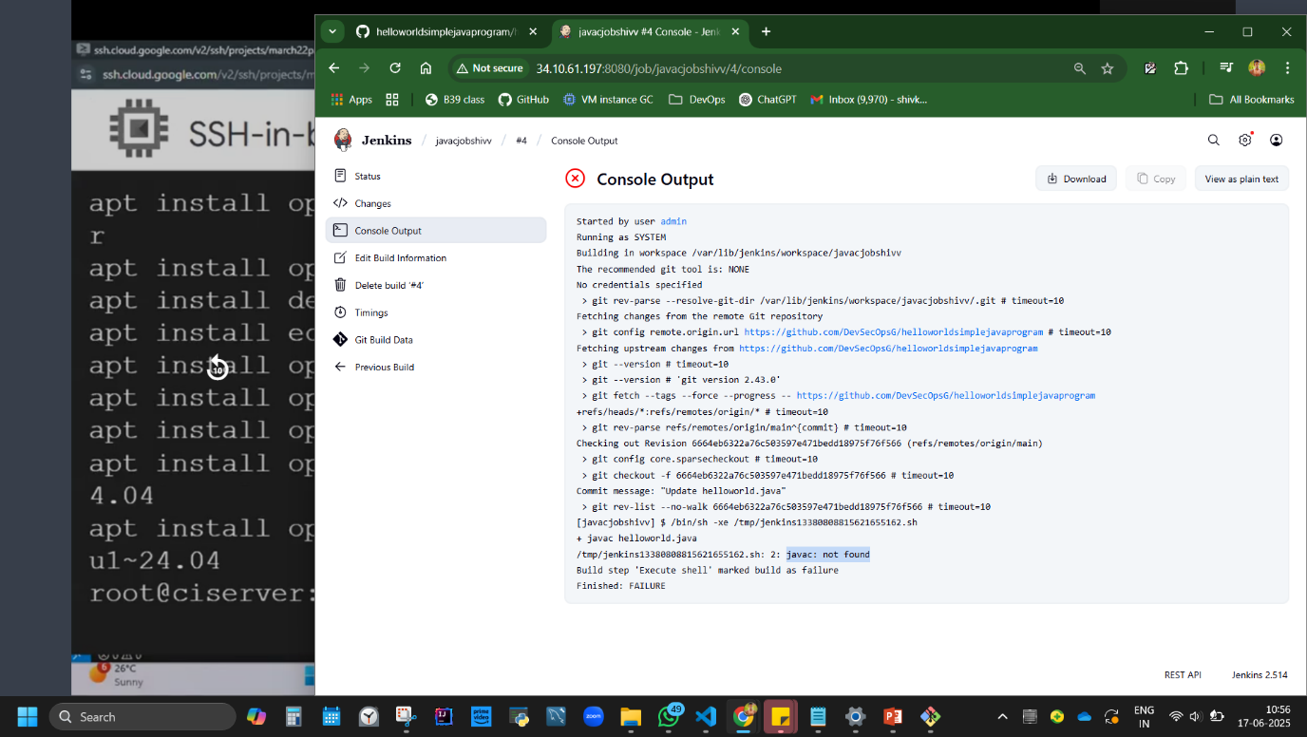

open SSH and check javac -> not found

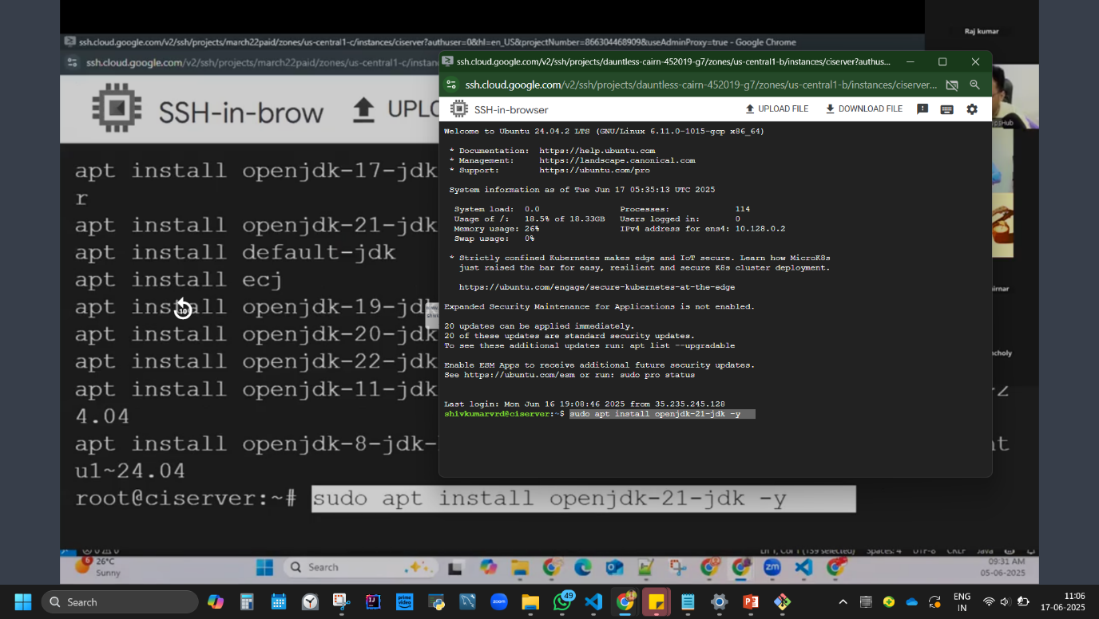

(WE HAD INSTALLED JRE “sudo apt install openjdk-17-jre-headless”)

SO NOW INSTALL JDK in SSH - code: sudo apt install openjdk-21-jdk –y

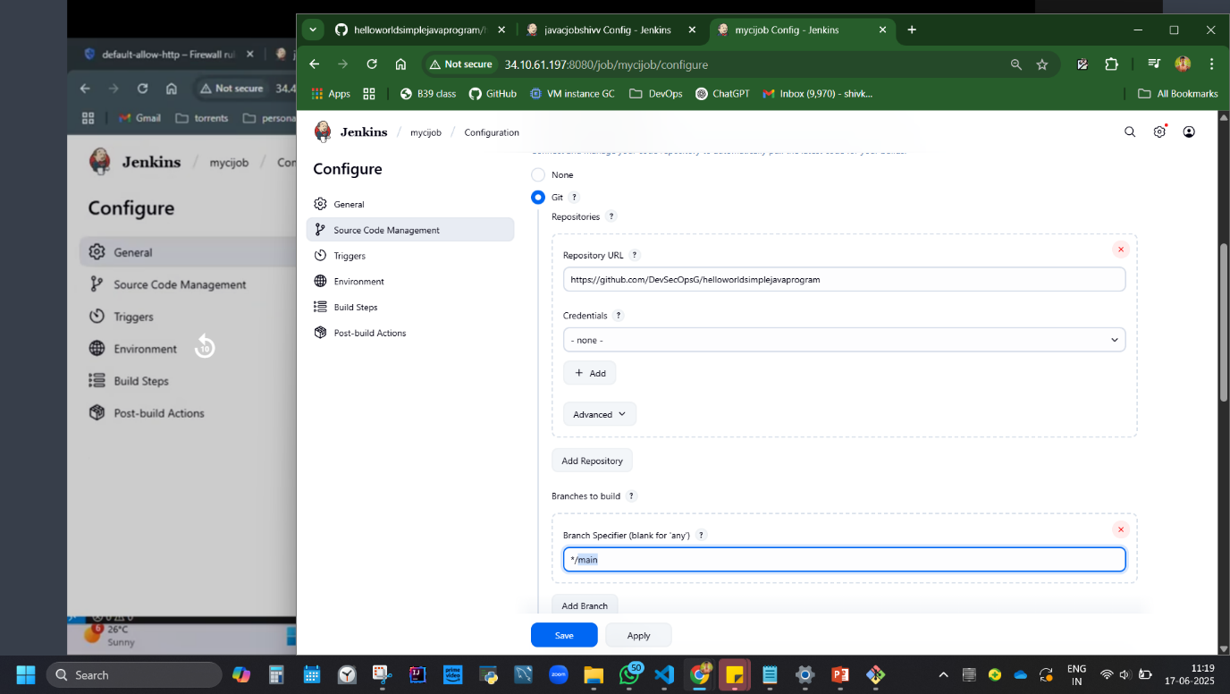

<https://github.com/ShivK8431/helloworldsimplejavaprogram>

jenkin pipeline, build, SUCCESS! java code is now compiled. need to execute now in CI

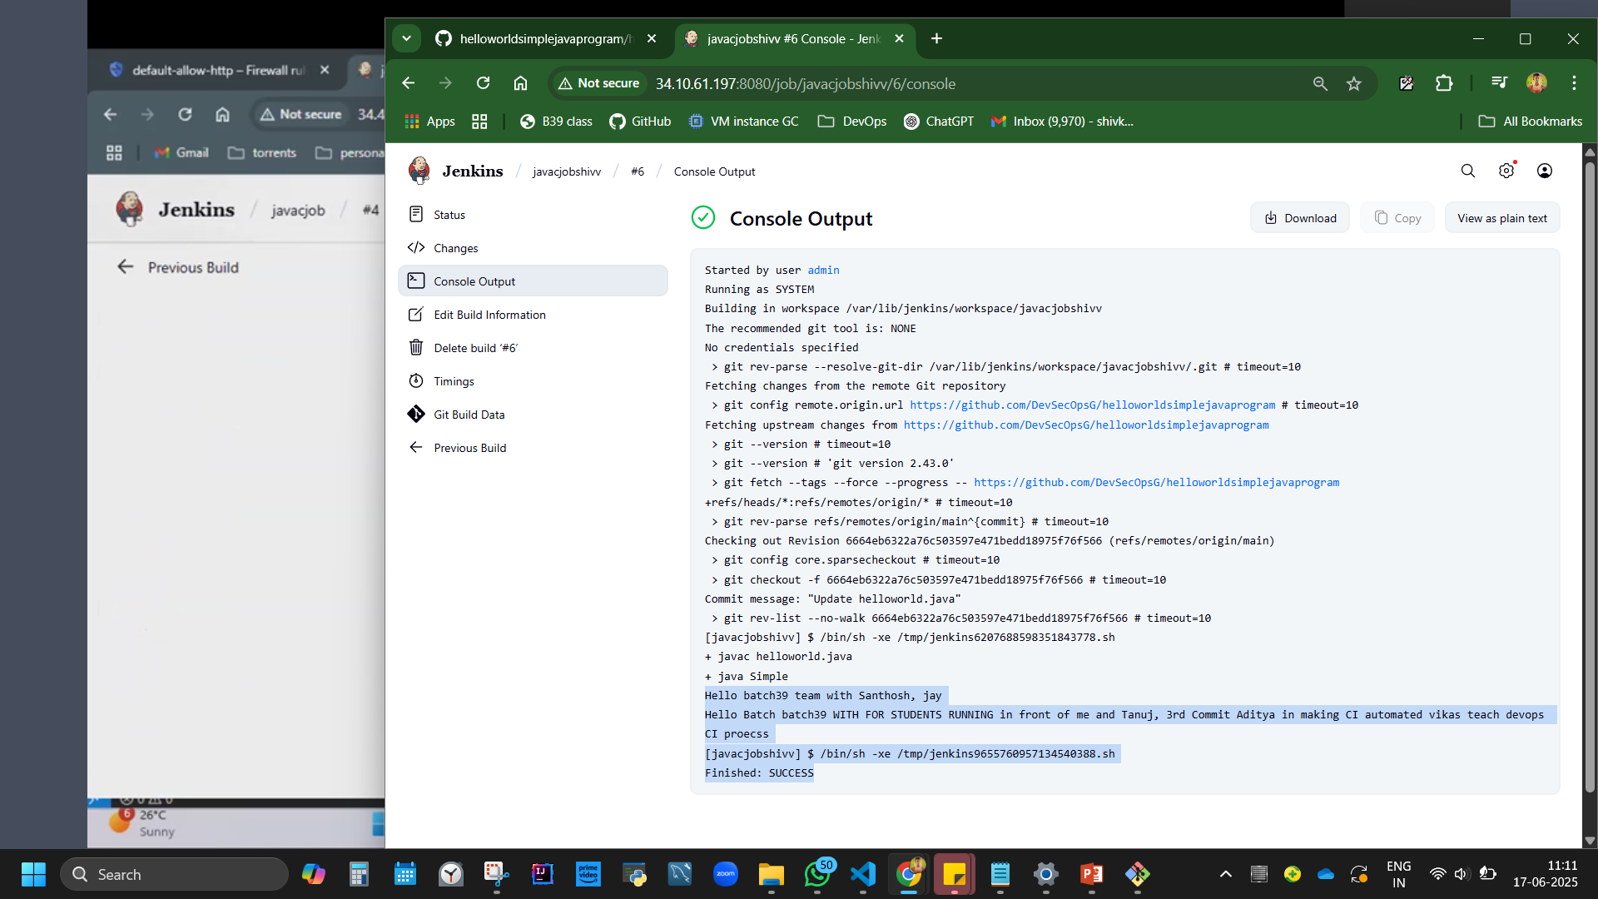

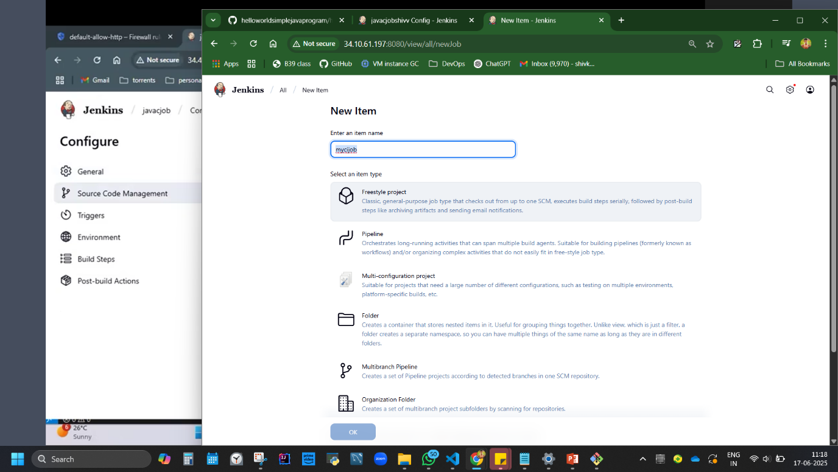

SET UP CI CONFIG NOW 5MIN.

steps: jenkin, new item, mycijob, freestyle, copy paste git hub repo in repo url, master to main, poll SCM, schedule: * * * * *, add build step, execute shell, add code:

javac helloworld.java

java Simple

save. build now. success. code runs every minute now.

//when you say "* * * * *" it means "every minute" link for reference: <https://crontab.guru/#0_8_1_4_2>

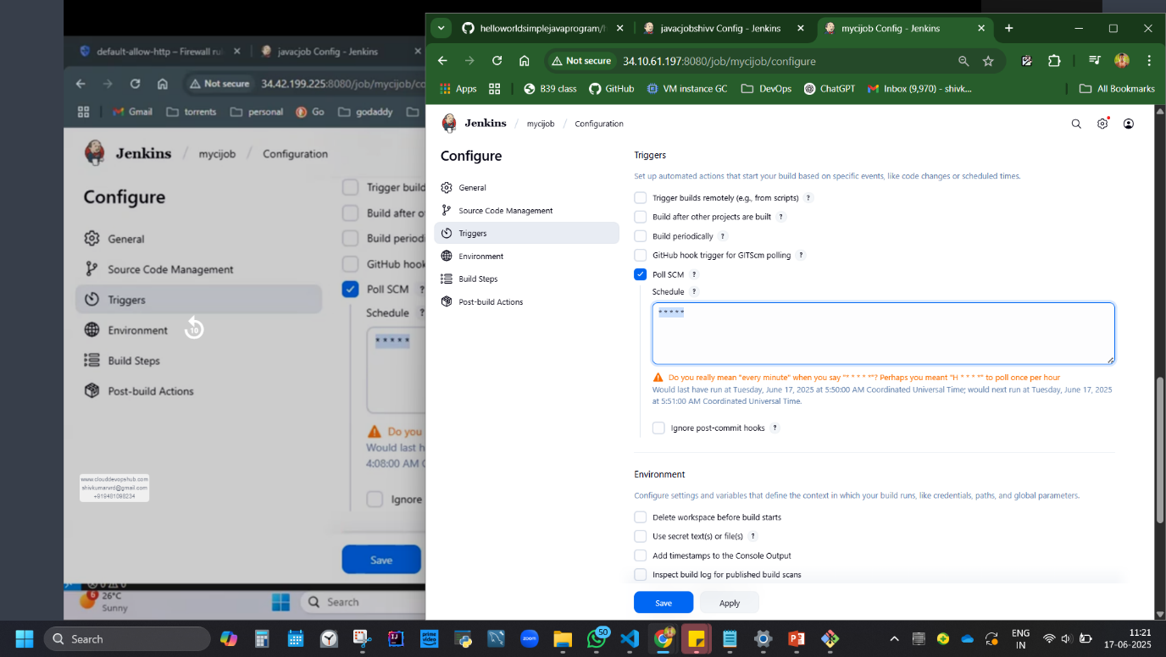

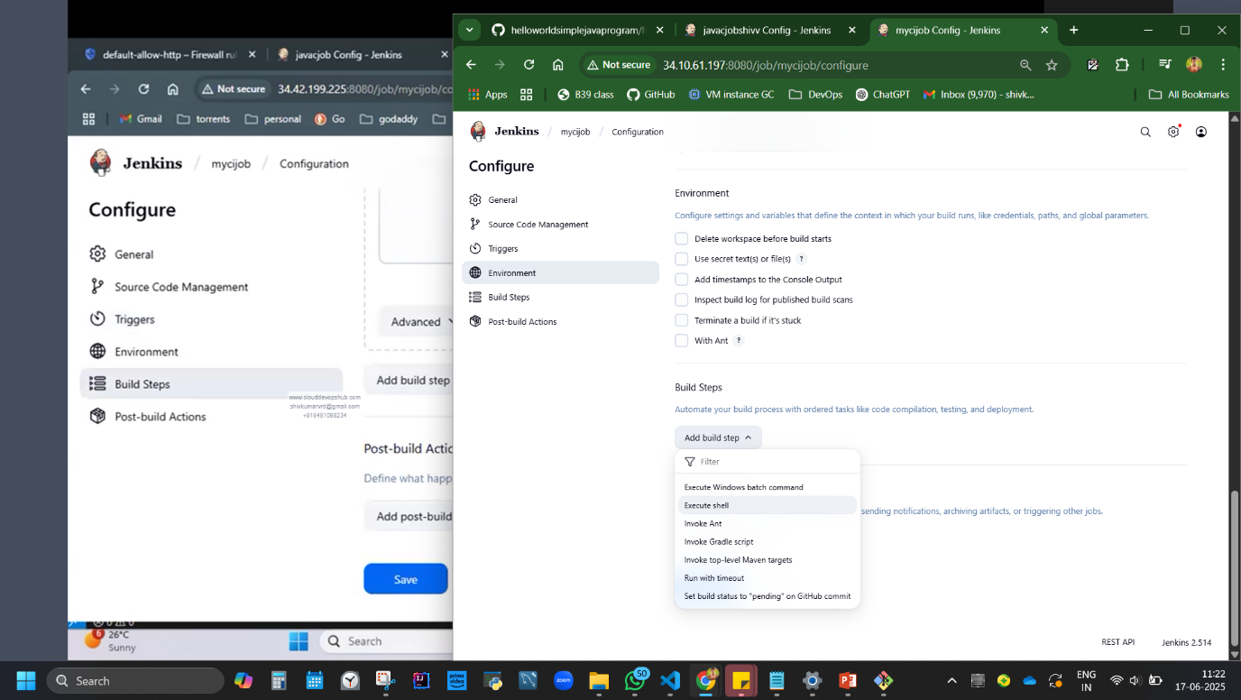

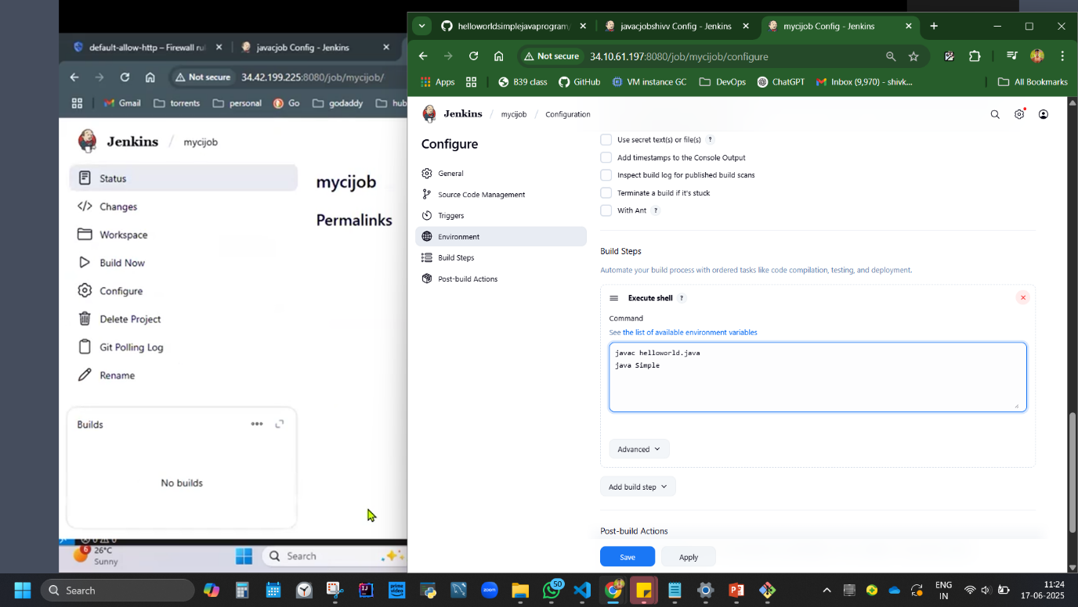 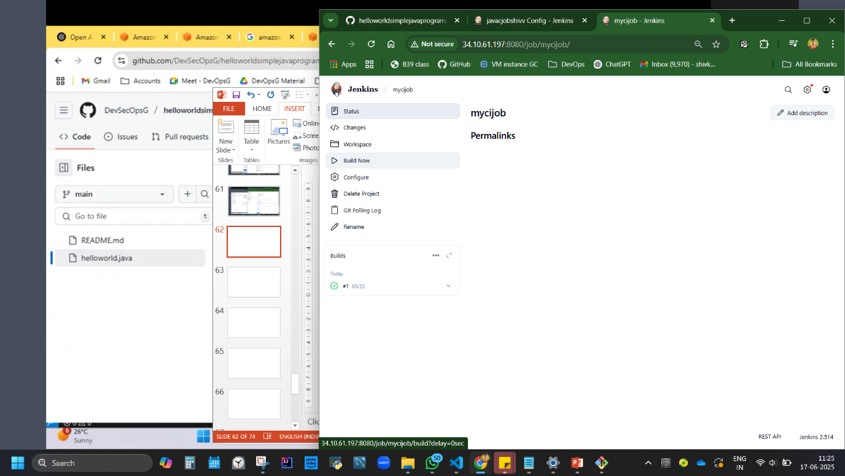

Why * why CI? if you make changes in git hub code, same is compiled and executed in Jenkins every 1 minute.

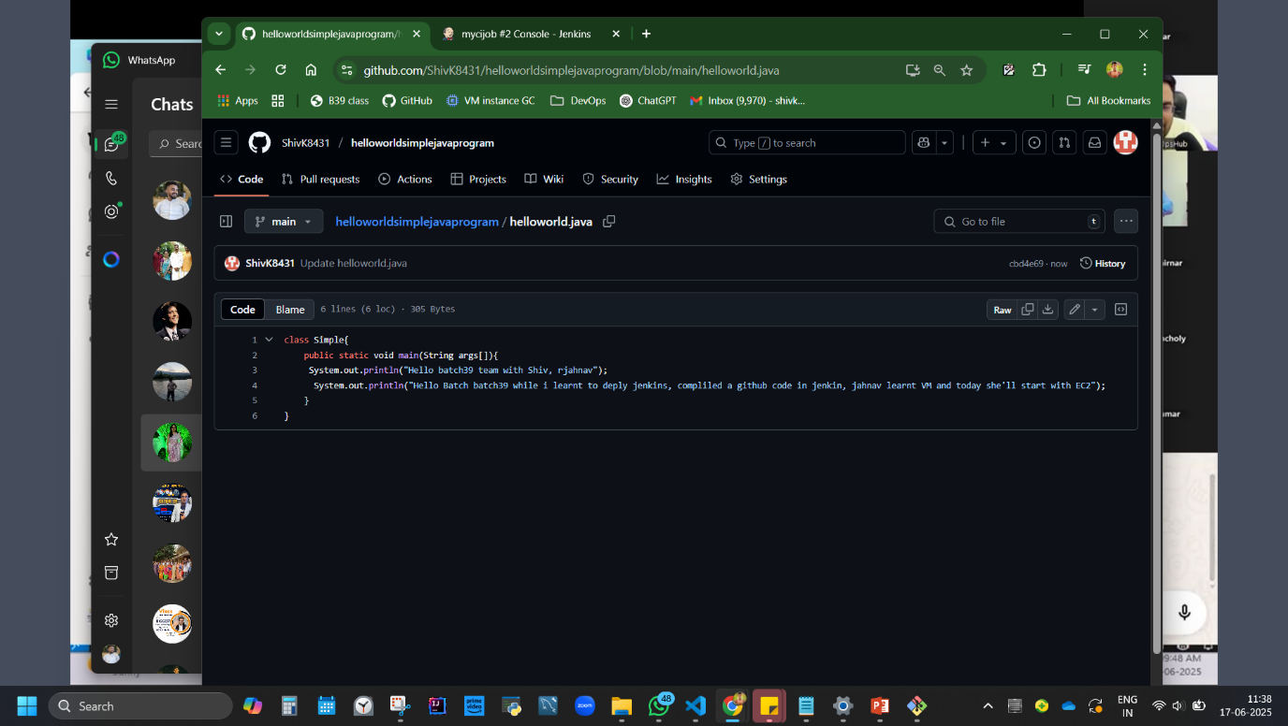

**Change some code (as a devops we keep changing codes) in git hub code.   
We are expected the same to run in Jenkins automatically because of ‘Continous intergration * * *’**

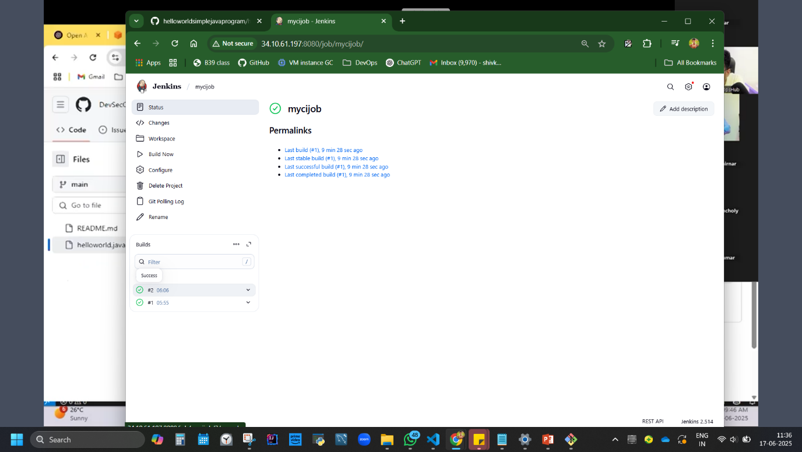

2nd build ran automatically, that Is CI

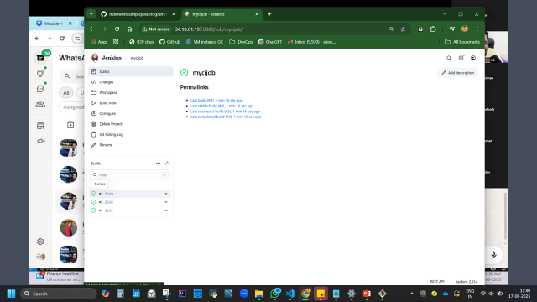

3rd build ran automatically, that Is CI

Sumamry of **Practical 5:** *Compile/pull Java Project code from Git in Jenkins*  
**Steps:** ➤ Create Git repo with Java code  
➤ Link Git repo in Jenkins freestyle job  
➤ Build step: Compile & Run Java

**Code:**

javac helloworld.java  
java Simple

**Error:** *JAVA C NOT FOUND*  
**Fix:** Install JDK

sudo apt install openjdk-21-jdk -y

**Learned:** How to configure Jenkins jobs with build triggers like poll SCM.

**Disadvantage:** Jenkins doesn’t ship with compilers like javac.

## **6. Jenkins Setup as developer/devops - using WAR file Deployment (Oracle - Day 4 Contd.)**

**Tools Installed:**  
**5. Jenkins WAR File (jenkins.war)**

**Practical 6:** *Run Jenkins using WAR*  
**Steps:** ➤ Download WAR download jenkins.war file <https://updates.jenkins-ci.org/download/war/>   
➤ PC, Create bin folder, cut paste war file here, pc address bar, Open CMD in folder  
➤ Run using Java

**Code:**

java -jar jenkins.war --httpPort=8082

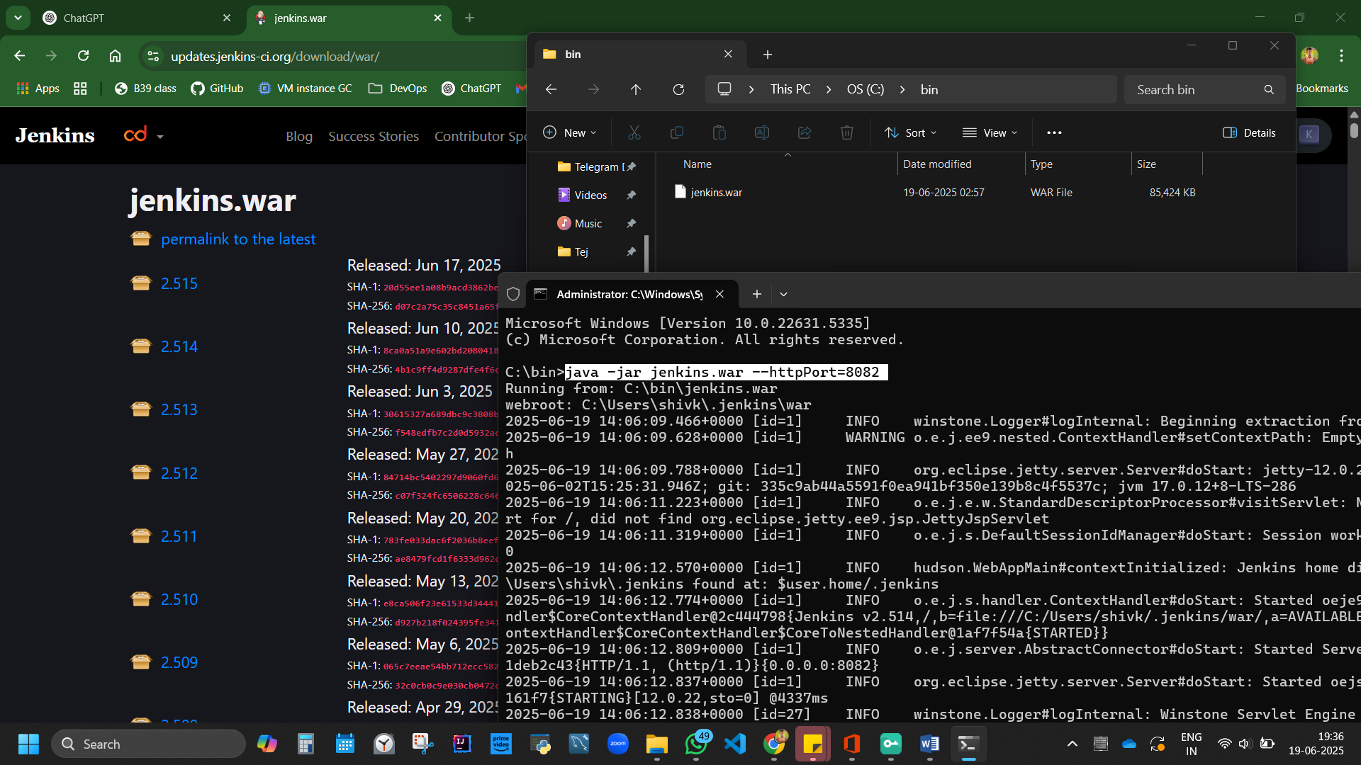

Jenkins is fully up and running

localhost:8082 works now.

to get password, go to red location, copy paste in pc address, open via notepad, password paste in browser localhost, Jenkins opens. [password will also be in cmd in middle if you search]

**Note:** //Unlock Jenkins using initial password from .jenkins/secrets.

install plugins.

## **7. Project 1 – Java Spring Boot Application CI Pipeline with Maven & Jenkins (Day 5)**

**Spring Boot:** Java framework to build web apps quickly with minimal configuration. **Maven:** Build automation tool for Java projects.

**Tools Installed:**  
**6. Maven**

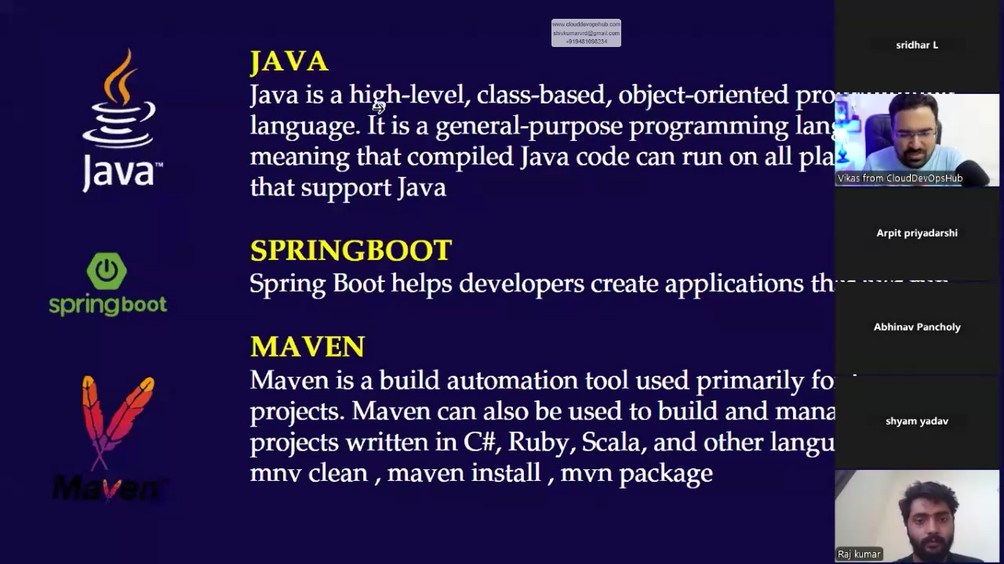

JAVA apps is platform independent. We can run anywhere.

SPRING BOT is a framework of java where web application can be created. Readymade 90% code is available for web based application in springboot, write small logic and app is ready. Has predefinied classes, run cmd, input.

MAVEN – build tool. After compile we need to build. Other ex: gradle, ant. mavan is a build tool. We are compliling via java.

Build vs compiling?

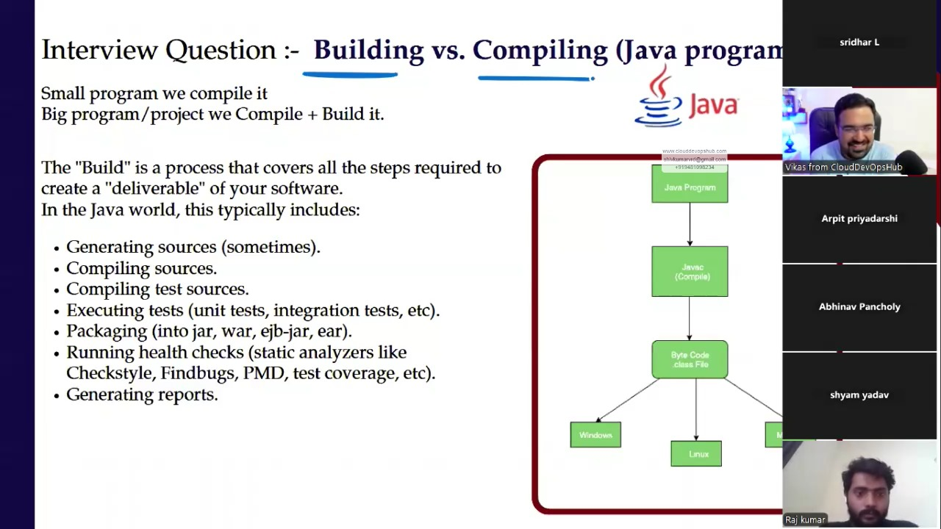

**Practical 7:** *Build and Deploy Spring Petclinic App in Jenkins*  
**Steps:**

open google cloud, create Ubuntu machine, allow trafficking in networking, create.

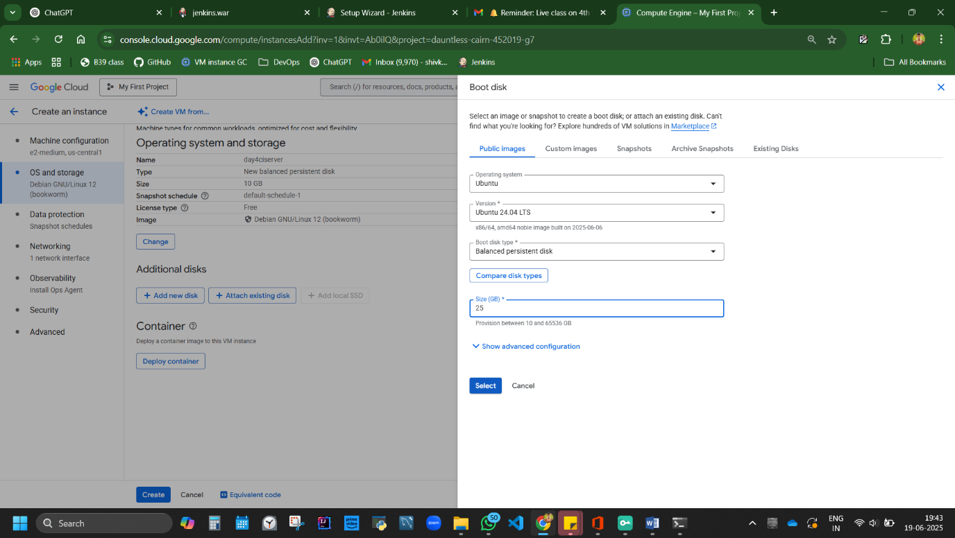

How to give access to others?

Use IM servise

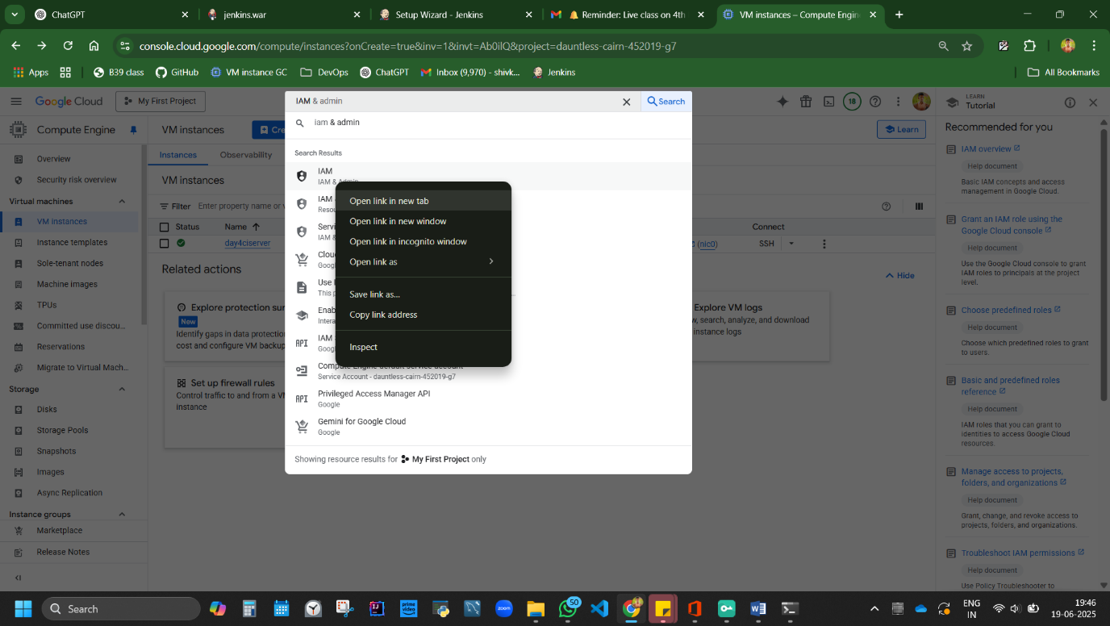

Grant access, enter gmail, role=owner access, save

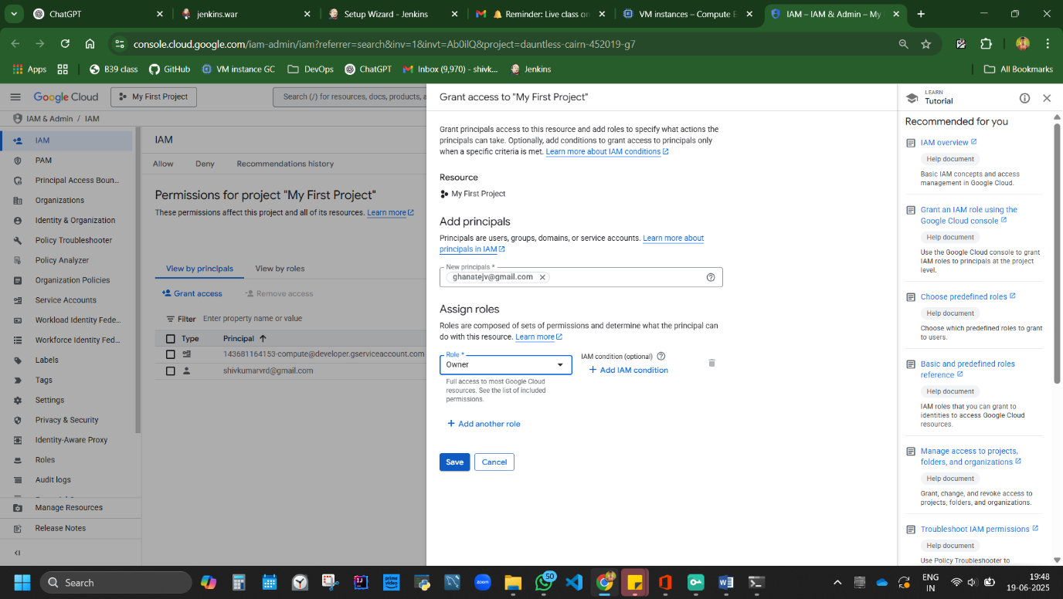

Recipient gets mail id, can open the project via link.

Coming back to **PROJECT 1 JAVA – Build JAVA spring boot application with maven integration and CI configuration and deploy/create build.**

Summary of Overview Approach:

➤ Connect SSH  
➤ Install JDK & Maven  
➤ Clone repo  
➤ Compile and package using Maven

**Code:**

mvn clean  
mvn install  
mvn package

Commands of maven:

mvn clean //to start from starting

mvn install //install dependency

mvn package //create artefact

mvn deploy

detailed practical work with ss of connecting ssh, installing jenkin and building maven command in jenkin:

Connect SSH server

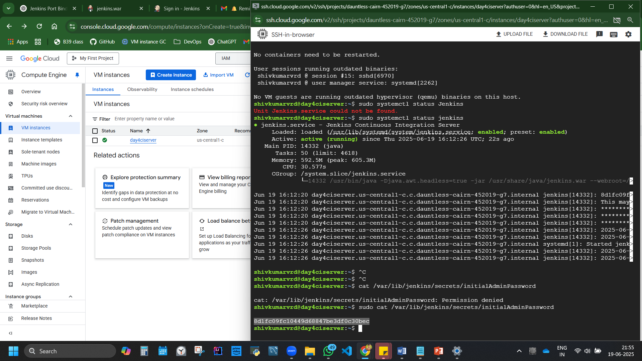

Setup Jenkins

Code:

*sudo apt update*

*sudo apt install openjdk-17-jre-headless*

*sudo apt install openjdk-21-jdk -y*

*curl -fsSL https://pkg.jenkins.io/debian/jenkins.io-2023.key | sudo tee /usr/share/keyrings/jenkins-keyring.asc > /dev/null*

*echo deb [signed-by=/usr/share/keyrings/jenkins-keyring.asc] https://pkg.jenkins.io/debian binary/ | sudo tee /etc/apt/sources.list.d/jenkins.list > /dev/null*

*sudo apt update*

*sudo apt install jenkins*

*sudo systemctl status Jenkins*

*IPaddress:8080*

*sudo cat <red/password>*

install plugins.

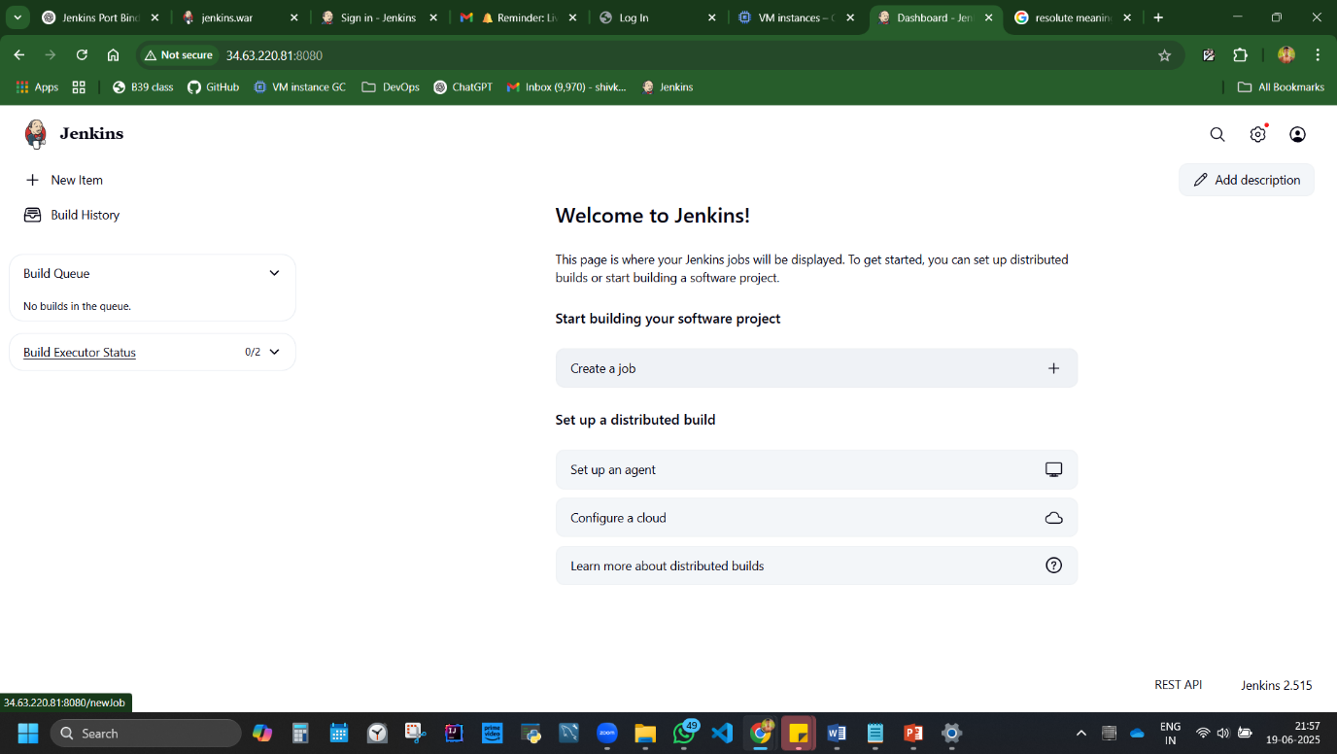

<http://34.63.220.81:8080/>

new item

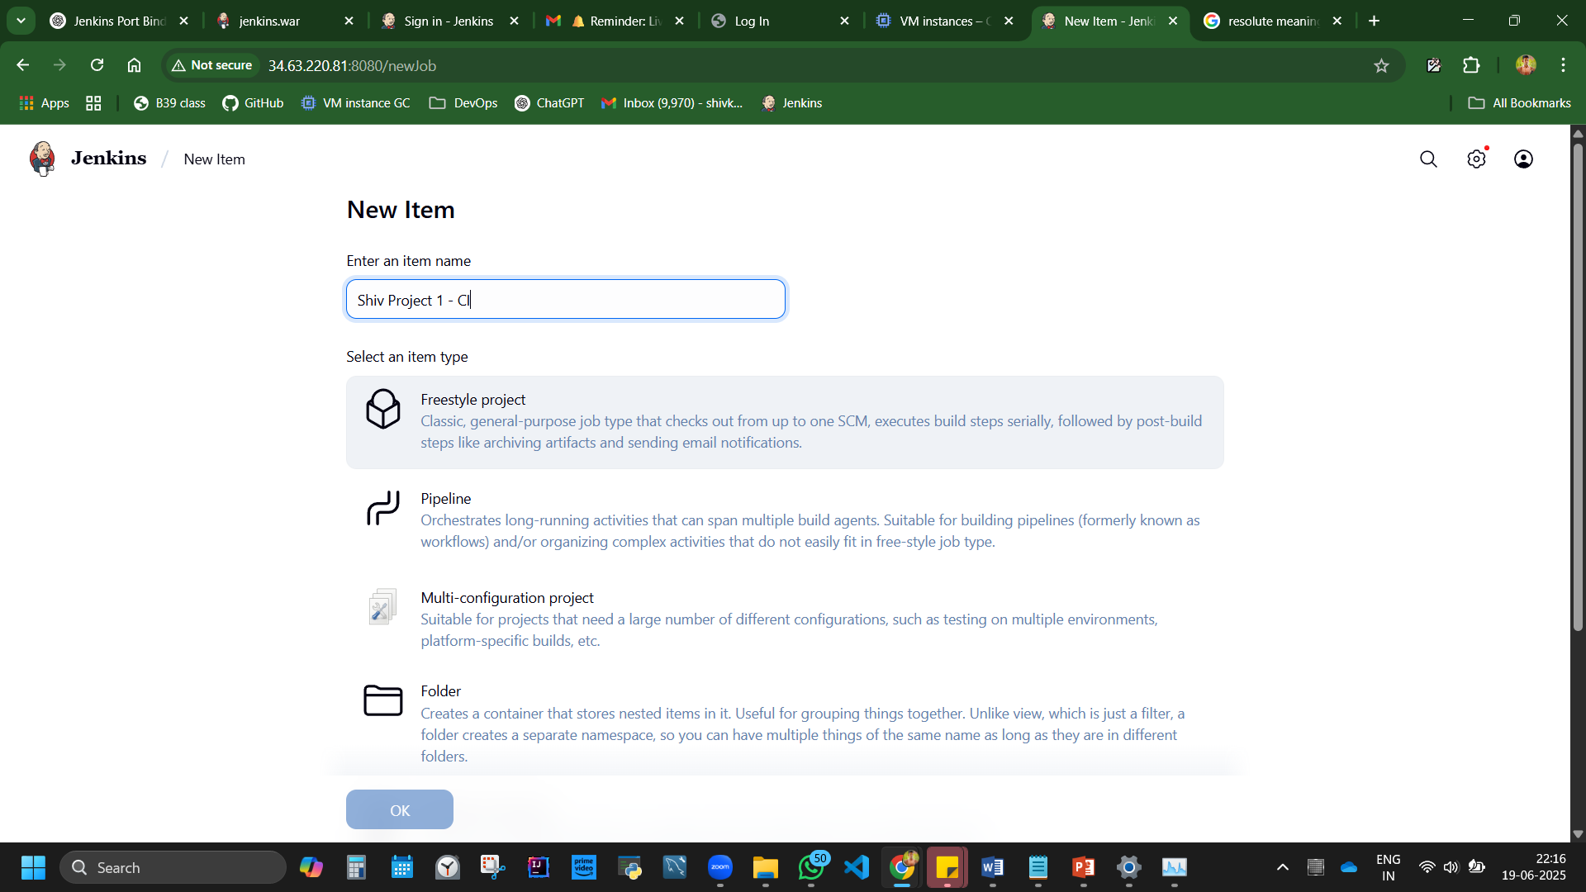

Steps:

Source code management

Git, repo url – <https://github.com/spring-projects/spring-petclinic>

Branch =main {can confirm from git hub which will be main}

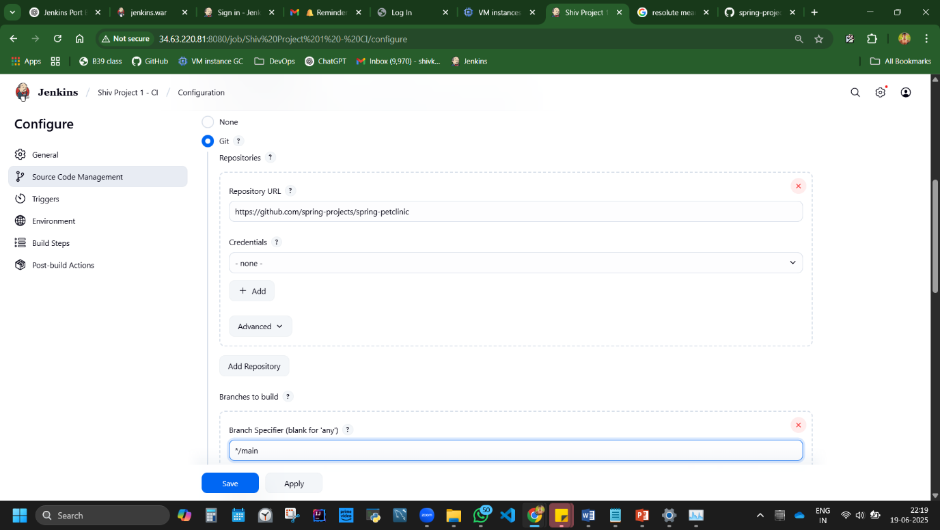

Build steps – mvn package

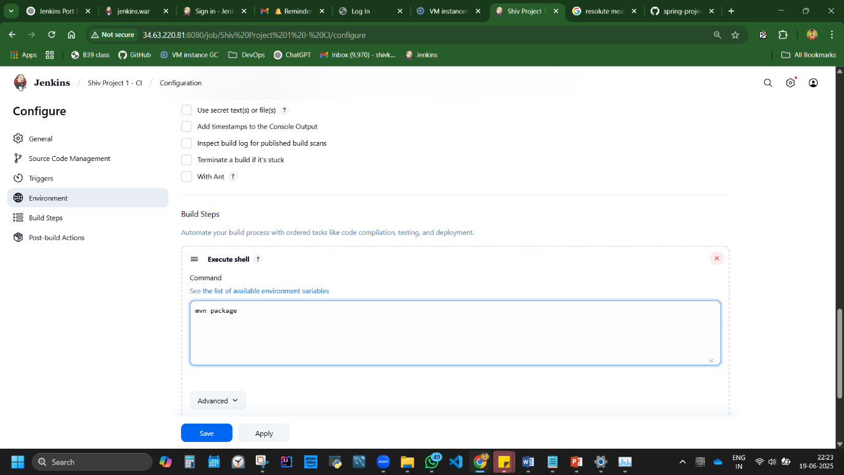

Fail.

Mvn not found. Gotto install mvn

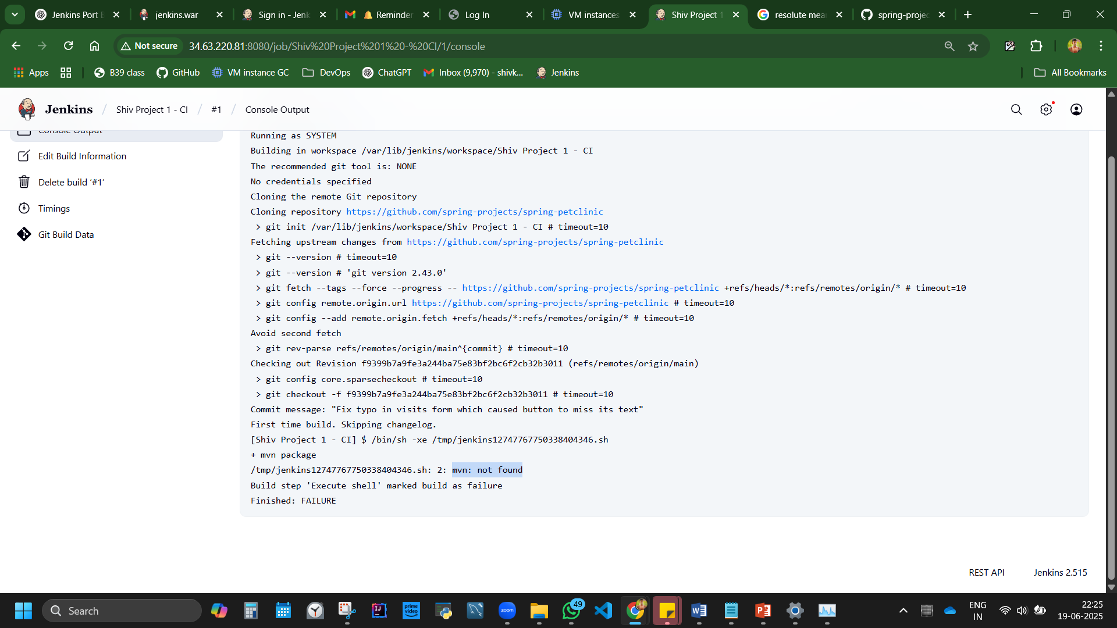

Install mvn from SSH server.

*sudo apt install maven -y*

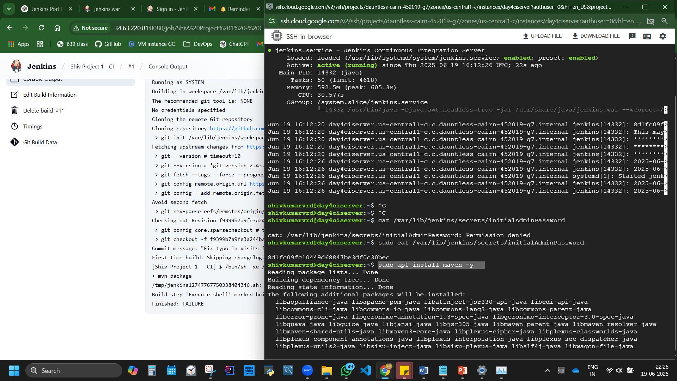

Build now, installing. In progress. From Mavel central repository, its downloading the dependencies and is in the compile and package process of converting 400mb maven into 4mb file.

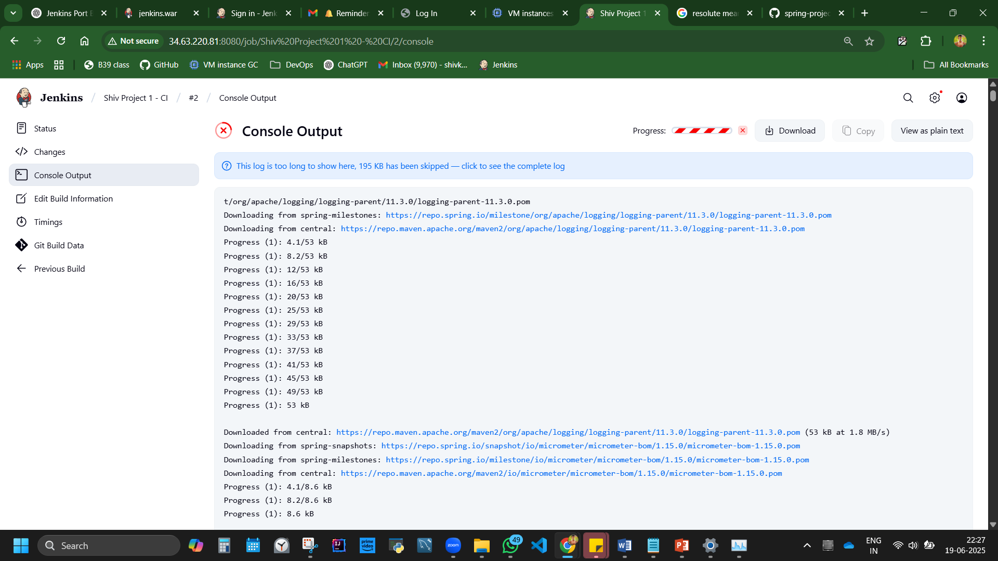

Total time: 02:49 min

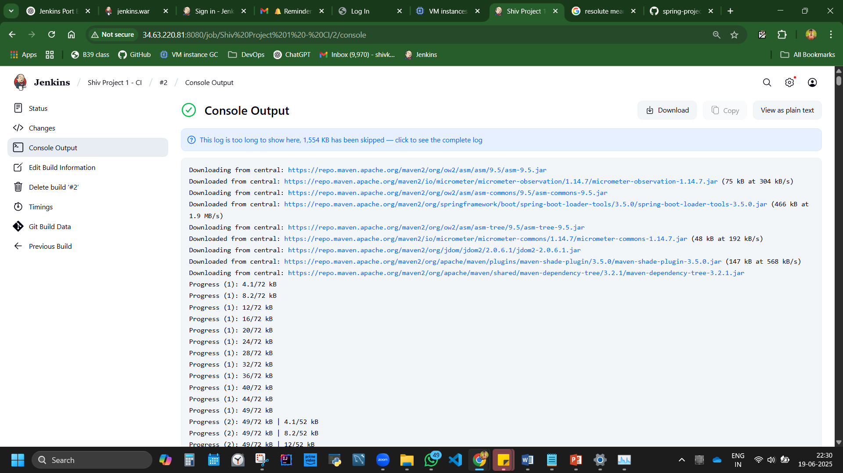

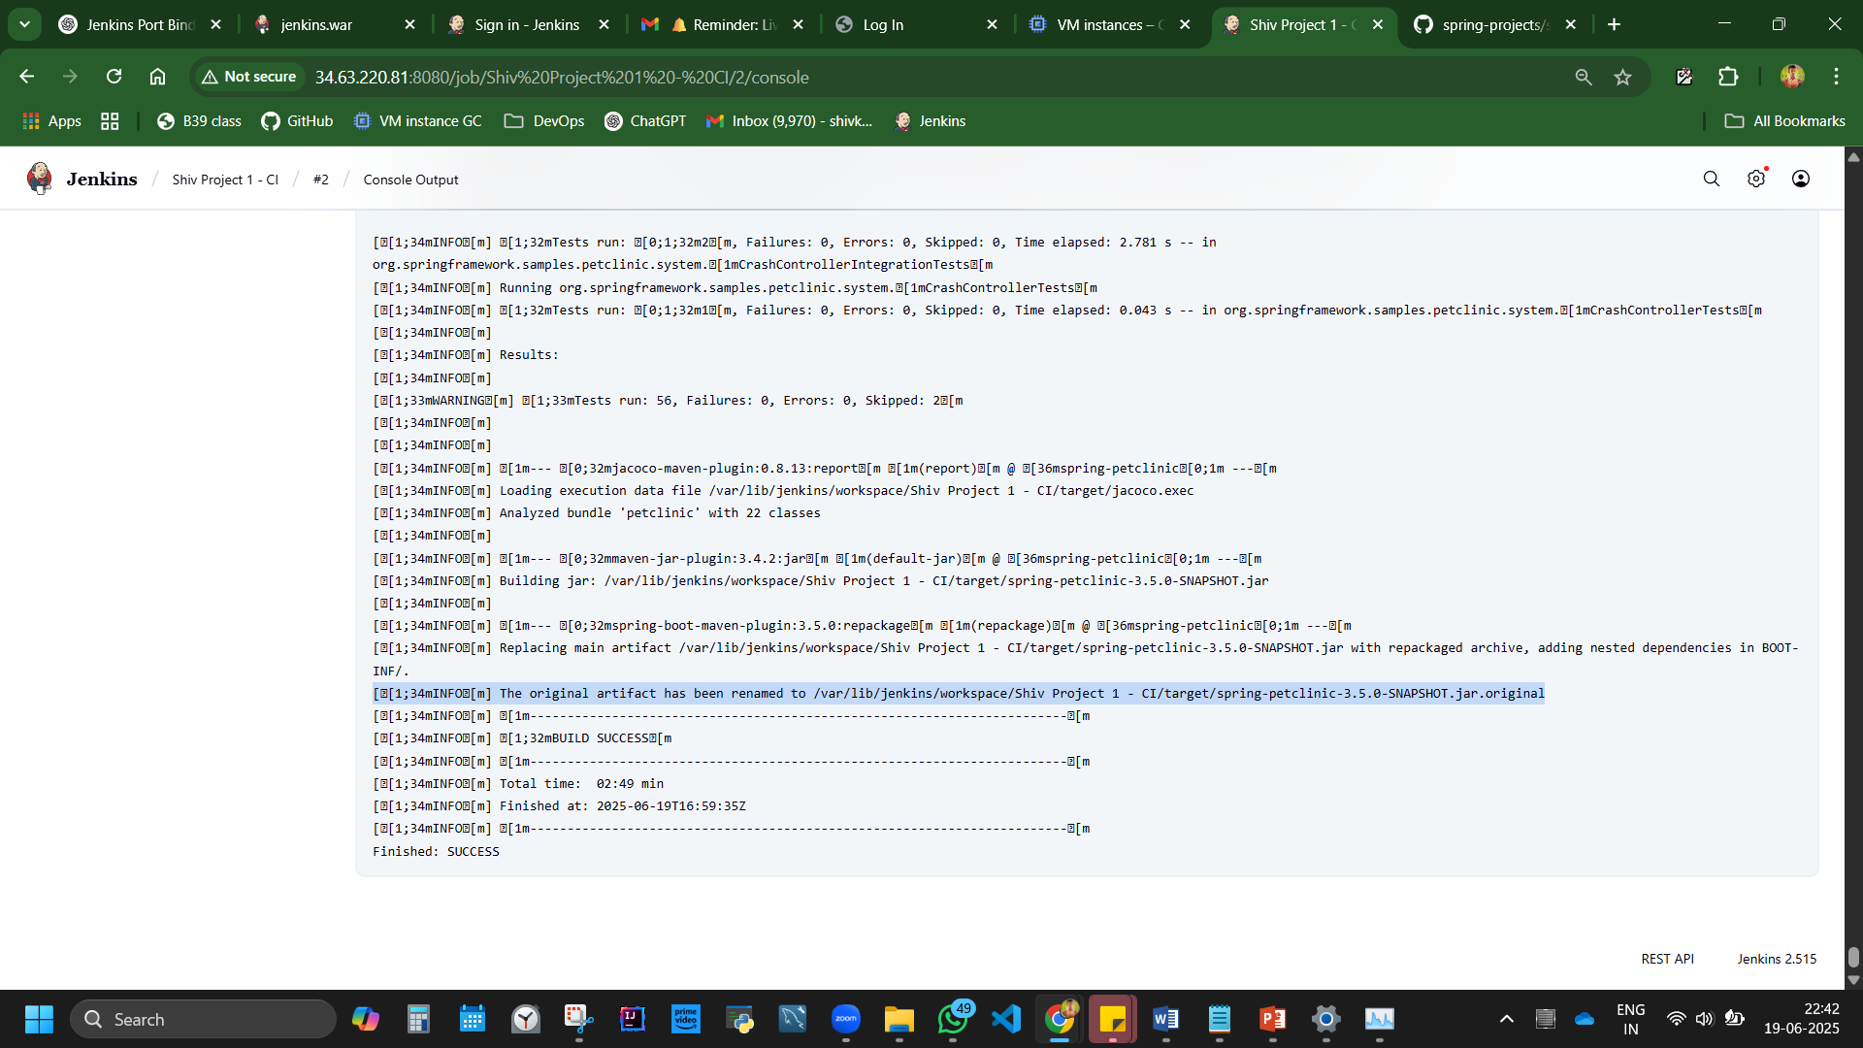

[[1;34mINFO[m] The original artifact has been renamed to /var/lib/jenkins/workspace/Shiv Project 1 - CI/target/spring-petclinic-3.5.0-SNAPSHOT.jar.original

Artifact saved location

Understand code form git hub repo:

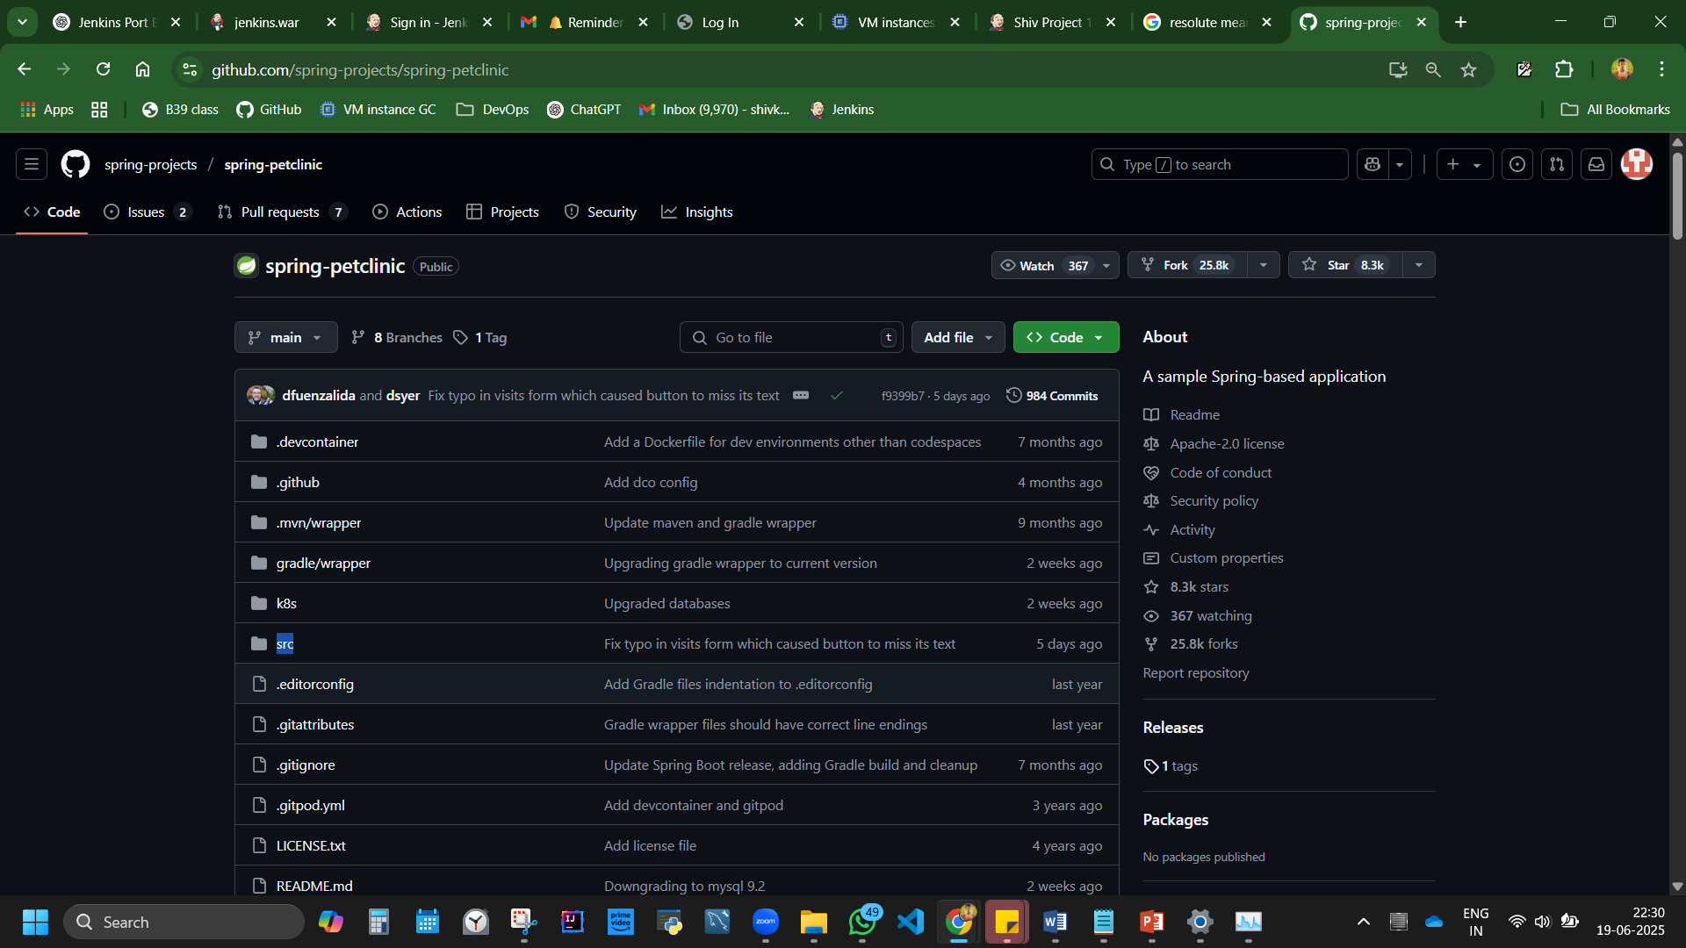

src – source code. All codes are available here. Within we have 2 files.

Test – 2 type.

Jmeter – performance testing code is in here.

java/org/springframework/samples/petclinic unit test cases.

PetClinicIntegrationTests.java – actual java code for testing purpose.

main - main code

java/org/springframework/samples/petclinic

PetClinicApplication.java – main application code. [developers write it. Not our work]

pom.xml – project object model. – full objective is in it. And is automated.

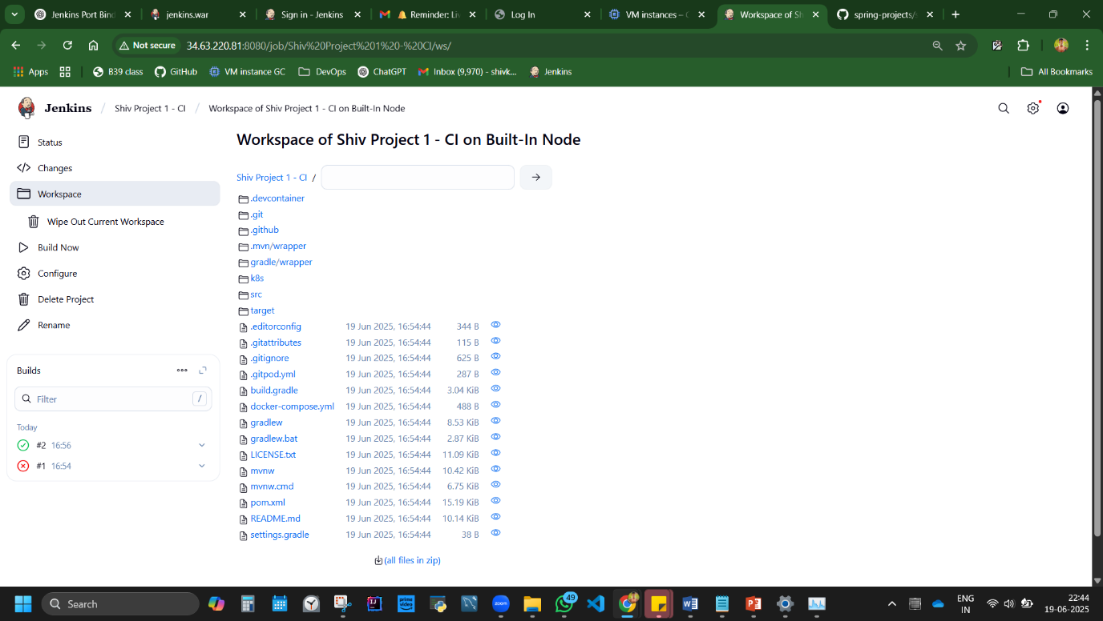

Workspace folder is created – actual code compilation, build, happens for java based application.

Artifact is saved in [target](http://34.63.220.81:8080/job/Shiv%20Project%201%20-%20CI/ws/target) folder

Inside is the jar file. Download it.

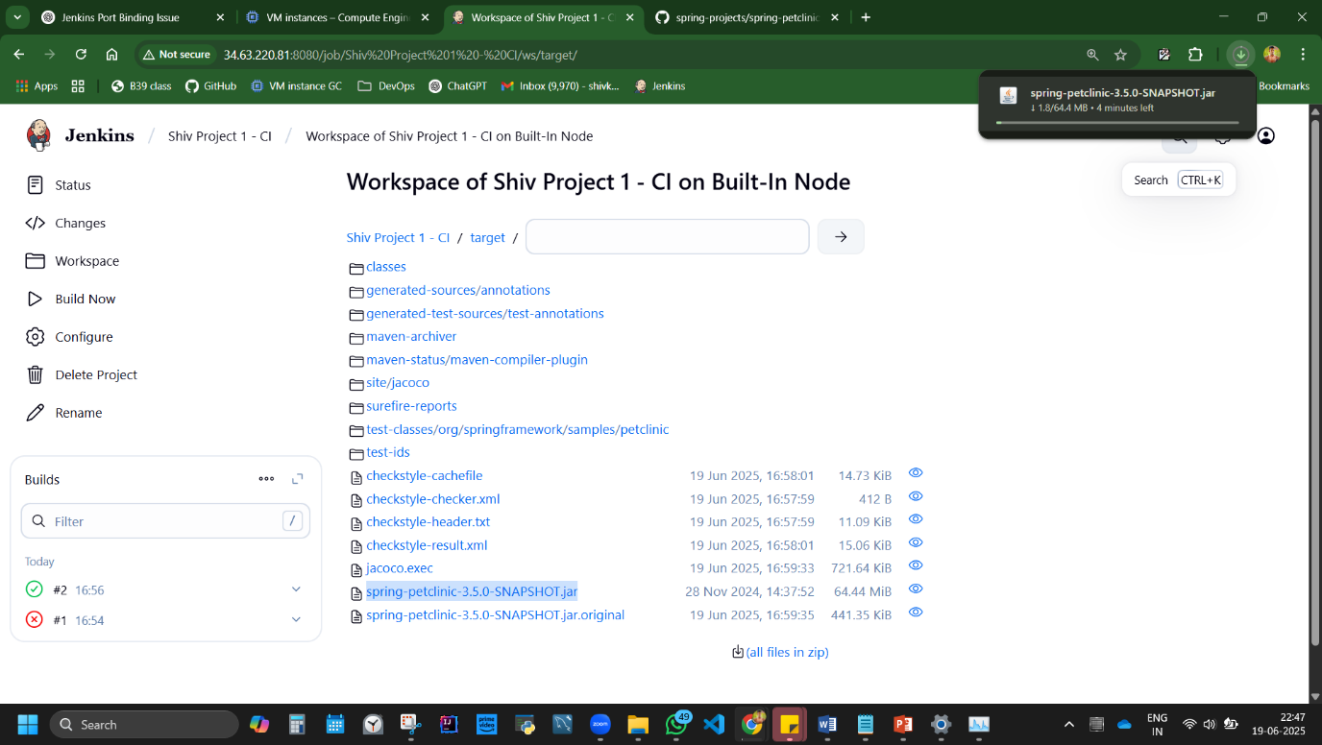

C drive>bin folder>paste the download file - [spring-petclinic-3.5.0-SNAPSHOT.jar](http://34.63.220.81:8080/job/Shiv%20Project%201%20-%20CI/ws/target/spring-petclinic-3.5.0-SNAPSHOT.jar)

*java -jar <filename>.war --httpPort=<any port ex:8082>*

cmd in adressbar > *java -jar spring-petclinic-3.5.0-SNAPSHOT.jar --httpPort=8090*

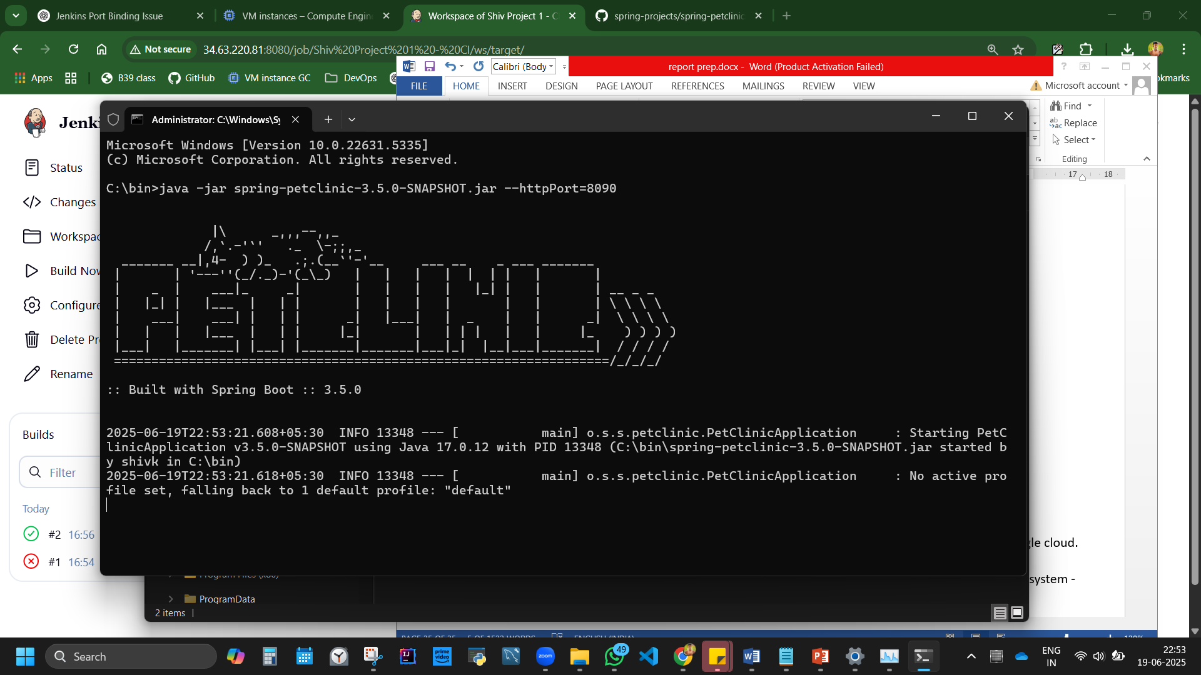

Failed to install

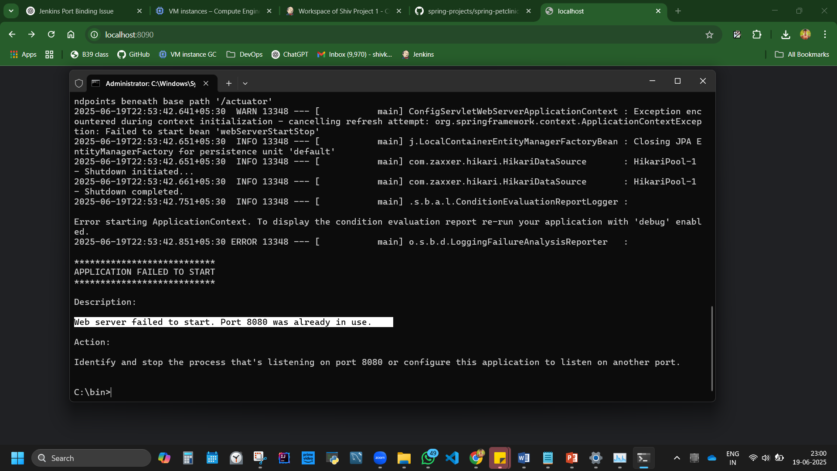

Reason: developer has configured/coded for it to work in 8080 only. So we cannot run in any other IP 8090.

Our Jenkins is running in 8080, so Stop Jenkins in task manager. Then try

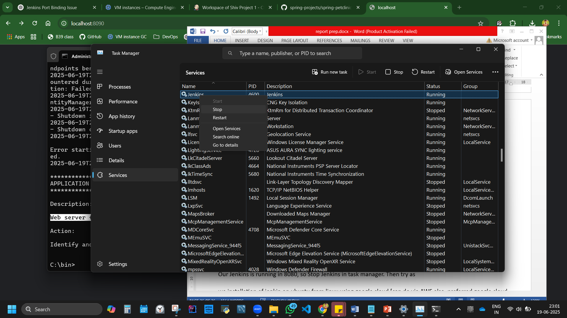

Run the code in cmd of adressbar > *java -jar spring-petclinic-3.5.0-SNAPSHOT.jar --httpPort=8090*

Working. Application is deployed manually. Remote deployment.

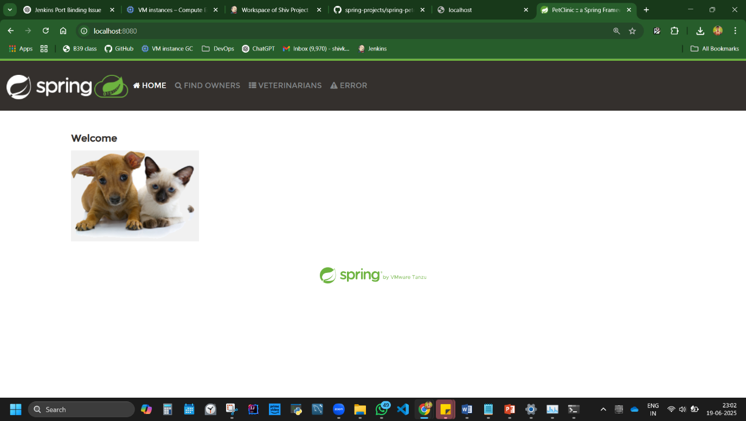

**Note:** //spring-petclinic-3.5.0-SNAPSHOT.jar runs on port 8080

**Disadvantage:** Maven builds can be slow; large apps take time to package.

Lets try in Ubuntu.

Create instance Ubuntu machine.

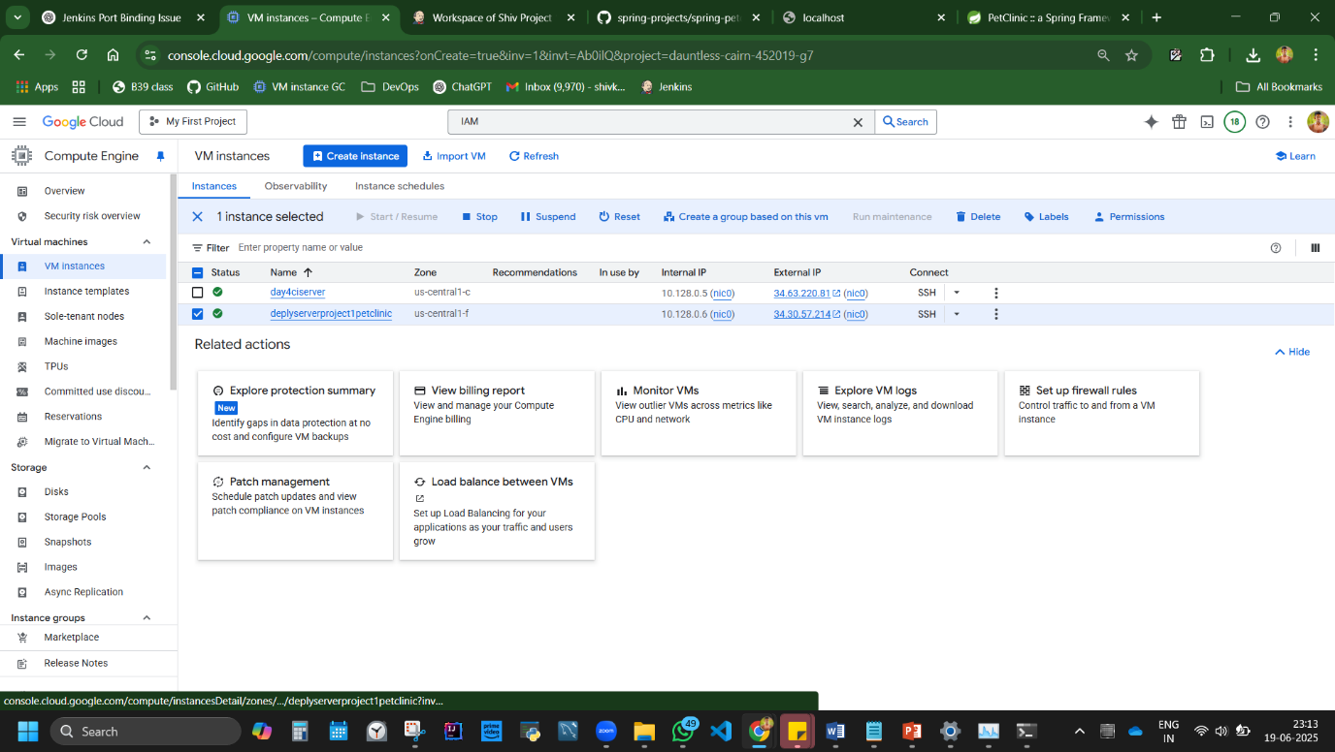

SSH

sudo -i

sudo apt-get update

sudo apt install openjdk-21-jdk –y

upload spring-petclinic-3.5.0-SNAPSHOT.jar file in SSH via upload option at top.

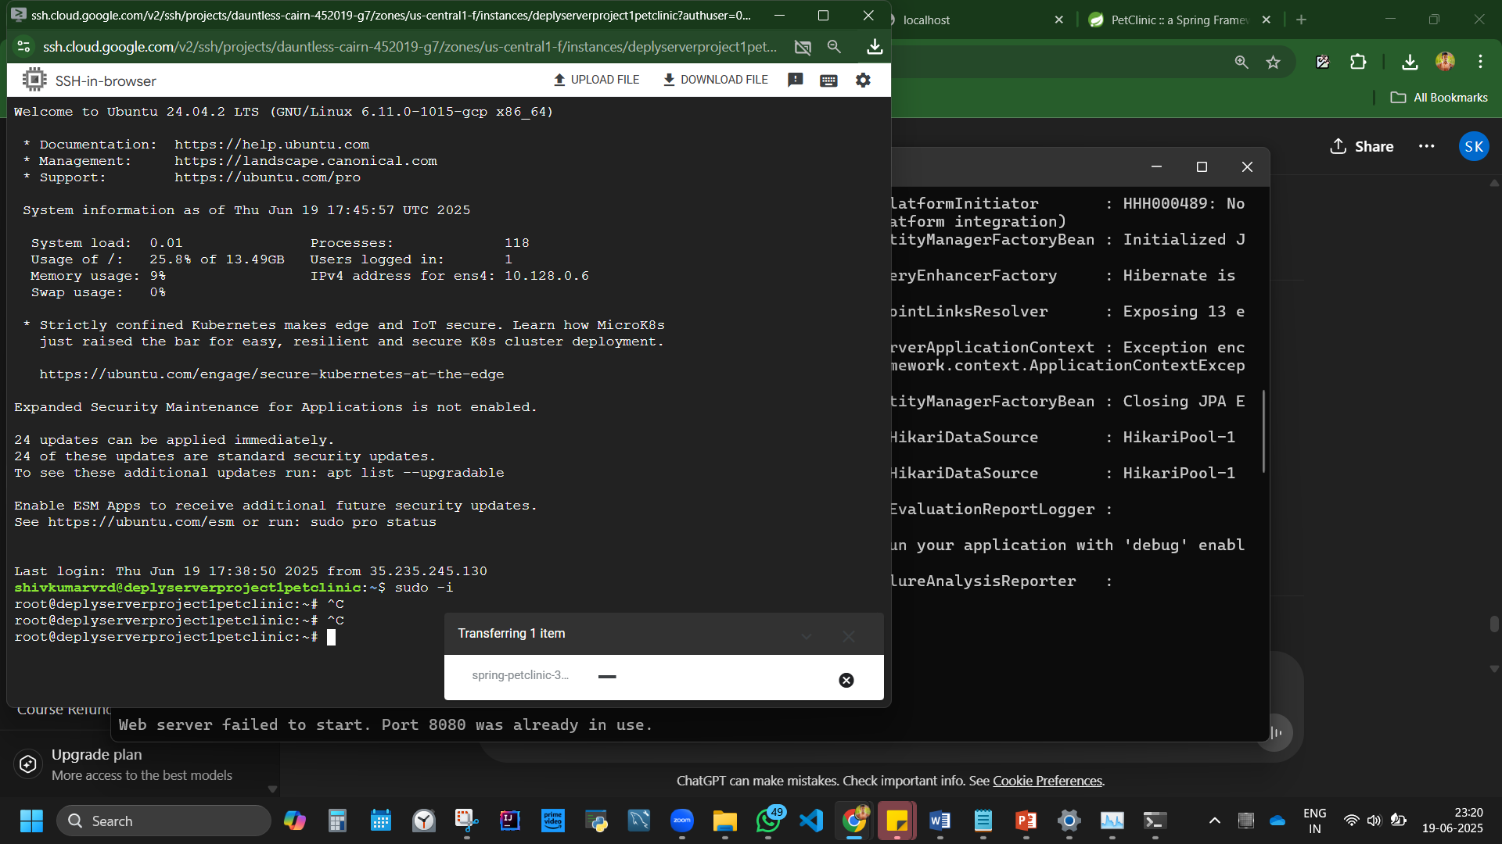

Done, but its gonna take time.

Note: What does sudo -i do?

sudo -i starts a new login shell as root, similar to logging in as the root user directly. It gives you: Root privileges (just like sudo), A clean shell session as root user

## **8. Setup Jenkins with dockerised container (Approach 3)**

**Docker:** Tool to run software in isolated containers.

**Tools Installed:**  
**7. Docker 27.5.1**

**Practical 8:** *Run Jenkins inside Docker*  
Summary of Overview Approach: **Steps:**

➤ Install Docker  
➤ Pull Jenkins image  
➤ Run container

Creating new Instance/machine with automation/IAAC **equivalent code this time.**

[Same as in approach 1: installation of jenkin on ubuntu from linux using google cloud, but using code]

Steps:

Compute engine API, Create new VM instance

machine config ‘name without space and capital L’

OS Ubuntu LTS x86 version. 24.04 x86/64 noble, 20gb machine

Networking ta, allow trafficking, 2 options.

Next to create, now click on **equivalent code**

Right side is the google code to create VM instance.,

You may copy and keep to create machine instantly. So everytime we don’t have to create machine from UI

3 ways to execute this code?

1. Install Google SDK in local pc,
2. Activate cloud shell.
3. Paste in terminal

Google cloud command to create instance machine.

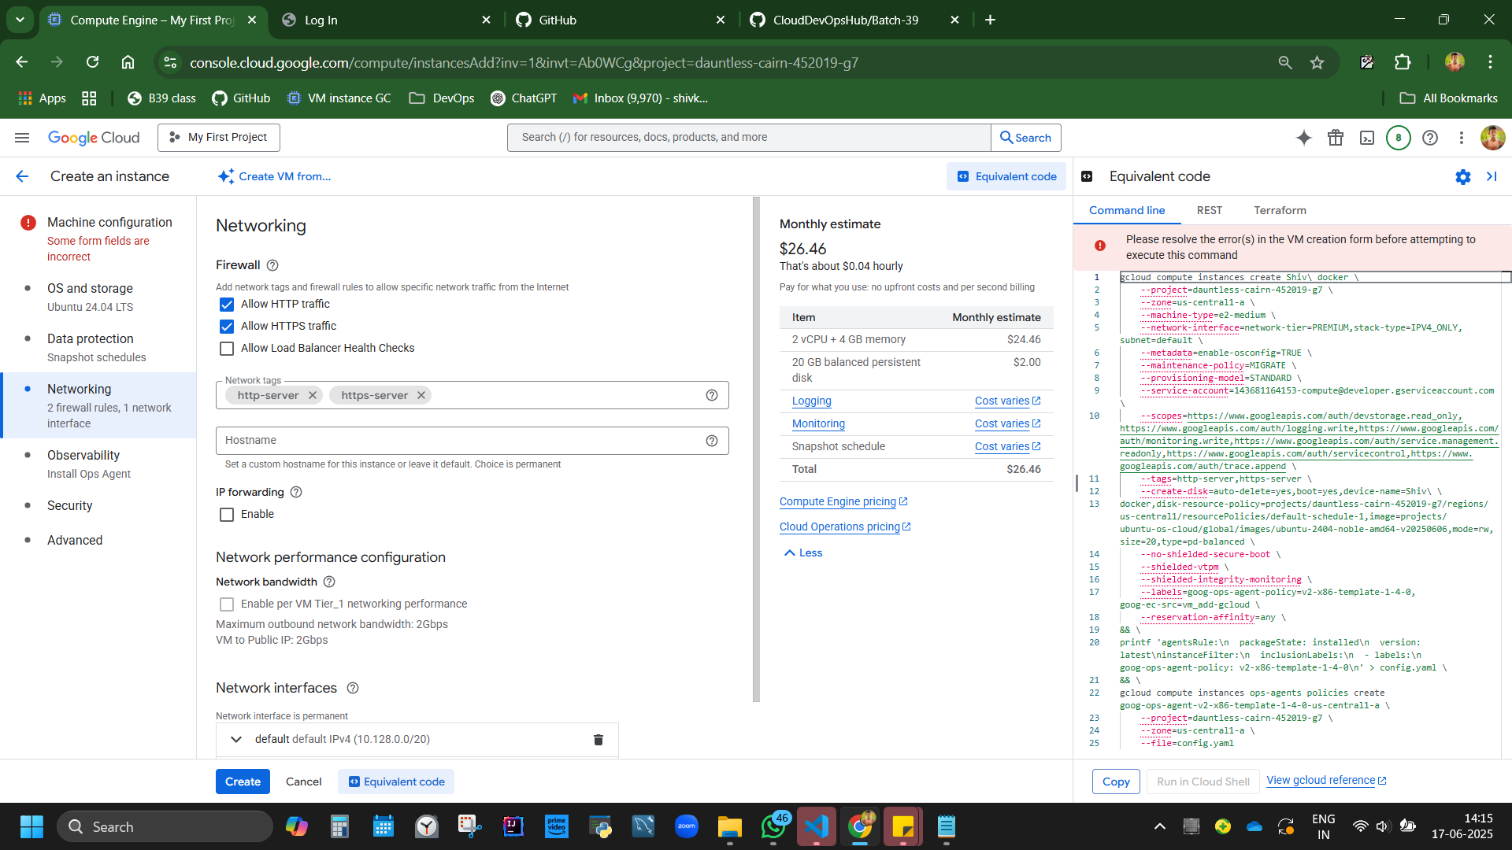

Run in cloud shell, authorise, another window opens, and VM I created.

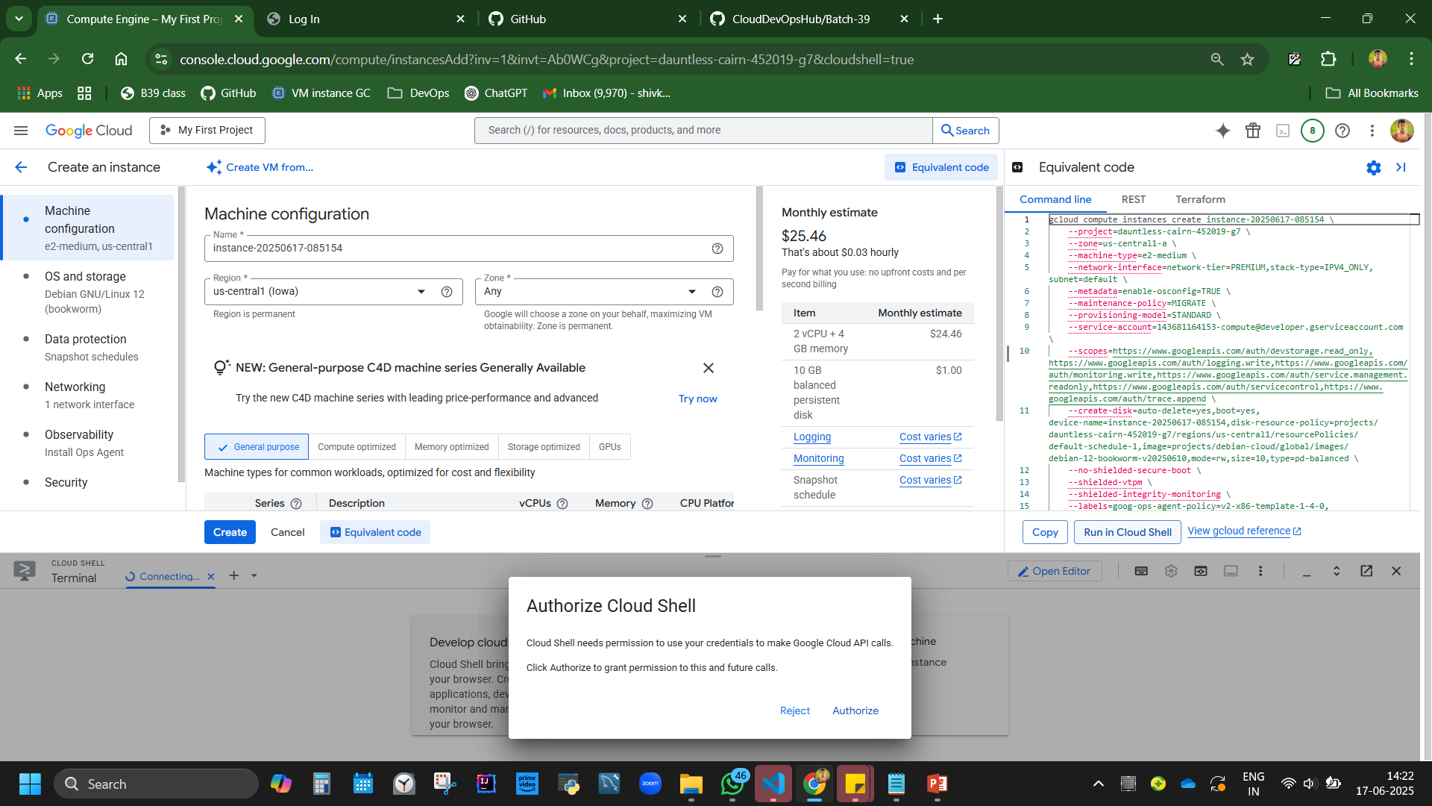

Go back, you can see a new VM machine

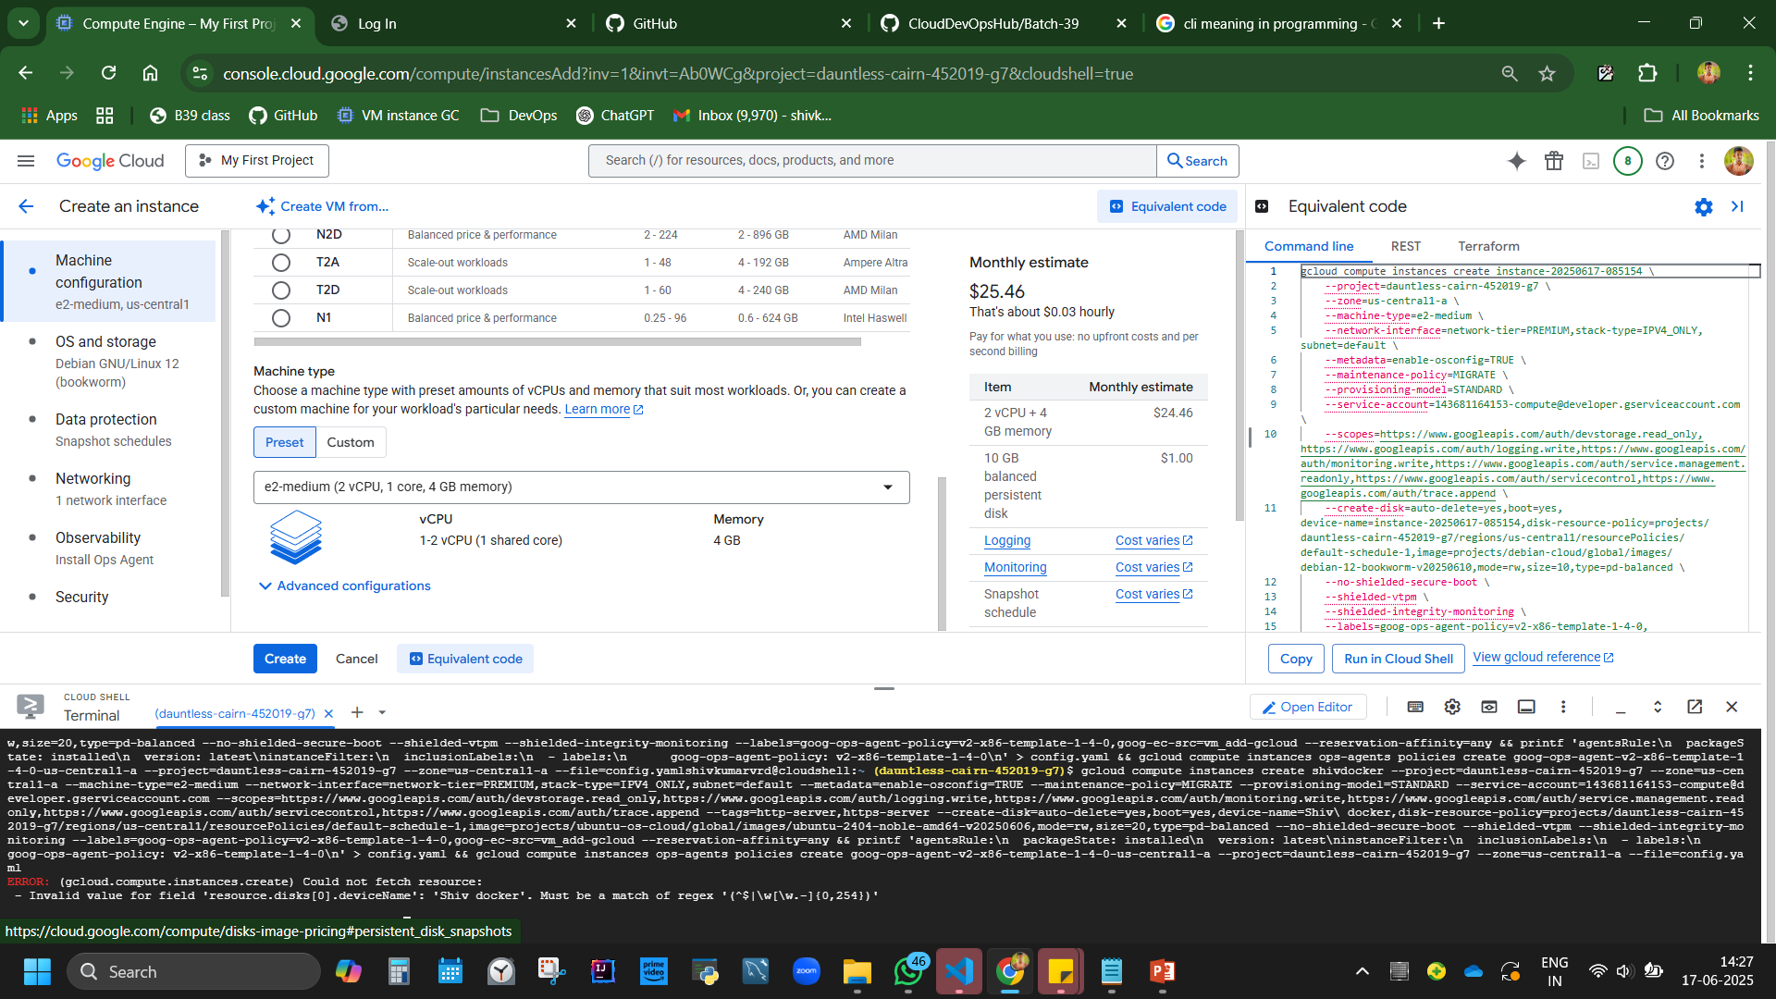

Creating a machine with the help of console code - With help of CLI, we have g cloud command generated from console for particular version, and when we execute, VM runs.

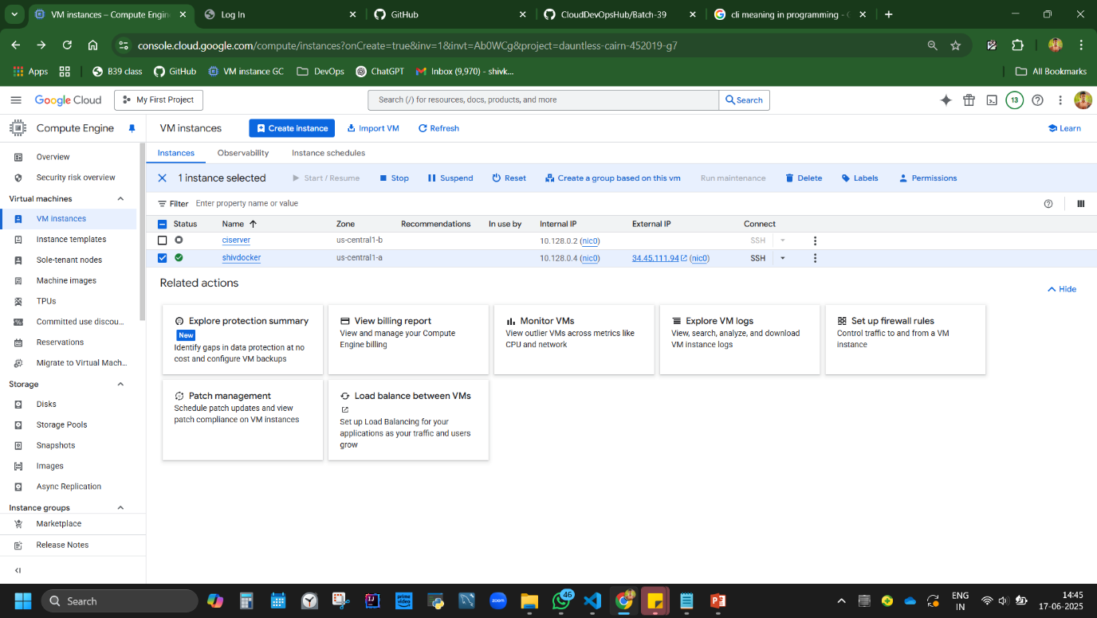

**Coming back to Approach 3: Run Jenkins with dockerised container.**

Connect SSH

**Code:**

apt-get update

apt install docker.io –y //Protip: [if donno the command, just type docker it will suggest the code]

sudo apt-get update

sudo apt install docker.io –y

docker --version

Docker version 27.5.1, build 27.5.1-0ubuntu3~24.04.2

shivkumarvrd@shivdocker:~$

Note: 🔐 *If it doesn’t execute, add sudo*

What is sudo?= "superuser do". It allows a regular user to run commands with administrative (root) privileges. This is important because some commands — especially those that modify the system (like installing software, updating packages, or changing system configurations) — require elevated permissions for security reasons.

Why do we have to use sudo?When you try to:install a package (apt install),update the system (apt update),or write to protected directories like /var/lib or /etc,you're modifying parts of the system that should only be changed by an administrator. If you're not using sudo, the system will deny access to prevent accidental or malicious changes.

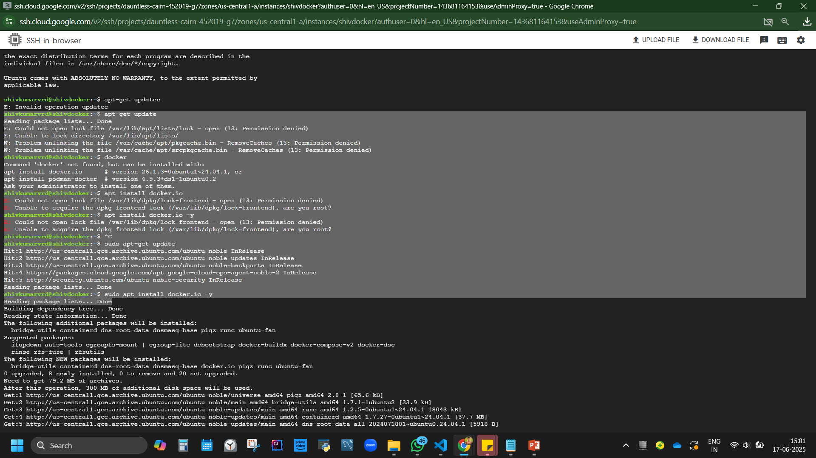

Complete code: [breakdown with ss in next page]

docker run -it -d -p 8080:8080 --name jenkins jenkins/jenkins:latest

docker ps  
docker exec -it <container_id> /bin/bash  
cat /var/jenkins_home/secrets/initialAdminPassword

Understand the code:

Docker run ~ runs docker jenkin image of latest version

-it ~interactive

-d ~deattached

-p 8080:8080 ~maps VM port with container

--name Jenkins ~Name of container is jenkin

Jenkins/Jenkins

*docker ps – see that it is a containerised jenkin*

docker exec -it <container_id> /bin/bash //cause we need to go inside container to find password

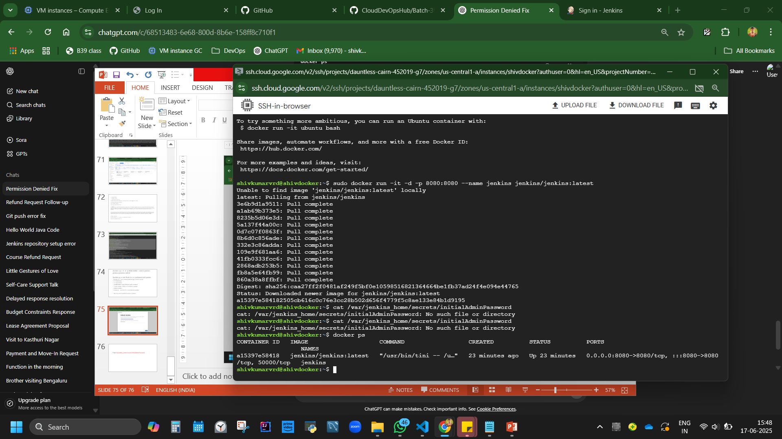

Figure Containerised jenkin up and running

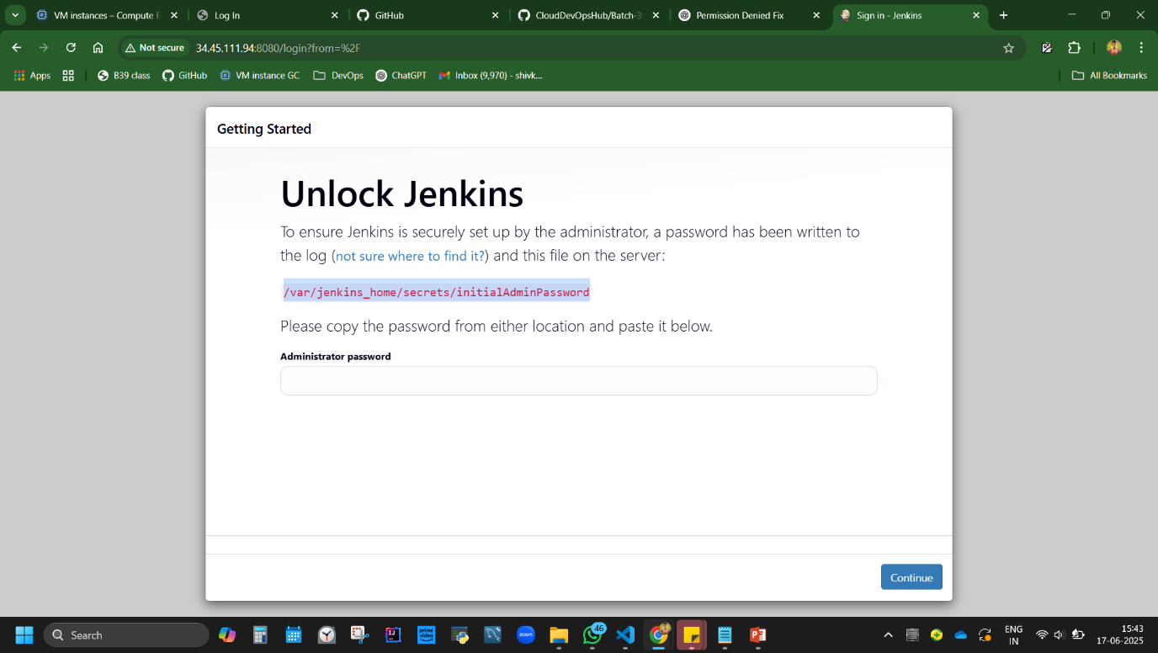

*cat /var/jenkins_home/secrets/initialAdminPassword*

This wont fetch password as we are not in server but in container now

So use

docker exec -it a15397e58418 /bin/bash

Then use

cat /var/jenkins_home/secrets/initialAdminPassword

To obtain password

Note:

exec goes into the container

a15397e58418 is obtained from docker ps code that is container id

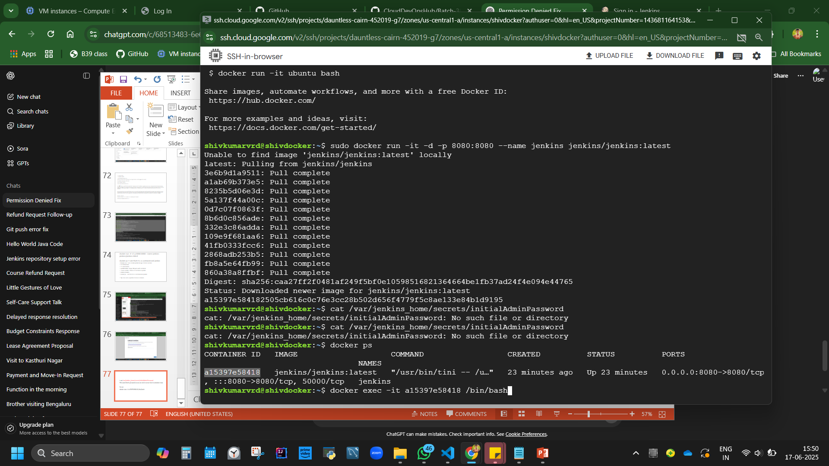

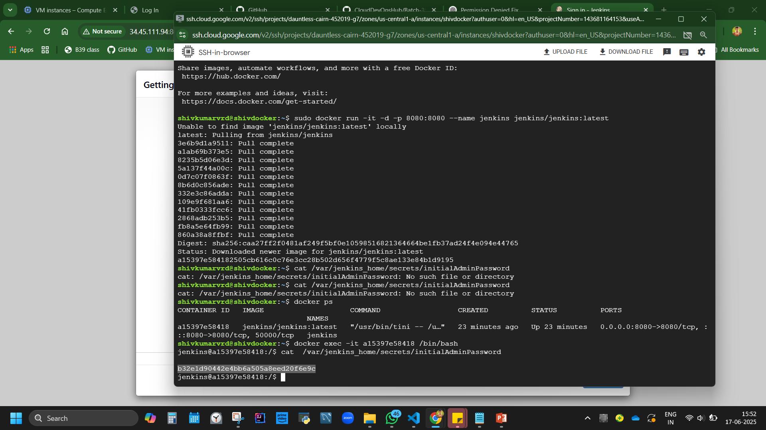

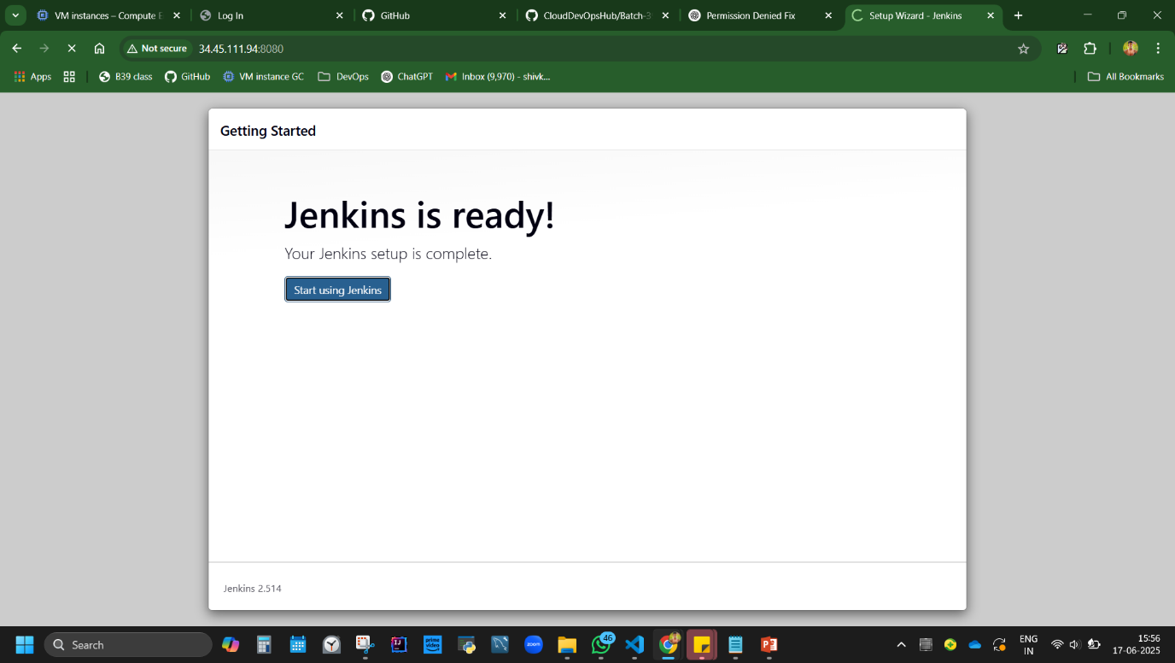 <http://34.45.111.94:8080/>

Tip: Use sudo as prefix if access is denied.

**Disadvantage:** Docker setup may require root access and careful volume management.

**Welcome to pipeline.**

Lets understand pipeline usage here

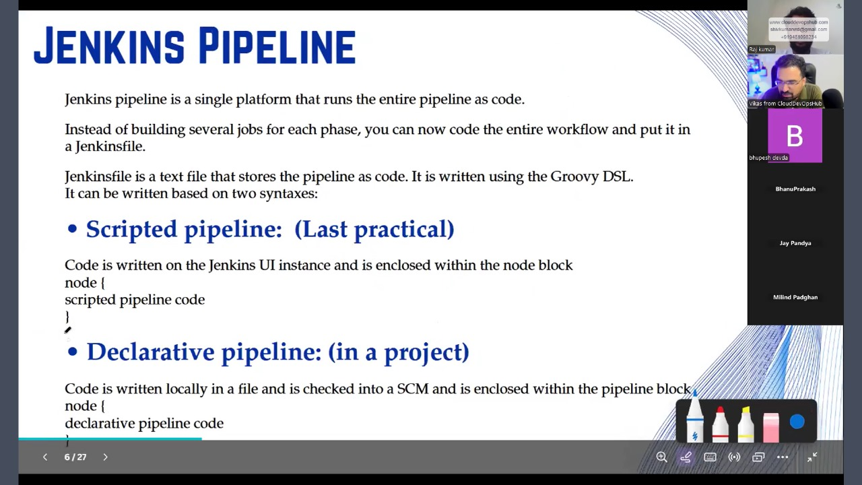

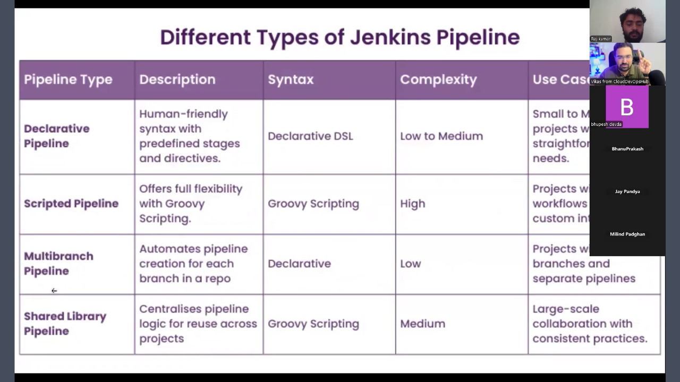

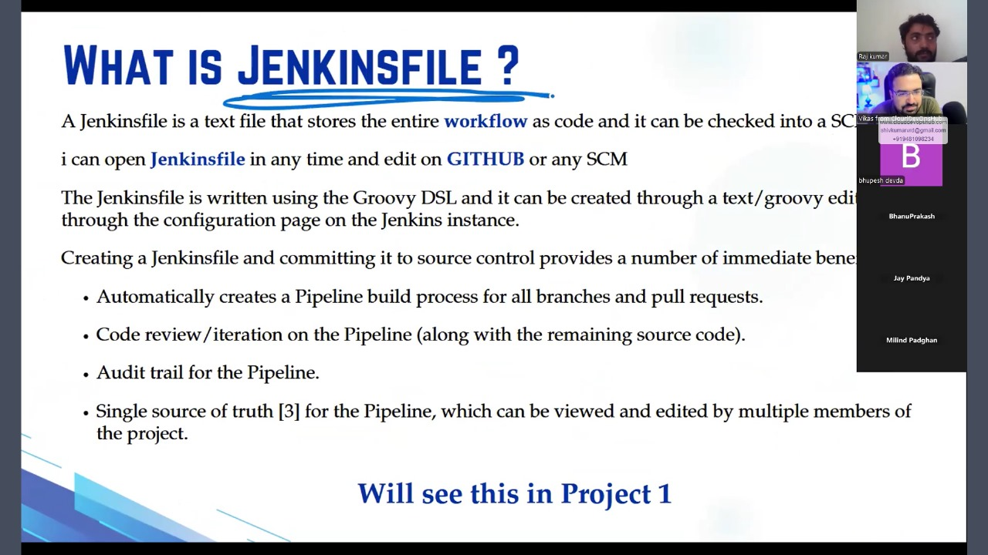

Explore, different types of jobs in Jenkins>New job

1. Freestyle project – 50% work happens here
2. Pipeline – 40% work
3. Multi config Project
4. Folder -
5. Multi pipeline – if code is available in multi branch.
6. Organisation folder

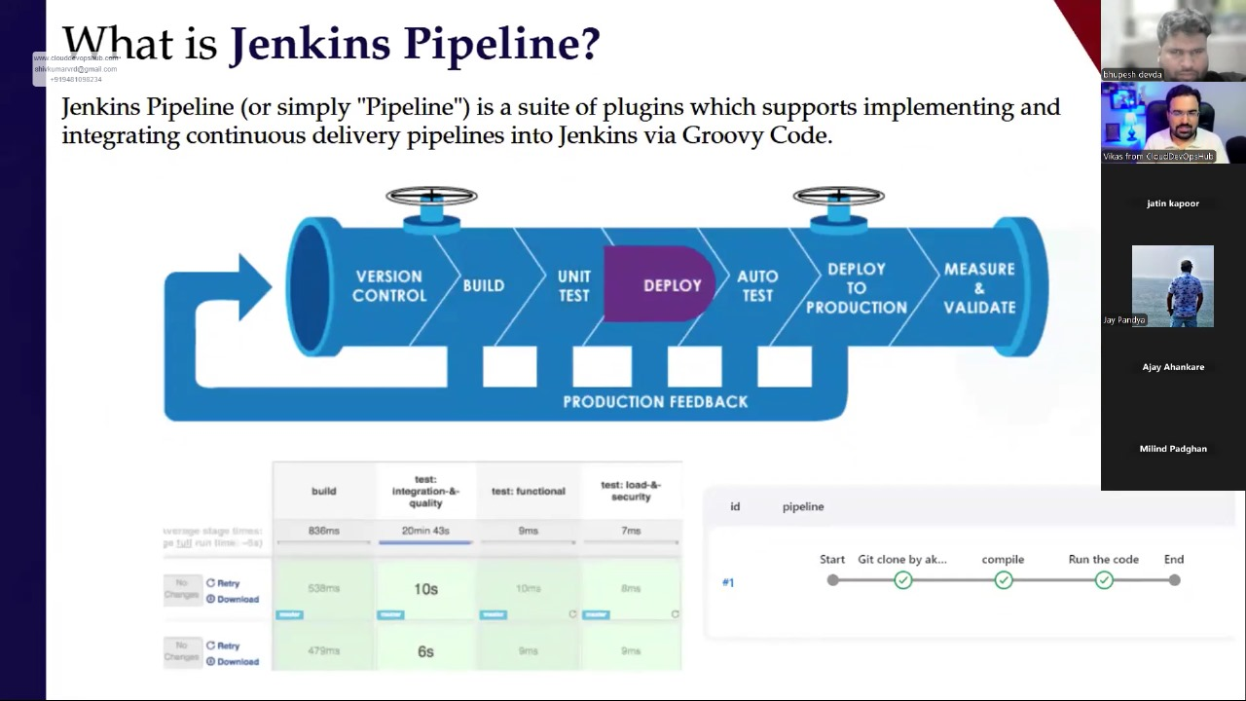

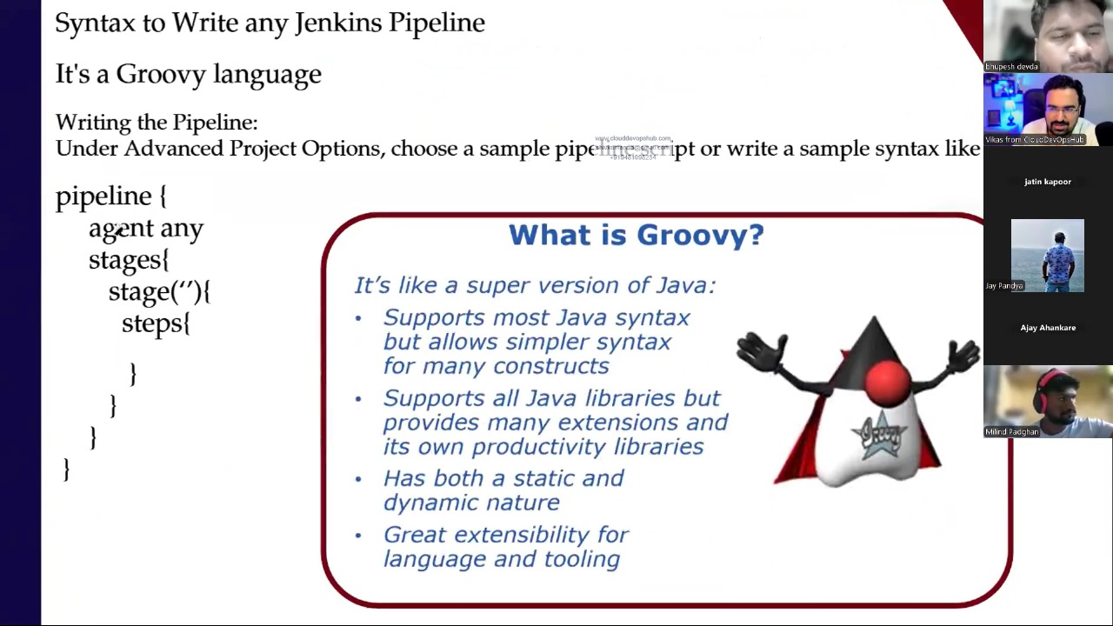

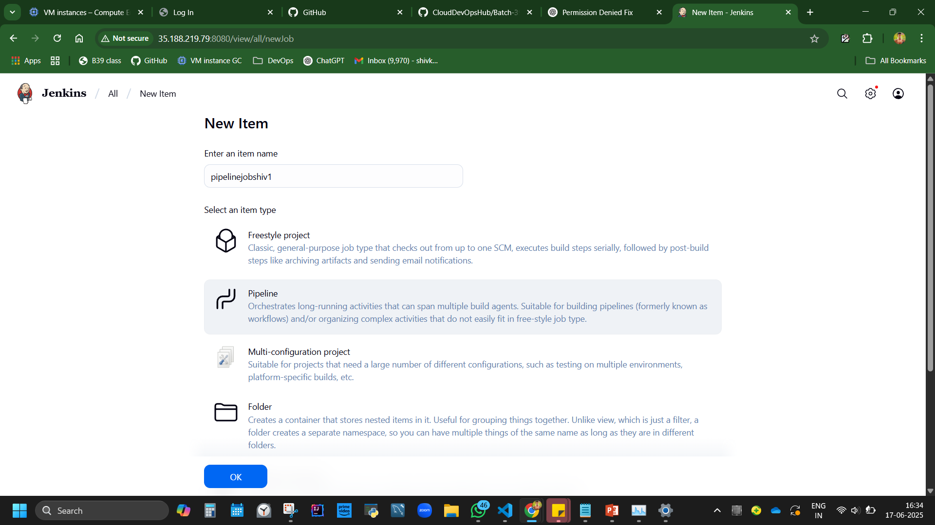

**Pipeline Job Creation in jenkins by running a Groovy Code**

**New item, Pipeline, ok**

**Config tab – script – paste the code, save, build.**

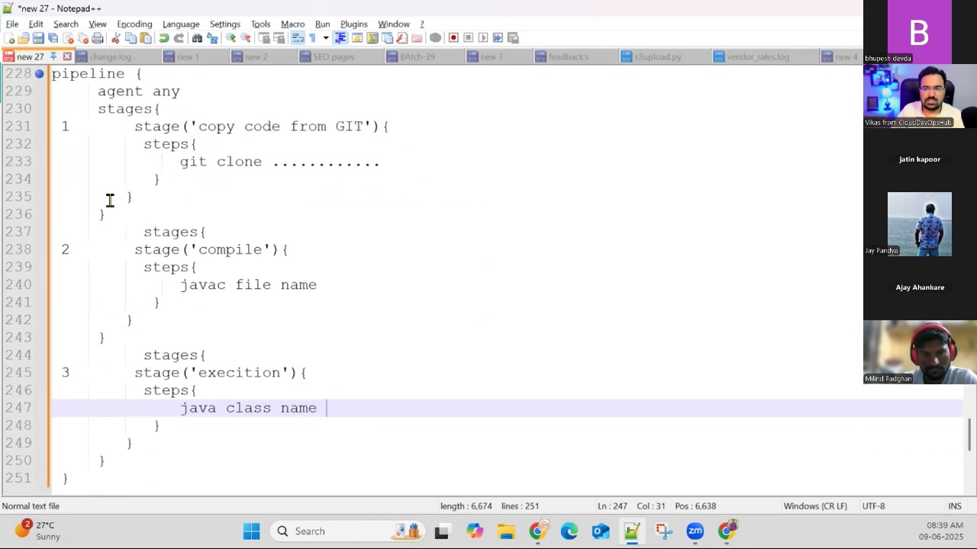

Code explanation:

Where agent gets a change he runs.

Can add trigger here.

1st stage – git clone. It copies code from that URL

2nd stage – compile/build the java code.

3rd Stage – executing the class file/running the project. No need to write code. Can get from ‘pipeline syntax’

***pipeline {***

***agent any***

***stages {***

*stage('Git clone') {*

*steps {*

*git branch: 'main', url: 'https://github.com/DevSecOpsG/helloworldsimplejavaprogram'*

*}*

*}*

*stage('Build'){*

*steps{*

*sh 'javac helloworld.java'*

*}*

*}*

*stage('Run'){*

*steps{*

*sh 'java Simple'*

*}*

*}*

*}*

*}*

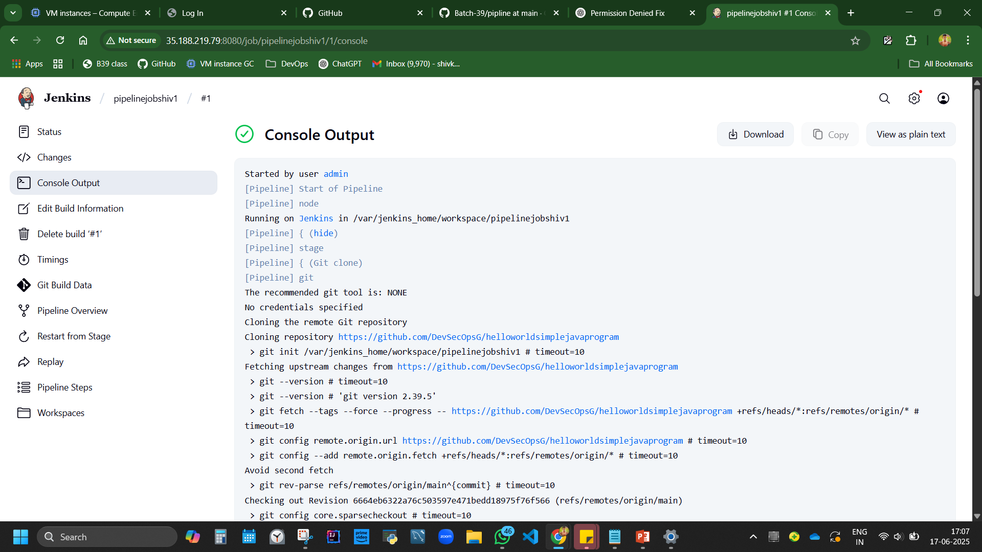

Usage of Pipeline syntax – It helps to generate the code.

How to get git clone part?

Pipepinename

Sample step – type what code you are taking from. Ex git

Copy paste repo url (from git hub of hello world)

Branch master to main

Generate pipeline script.

git branch: 'main', url: 'https://github.com/ShivK8431/helloworldsimplejavaprogram '

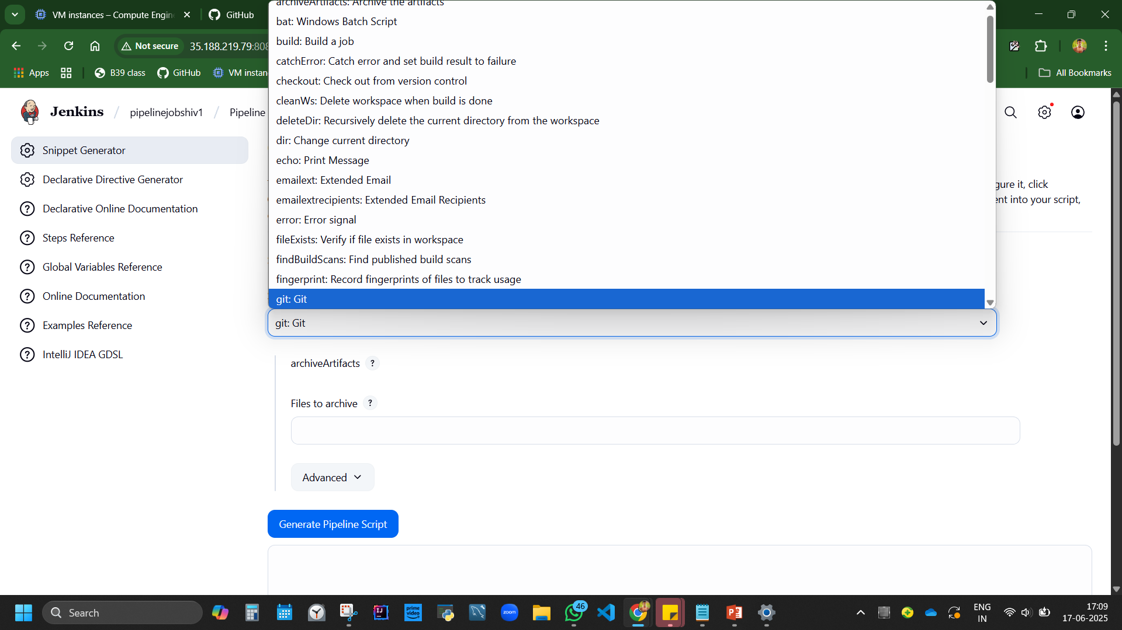 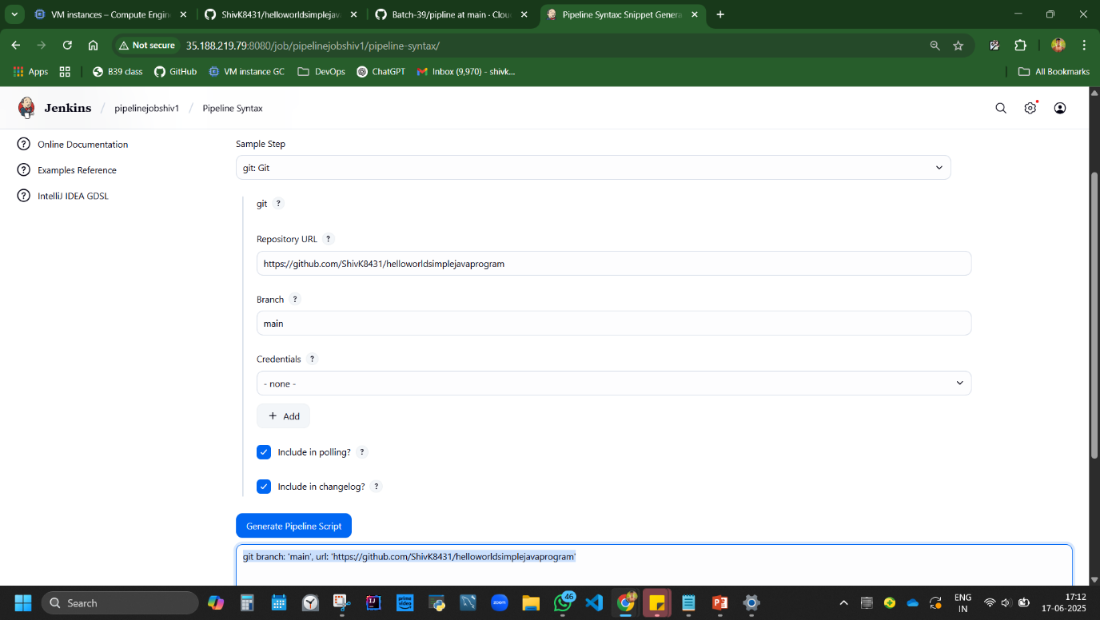

pipeline {

agent any

stages {

stage('Git clone') {

steps {

git branch: 'main', url: 'https://github.com/DevSecOpsG/helloworldsimplejavaprogram'

}

}

stage('Build'){

steps{

sh 'javac helloworld.java'

}

}

stage('Run'){

steps{

sh 'java Simple'

}

}

}

}

How to Add a Feature to send email feedback trigger:

Add new Stage in pipeline, copy paste the last stage in syntax.

To get the ‘step’ part of the code use pipeline syntax

Pipeline name>Pipeline syntax

In Search step search mail, Enter Add to, cc, subject, body.

Email configuration:

SMTP config is required if you want a mail triggeded if a build is successful:

Simple Mail Transfer Protocol. You can take SMTP from mail or port/server from company. You can add that in Manage jenkin>system>SMTP add server, port, email.

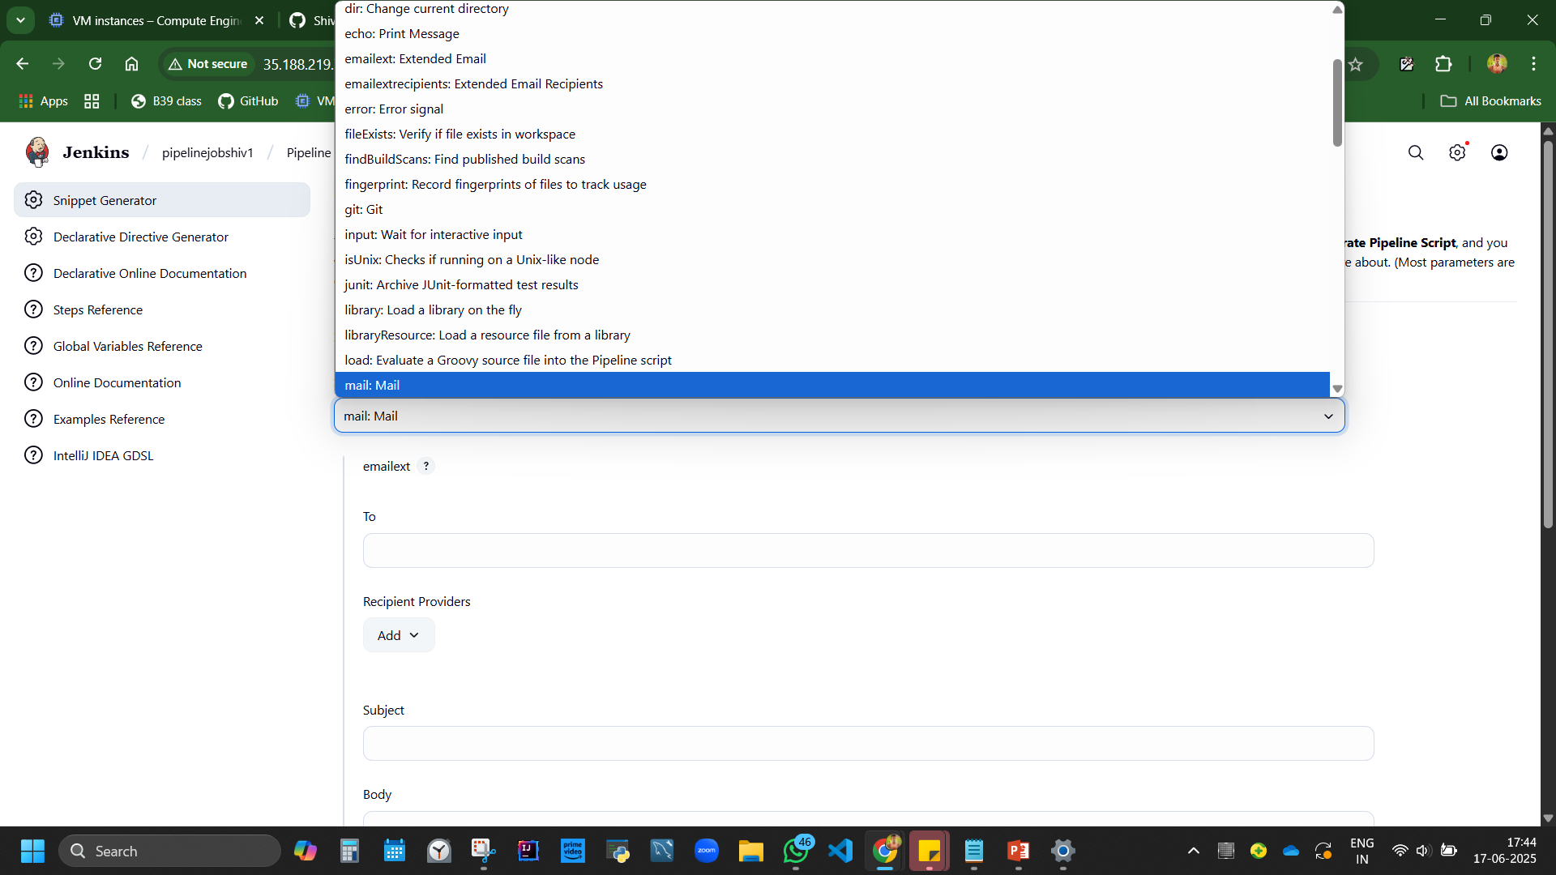 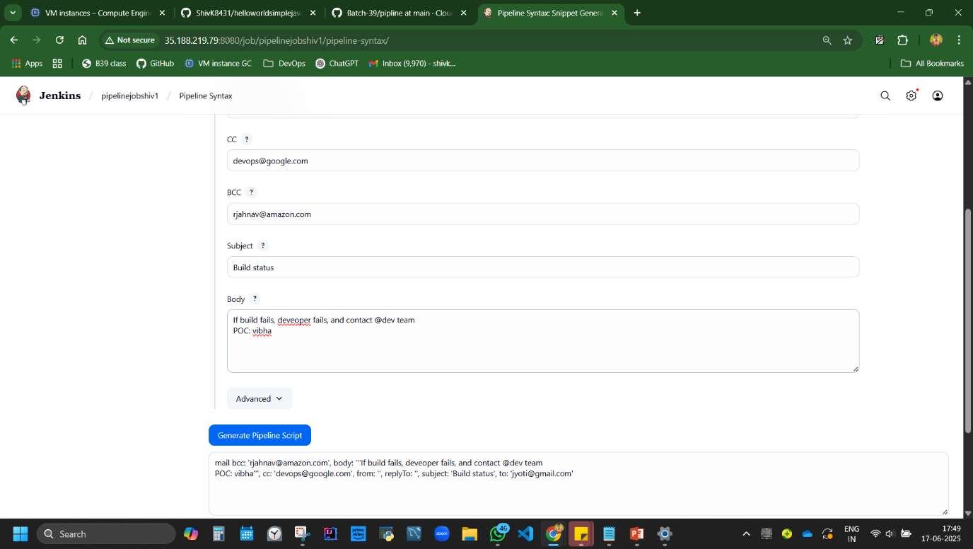

To add another build stage, copy paste stage. Code is mvn package to compile war file.

pipeline {

agent any

triggers{

pollSCM(H/5 * * * * *) //Polls SCM every 5 minutes

}

stages {

stage('Git clone') {

steps {

git branch: 'main', url: 'https://github.com/DevSecOpsG/helloworldsimplejavaprogram'

}

}

stage('compile java code'){

steps{

sh 'javac helloworld.java'

}

}

stage('Run the classfile'){

steps{

sh 'java Simple'

}

}

stage('build war file'){

steps{

sh 'mvn package'

}

}

stage('send email'){

steps{

mail bcc: 'rjahnav@amazon.com', body: '''If build fails, deveoper fails, and contact @dev team

POC: vibha''', cc: 'devops@google.com', from: '', replyTo: '', subject: 'Build status', to: 'jyoti@gmail.com'

}

}

}

}

Agent any = takes all

We can use master slave and mention dedicated names

## **9. Jenkins by Windows desktop installer [end user approach] (Approach 4)**

**Practical 9:** *Install Jenkins using Windows Installer*  
**Overview summary of approach Steps:** ➤ Download Jenkins EXE  
➤ Run installer  
➤ Test Java path and port  
➤ Get initial password and start Jenkins

1st see if java is installed in cmd.

Download Jenkin <https://www.jenkins.io/download/> - 95mb software

Install app, test portal give 8080 or other port to test, give path to fetch java.

Browser localhost:8080 <http://localhost:8080/login?from=%2F>

Copy paste the red thing in address bar in file explorer. It fetches the passwordfile, open via notepad, you’ll have password

C:\ProgramData\Jenkins\.jenkins\secrets\initialAdminPassword

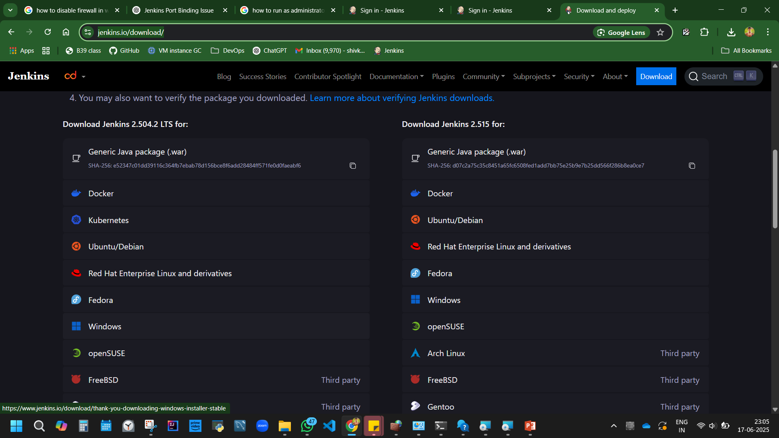

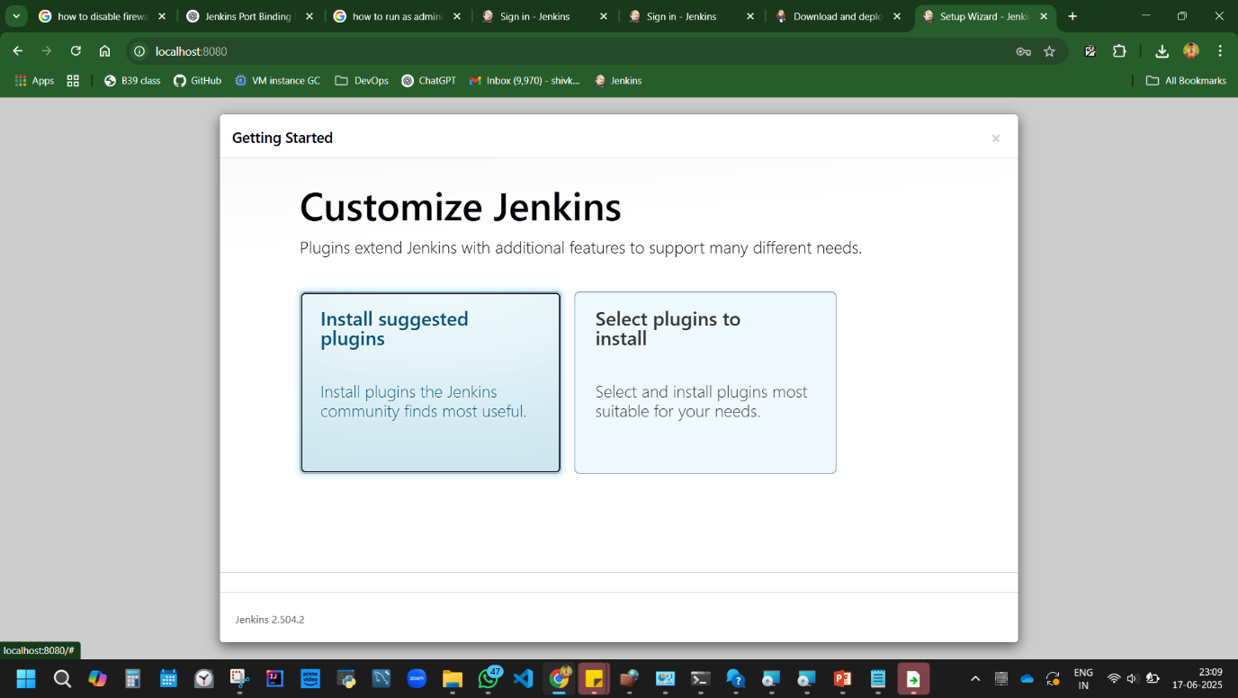

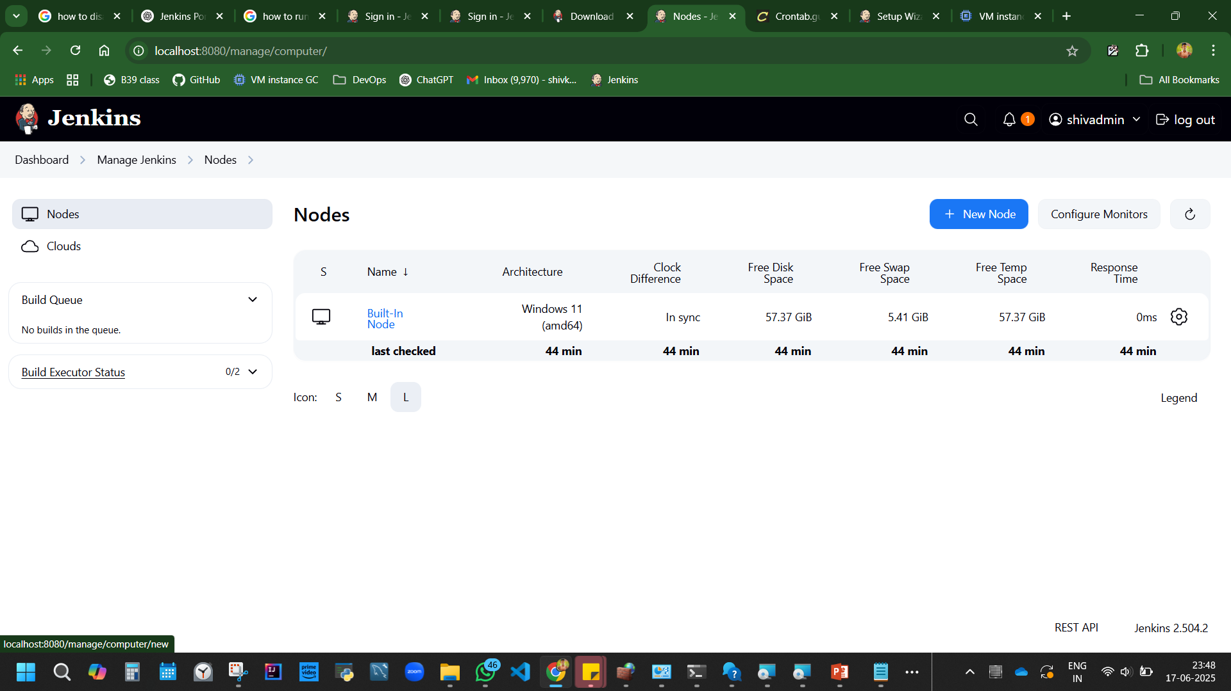

**Disadvantage:** Port conflicts can occur (8080 in use by other apps).

## **10. Master-Slave Configuration Setup in Jenkin (Day 6)**

**Master-Slave:** Jenkins Master distributes build jobs to Slave nodes.

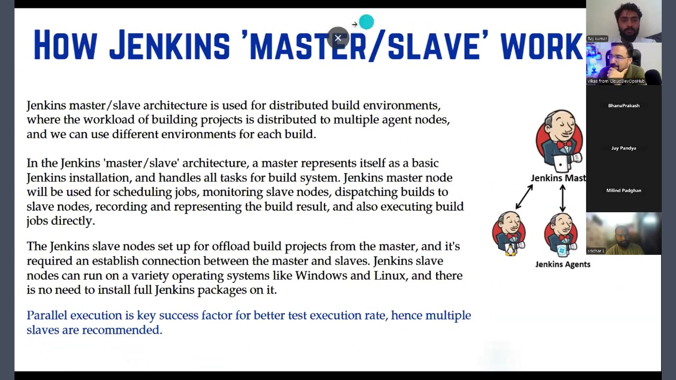

**Practical 10:** *Configure Master-Slave Nodes in Jenkins*  
**Summary of overall approach Steps:** ➤ Add new node in Jenkins  
➤ Download agent.jar  
➤ Run connection command with secret  
➤ Verify node is connected

**Code:**

curl.exe -sO http://localhost:8080/jnlpJars/agent.jar  
java -jar agent.jar -url http://localhost:8080/ -secret <secret> -name "shiv team" -webSocket -workDir "D:\Course & Learnings\DevOps\Git Week 1 June 2nd\dev"

**Note:** //To execute pipeline on specific node, restrict project execution by agent label.

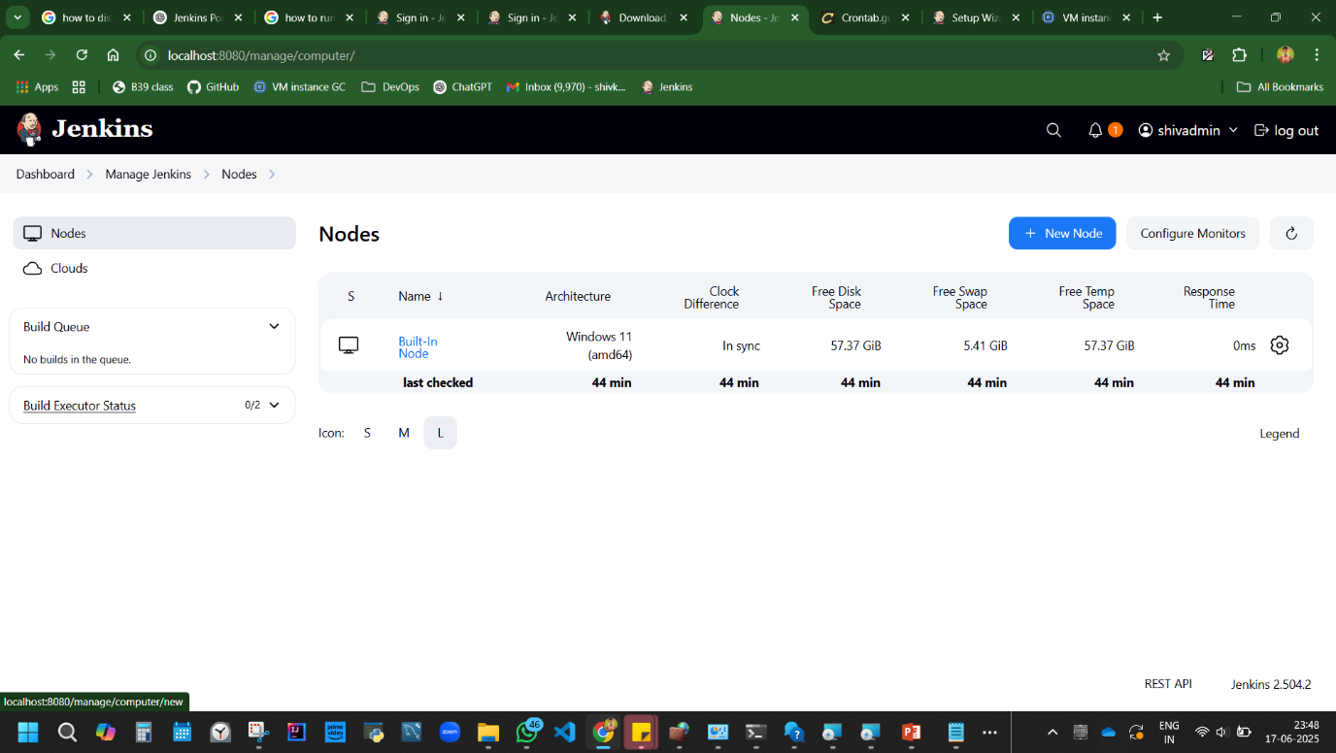

CREATE NEW NODE IN JENKIN.

Dashboard, manage Jenkins, New node, name, permanent, add path in Remote root directory {create a folder dev in pc, get that address, add in} save

D:\Course & Learnings\DevOps\Git Week 1 June 2nd\dev

Built-in Node and is connected.

Try Added a new node shiv team. it wont be connected yet. Its down. As it does not have directory.

Right click, configure. We have some codes. Need to execute them for them to stay connected.

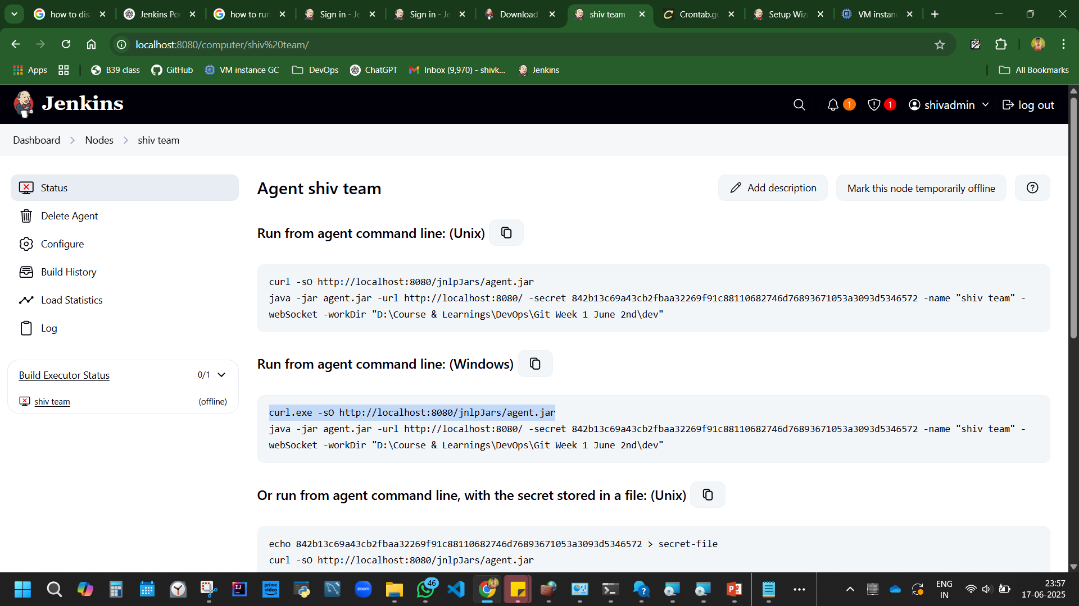

Go to file location, address bar, type cmd open command promt,

From Jenkins, Take 1st file command from Run from agent command line: (Windows)

*curl.exe -sO http://localhost:8080/jnlpJars/agent.jar*

A jar file agent is downloaded.

Then execute next line command. ‘agent.jar’ is being executed. connected to url, secret means some password is created with agent shiv team in the given address.

*java -jar agent.jar -url http://localhost:8080/ -secret 842b13c69a43cb2fbaa32269f91c88110682746d76893671053a3093d5346572 -name "shiv team" -webSocket -workDir "D:\Course & Learnings\DevOps\Git Week 1 June 2nd\dev"*

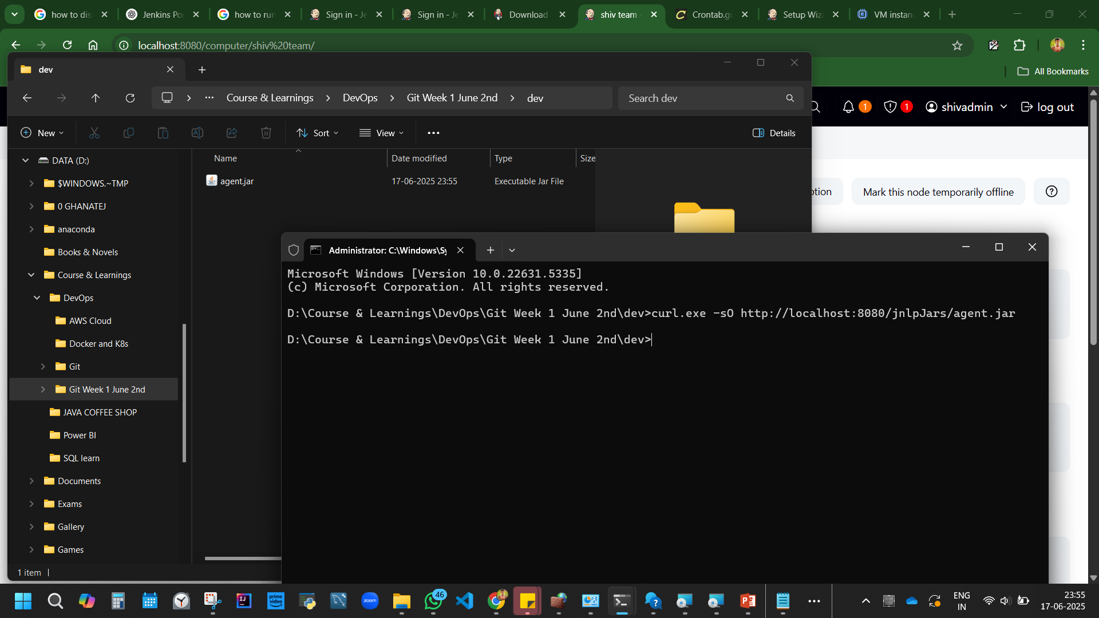

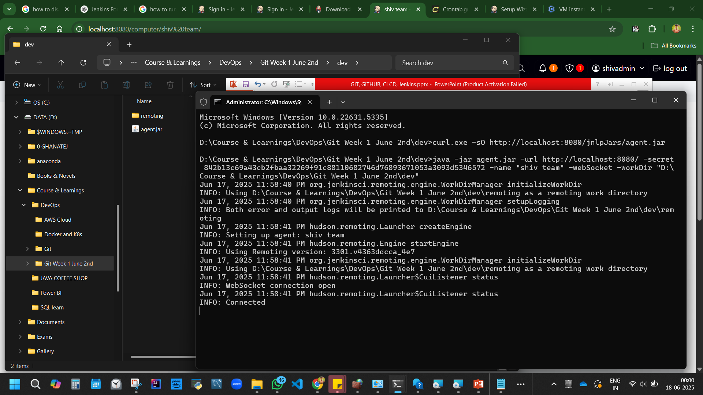

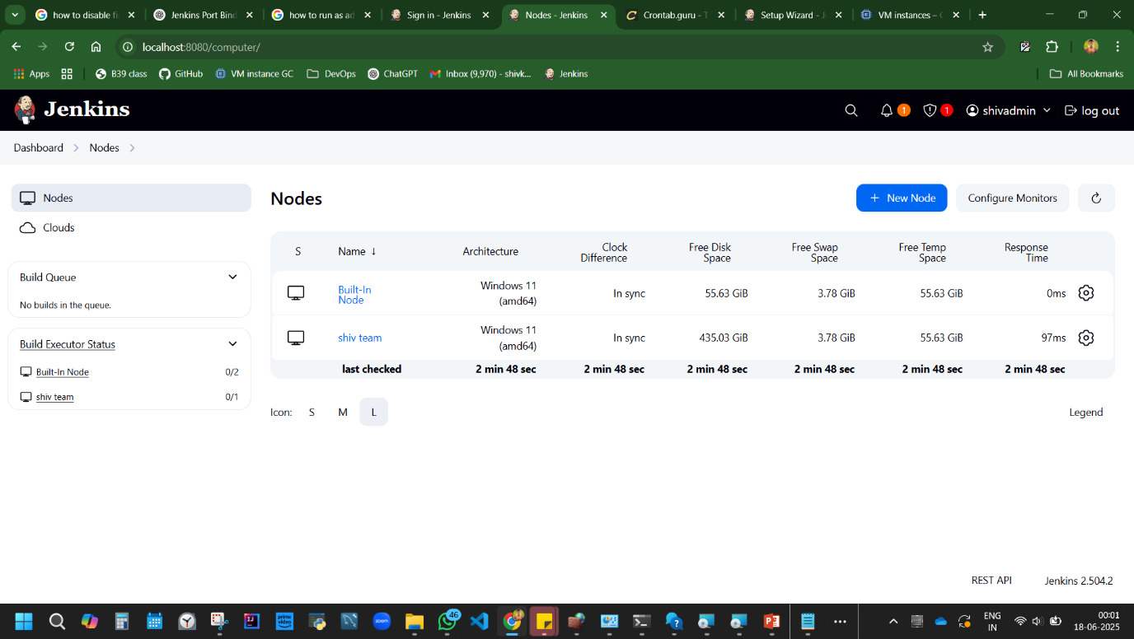

Figure Shiv team node Connected now

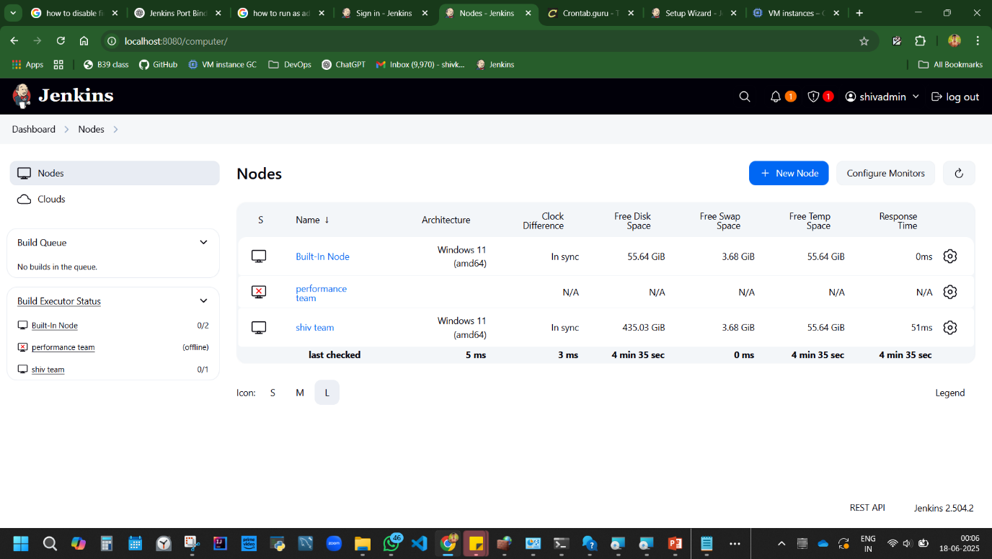

Figure Added a new node ‘performace team’but its down.

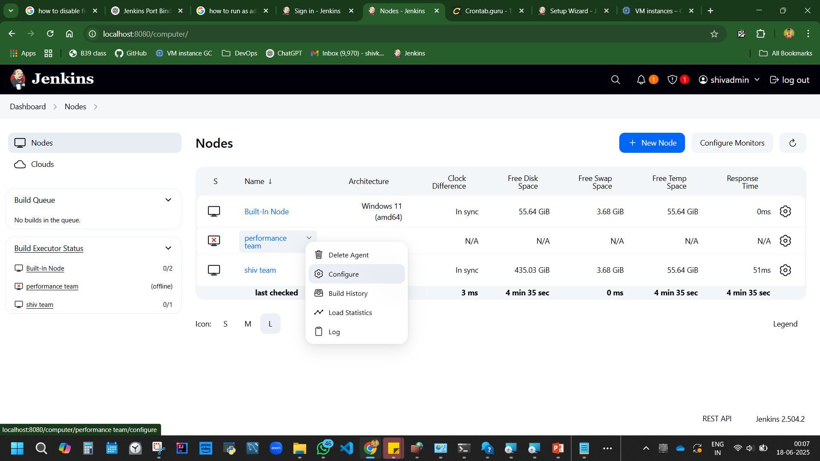

Figure Click on node,

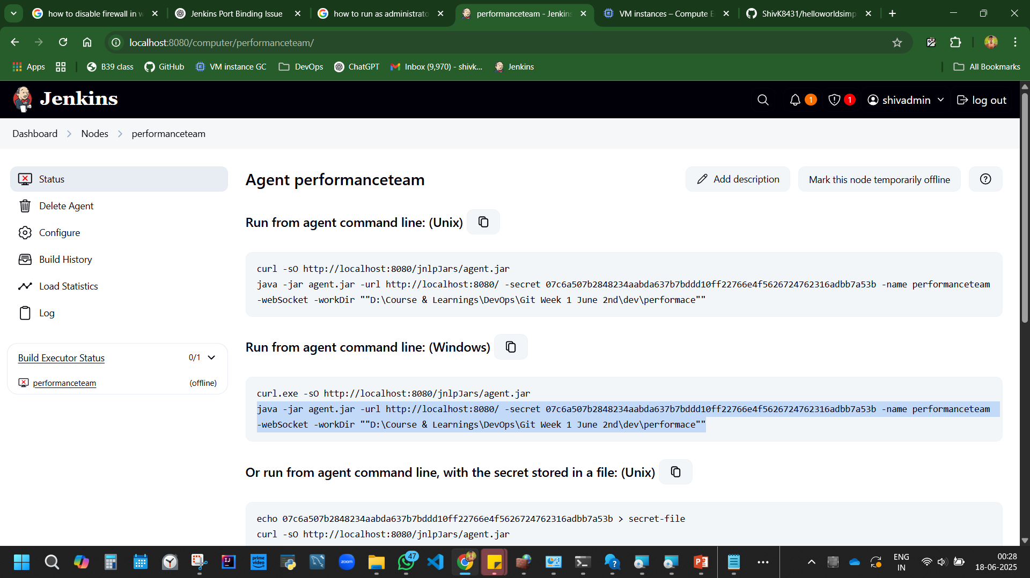

Figure execute 1st and 2nd code in cmd of performance folder in file pc.

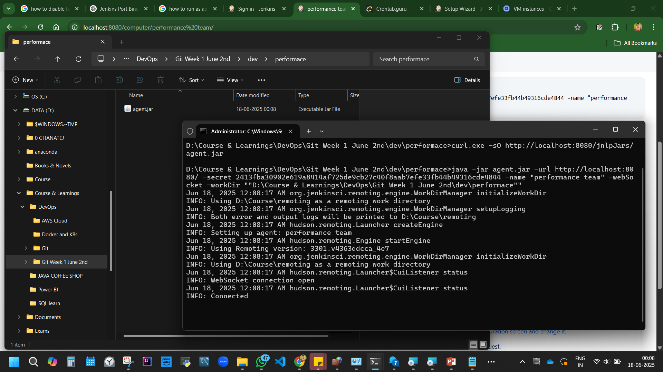

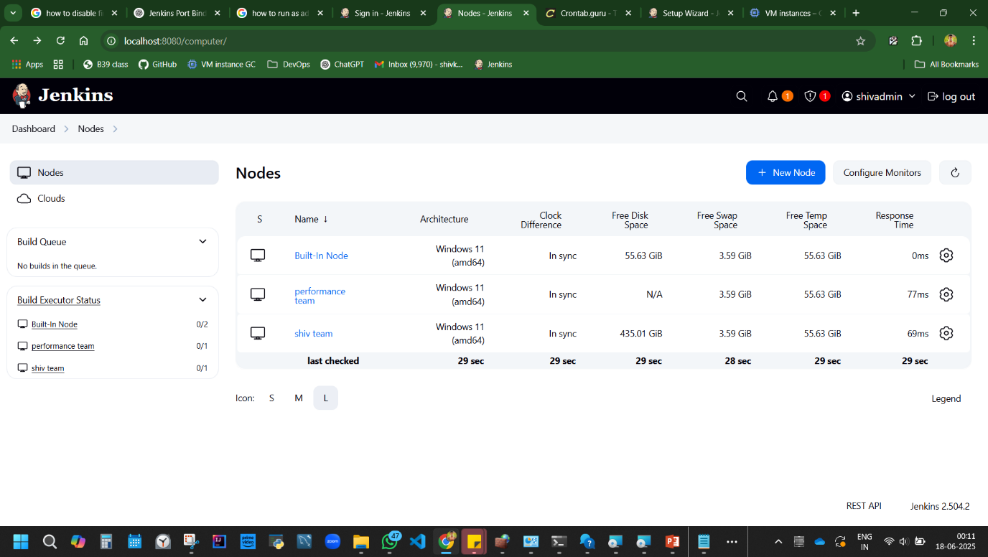

Figure Node conencted now

How to create agent in Jenkin. Master slave

Pipeline

Agent any

Stage

Steps

*This Pipeline will be executed anywhere*

Pipeline

Agent Shiv

Stage

Steps

*This Pipeline will be executed on Shiv node*

Pipeline

Agent Performance

Stage

Steps

*This Pipeline will be executed on Performance node*

Master slave Configuration.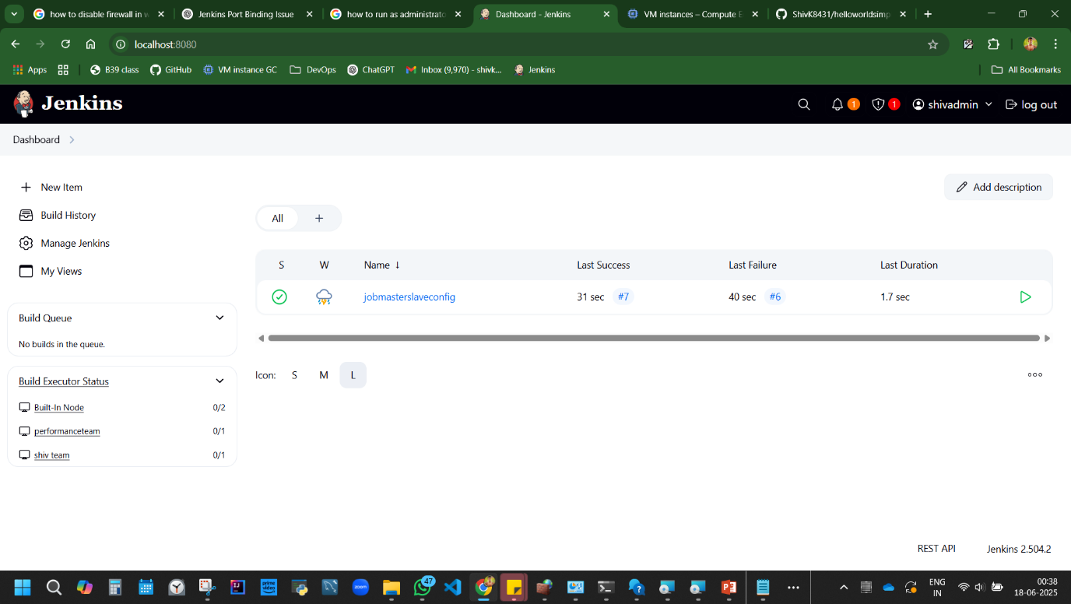

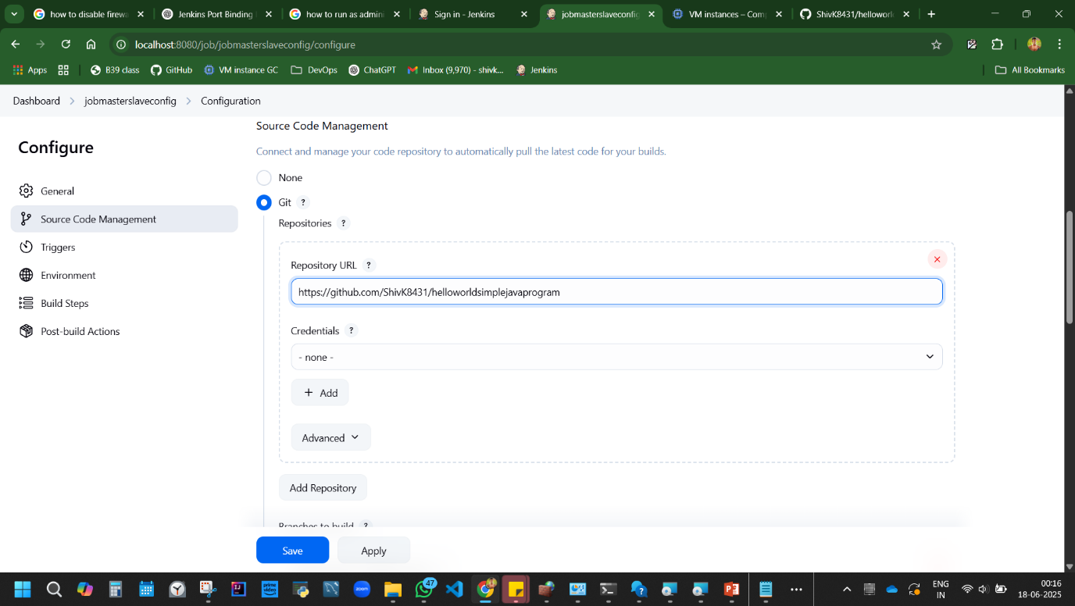

<https://github.com/ShivK8431/helloworldsimplejavaprogram>

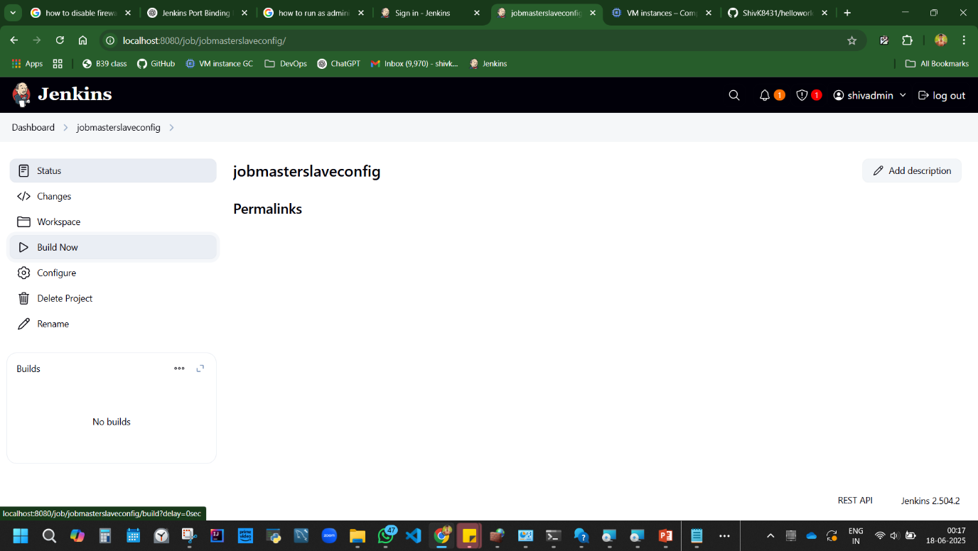

Try to build

Fail. Click on fail  
why?

Check repo url – its correct

branch…change from master to main.

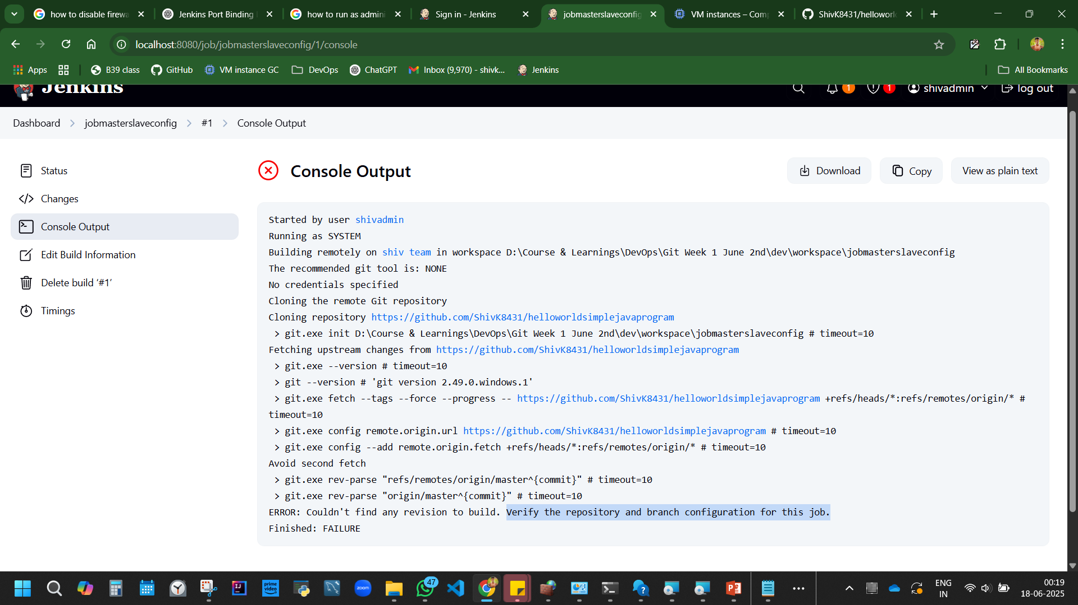

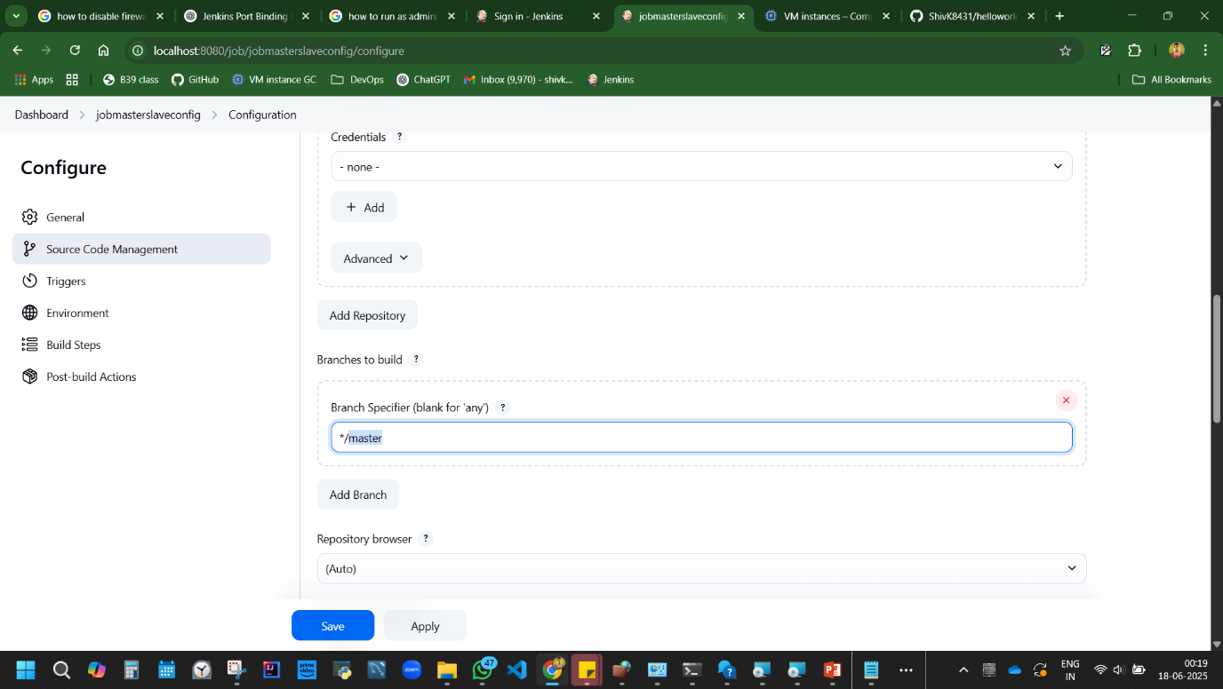

Figure Change master to main

Save, Build. Success.

Now its running in mater node.

Now if I want to run the job on Shiv node or performance node. Select agent.

Job>configure> restrict where the project can be run>performace>save.

Build. It executes on performance node. Check in console output. The directory will be

D:\Course & Learnings\DevOps\Git Week 1 June 2nd\dev\performace

